DEPARTMENT OF BOTANY
JAWAHARLAL NEHRU COLLEGE, BOKO
SESSION: 2024-2025

1.2.2 Number of Add on /Certificate programs offered during the year
1.2.3 Number of students enrolled in Certificate/ Add-on programs as against the total number of students during the year
*Name of the Course- Mushroom Cultivation Technology and its Utilization
*Number of Students Enrolled- 11
*Number of Students Passed- 11
*Duration of the Course- 6 Months
List of enrolled students-
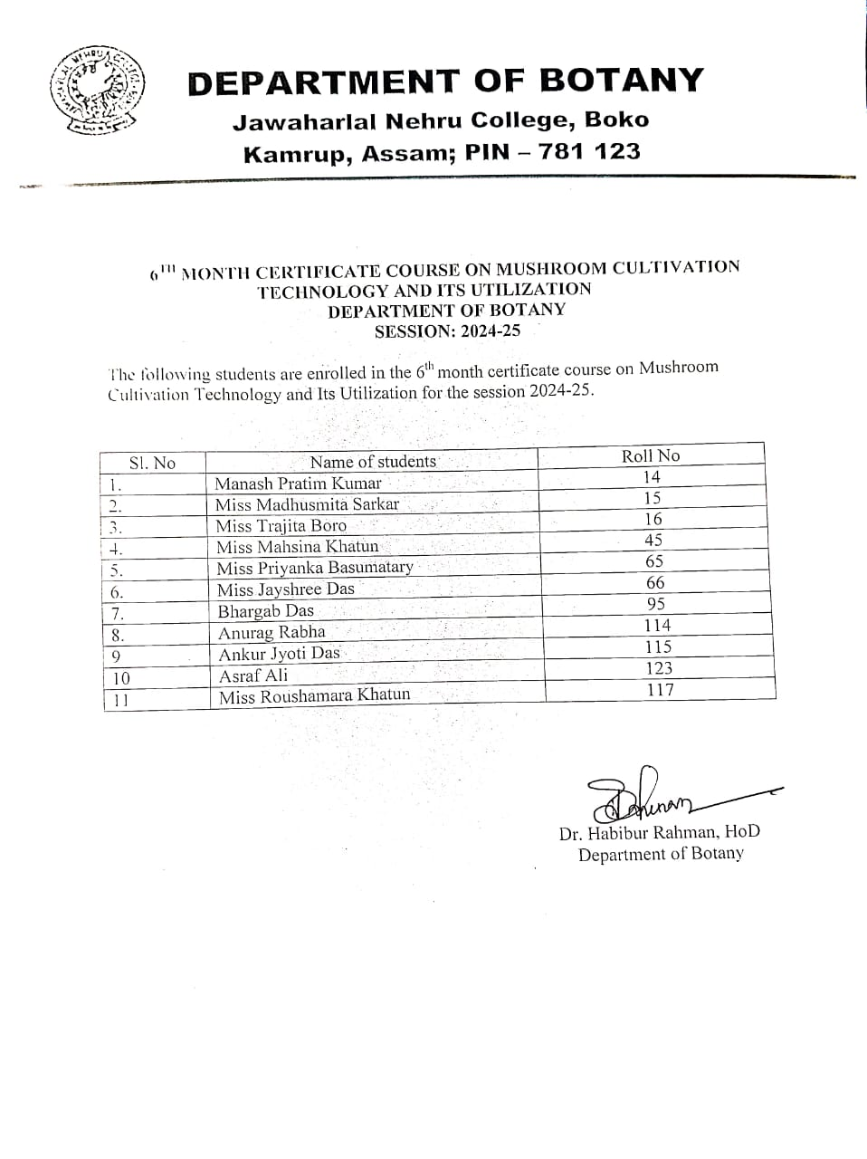
*Marksheet and Result of the students-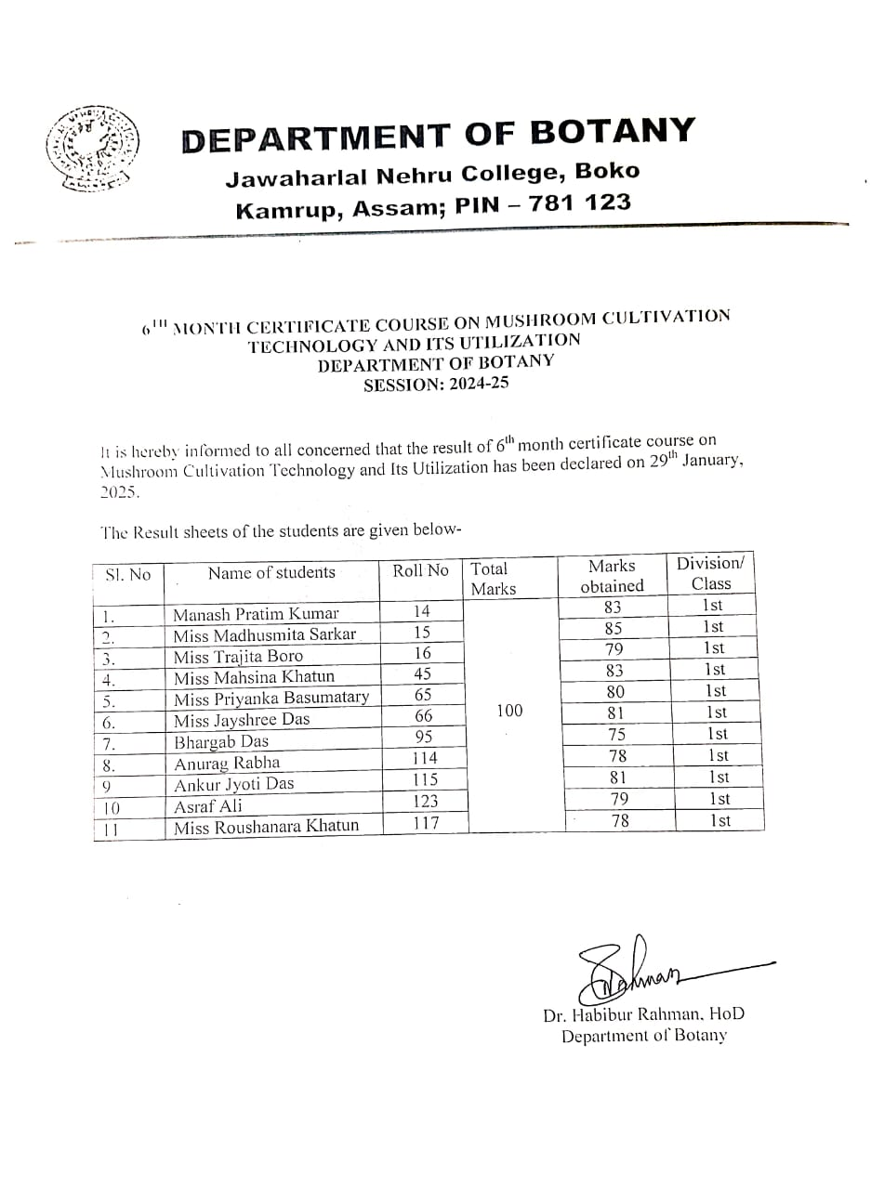

Register copy of daily attendance of students-
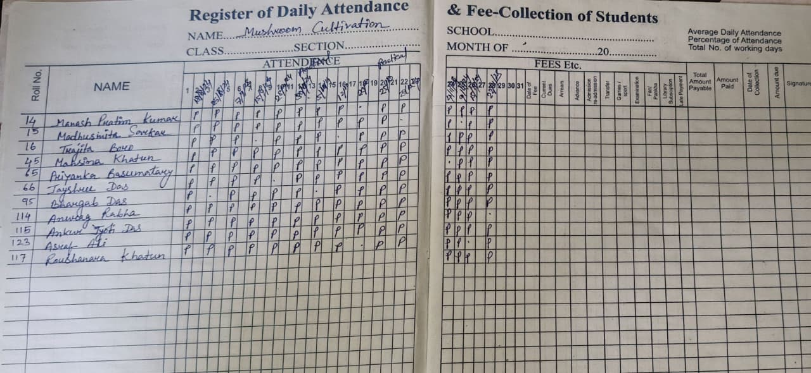

*Certificate of Completion of the 6th month Add on course-

