CULTURAL UNIT REPORT
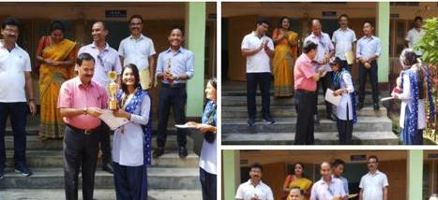
Details of the event: DIPANWITA KALITA & NIKUMONI DILO SECURED 1st POSITION IN JYOTI SANGEET COMPITITION AND 2nd POSITION IN TRADITIONAL TRIBAL SONG respectively, in the Inter College Youth Festival organised by Gauhati University, 2019. They were felicitated by our Former Principal Dr. Nripen Goswami in the college.

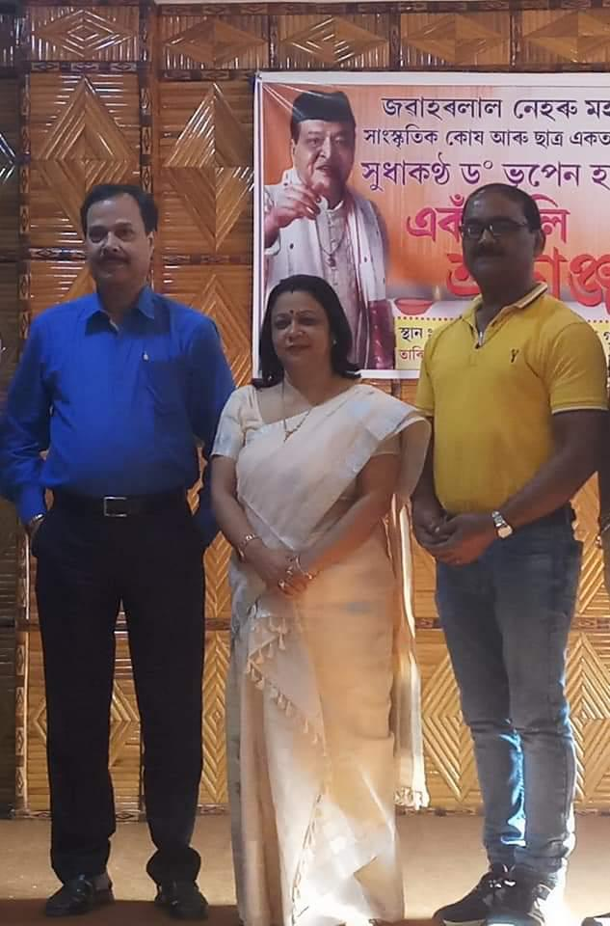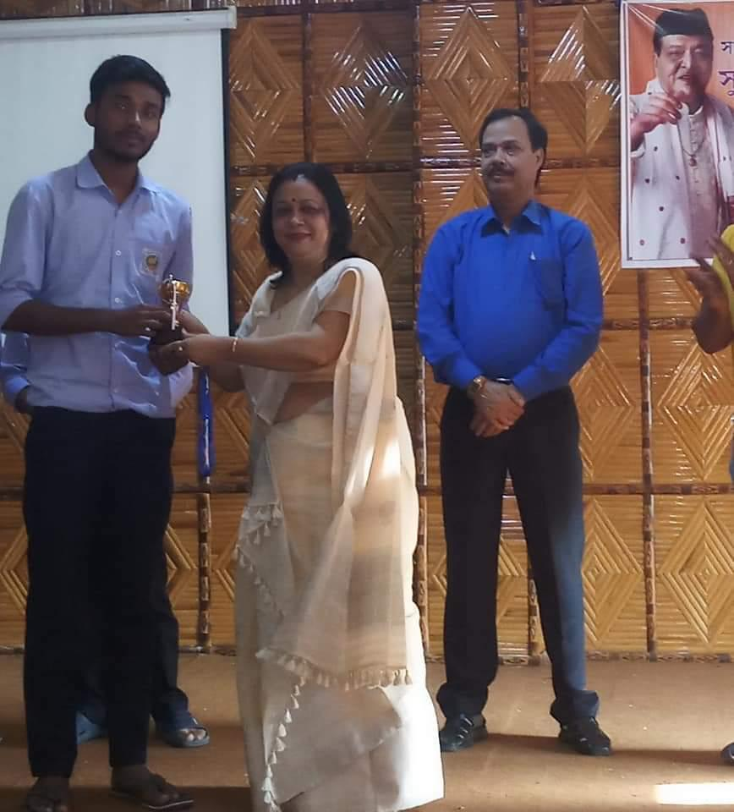
Details of the event: The Cultural Unit of JN College Boko organised Bhupendra Sangeet Compitition among the students of the College on the Death Anniversary of Sudhakantha Dr. Bhupen Hazarika on 5th November, 2021. Angshuman Das, a final year student of English Department got 1st prize.

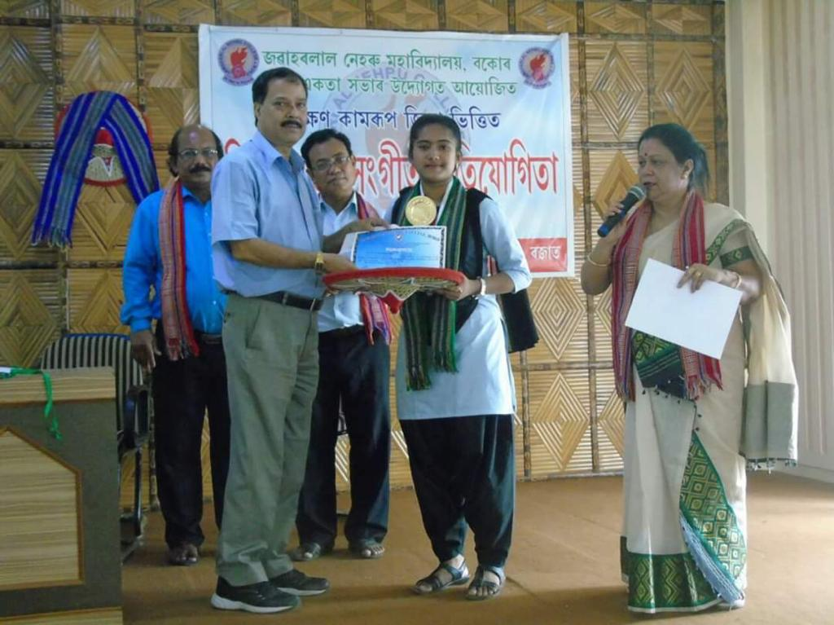
Details of the event: The cultural unit of JN College Boko organised Rabha Sangeet Compitition among Inter South Kamrup College on the occasion of death anniversary of Bishnu Rabha on 20th June, 2019.

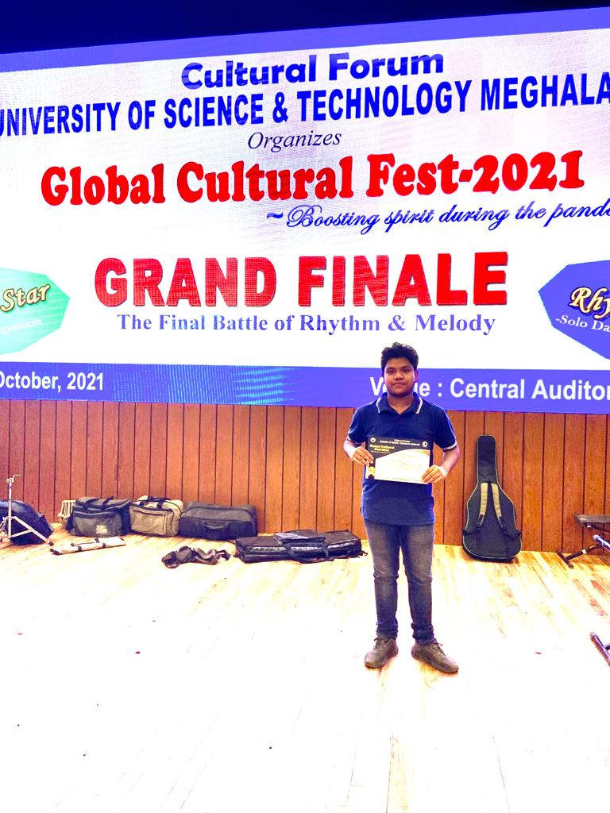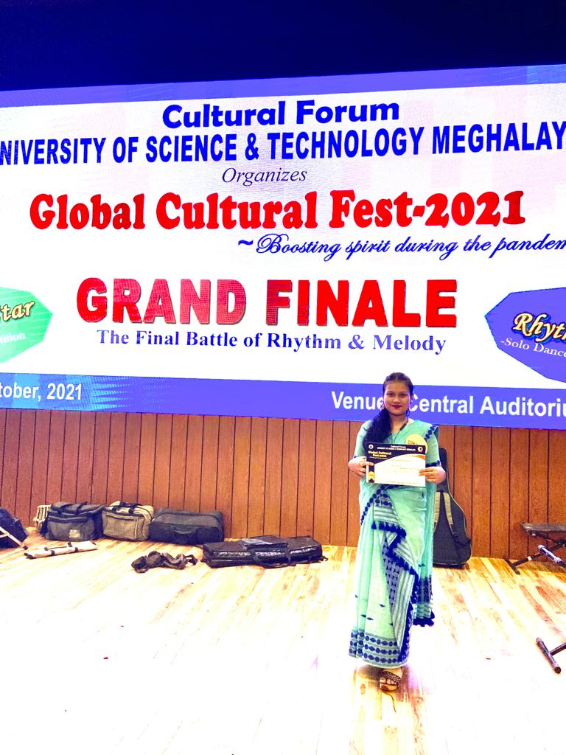
Details of the Event: The University of Science and Technology Meghalaya organised Global Cultural Fest, 2021 on ONLINE MODE. Devid Tamuli and Miss Gargee Kalita were selected for the final round. It was a stage performance, where both the student performed Gazal and Assamese Modern song and the performance was superb. They got certificates for their praiseworthy performance and participation.

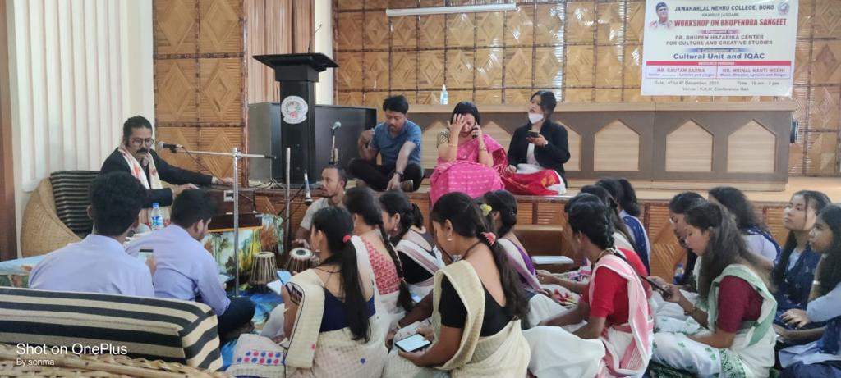
Details of the Event: WORKSHOP ON BHUPENDRA SANGEET, (04th & 05thDec), 2021 organised by Bhupen Hazarika Cultural and Creative Study Centre in collaboration with the Cultural Unit of JN college, Boko. Mr. Gautam Sarma and Mrinal Kanti Medhi was the resource person in that event. More than 50 students participated in the workshop and the workshop was fruitful one. Certificate was given to the all participants.

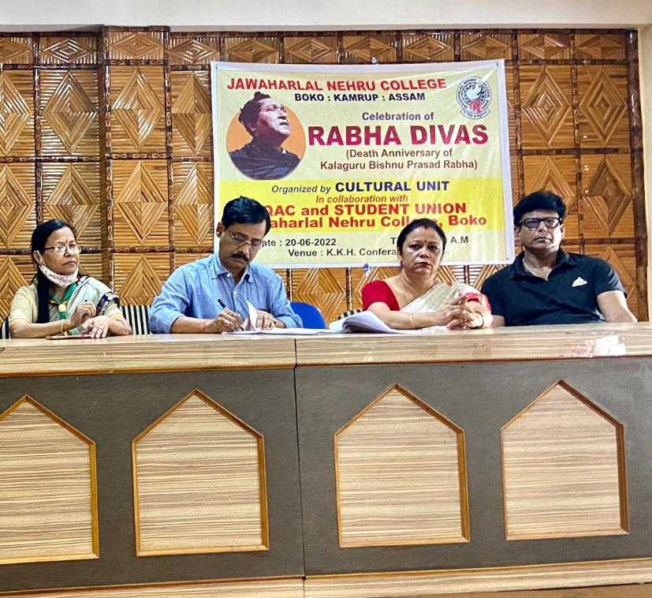
Details of the Event: Like every year the Cultural Unit of JN College, Boko organised Rabha Divas on 20th June, 2022 on the Death Anniversary of Bishnu Rabha.

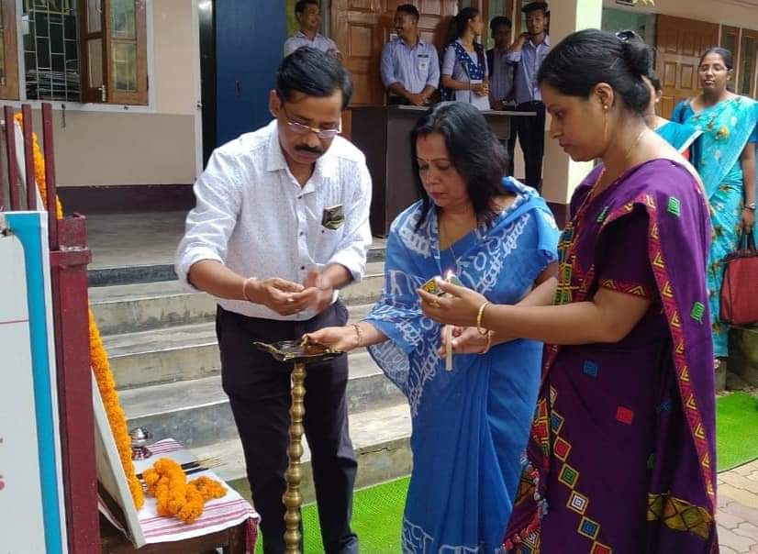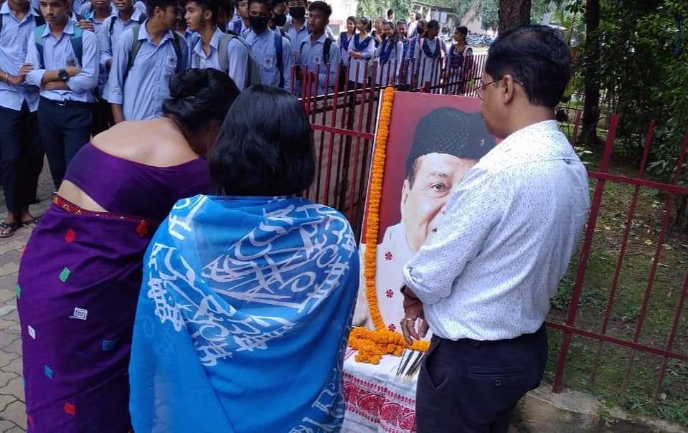
Details of the Event: Celebrated Birth Anniversary of Dr. Bhupen Hazarika on 8th September, 2022 by lightening diya and Miss Alee Borah, a student of MA course (Assamese), Dr. Diganta Kr Das, HOD of History performed Bhupendra Sangeet on that event. At the final hour of the event, all the students and faculties sang the most popular song of the legend, “Manuhe Manuhor Babe”.

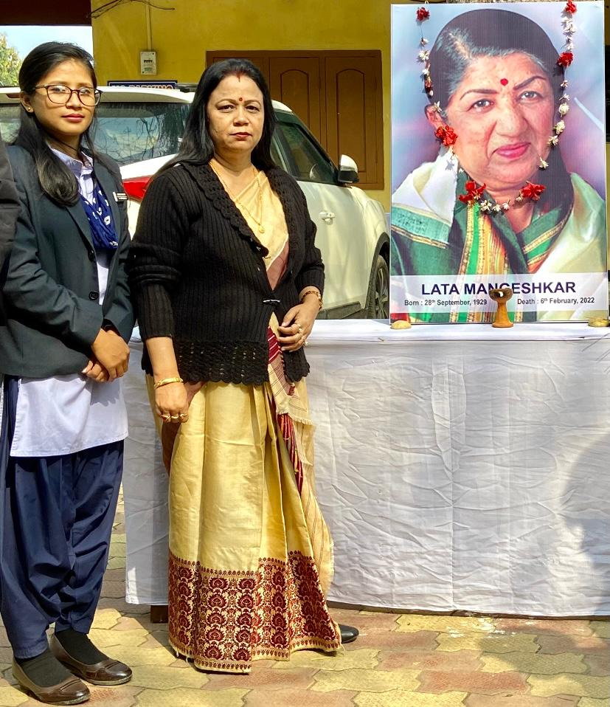
Details of the event: The Cultural Unit of JN College Boko paid homage to Lata Mangeshkar on 6th of February, 2022 when the news of her demise sprayed all over the world, the College also paid tribute to her.
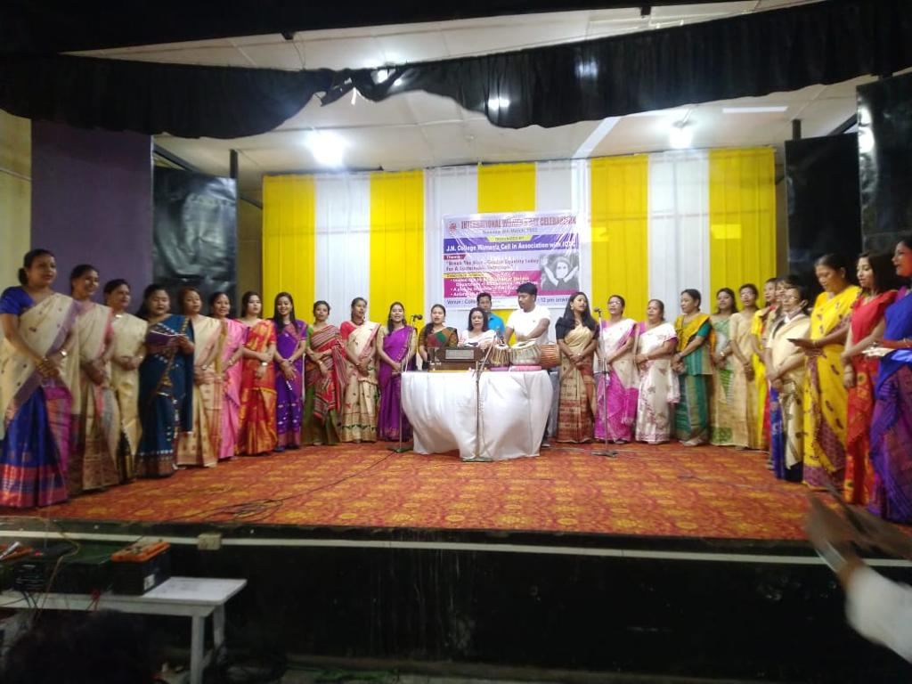
Details of the Event: The International Women’s Day was celebrated in the college on 8th March 2022 and the women faculty of the college performed a chorus from the Cultural Unit of JN College, Boko.

