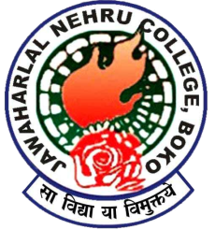 Srimanta Sankardev Centre
For Language Literature and Media Studies.
Jawaharlal Nehru College,Boko
Introduction and Brief History :-
The vision for this centre, outlined in this Proposal, had been developed by Sri D.K Das, Former HOD of English of Jawaharlal Nehru College, during his tenure and proposed to be named as English Language and Literature Cell. The vision of the centre at that time was expansion of knowledge, through research in diverse areas, whether historical or descriptive, basic or applied, concerning the languages, literatures, and cultures of India and the world .
During that time, the cell had organised a few activities and had involved faculty, staff and administration for a few programmes like workshops,seminars,literary Quiz programmes etc.
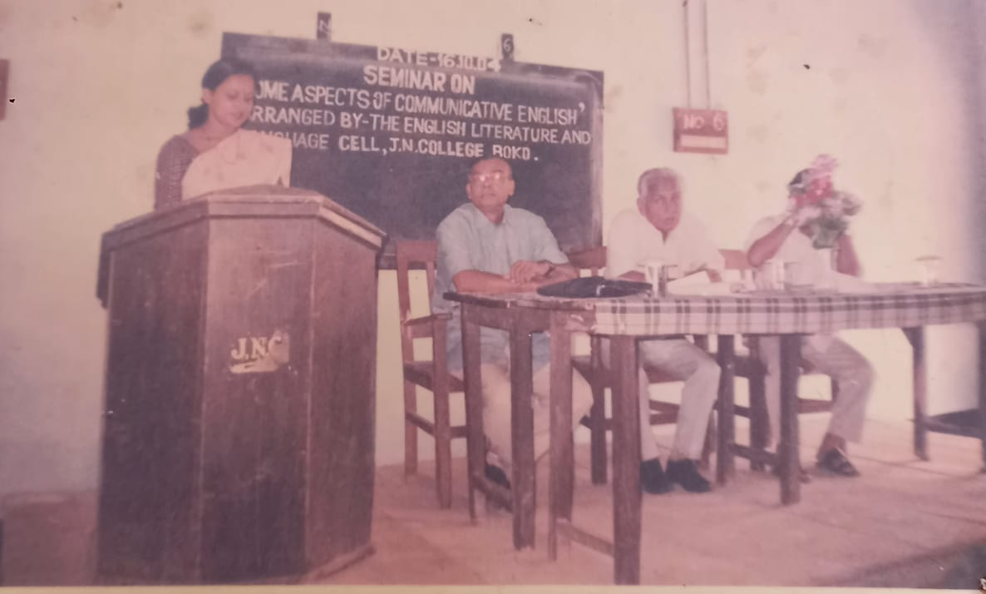
This cell which has not been very active in the recent years has been proposed to be revived and in its revived form proposed the inclusion of the other Language Departments of the college,namely Assamese and Bodo Departments and re-forming a composite Centre in the name and style of Shrimanta Shankardeva Center for Language and Literature Studies. Upon submitting the proposal to the College Principal , He suggested us to incorporate ‘Media studies’ also into this proposed centre. Thereafter he suggested to name the centre as the Srimanta Shankardev Centre for Language Literature and Media Studies.
Inception-The proposal to start the centre was presented to the Principal Dr. Tapan Dutta on 22-02-2022 , jointly by the departments of English ,Assamese and Bodo. As suggested by the Principal to Incorporate Media Studies also into this centre it was likewise agreed upon to christen it as The Srimanta Shankardeva Centre for Language, Literature and Media Studies. The formal inauguration took place on 23.02.2022 in conjunction with a Lecture organised by the Department of English on Popular Literature and Contemporary Society, delivered by Dr.Bibhash Choudhury Dean Faculty of Arts and HOD,English Department, G.U.
Aim-The aim of the proposed centre is to facilitate the promotion and study of languages, literatures and various aspects of Film and Media and to promote studies and academic explorations in the respective areas of the above mentioned subjects.

Objectives-
- To promote the mutual enrichment of languages and literatures through explorations of literary texts and other works of renowned writers and scholars of India and the world.
- To bring out of the essential unity and commonness of languages by organizing various scientific, cultural and academic studies and programmes.
- To work upon inter-translation into Indian languages and translation of Indian languages to English language.
- To undertake various student level and research level programmes in the field of language, literature and Media Studies.
- To organize seminars/workshops on comparative study of Indian languages and various facets of Films and Film Studies.
- To organize programmes on second language teaching and learning.
- To undertake various projects related to language,literature and Media studies.
Members
The Department of English is functioning as the coordinating department of the centre.
Committee
President-Dr Tapan Dutta ( Principal)
Vice President-Mrs. Bijaya Deka (Vice Principal)
Coordinator-Mrs. Ratnamala Sarma (Dept Of English)
Members –
- Mrs.Manjira Sarma(Dept.of Assamese)
- Miss Bhairabi Boro(Dept.of Bodo)
- Mr. Pulak Talukdar(Dept.of English)
- Alimpa Bhuyan Baruah ( do )
- Ruptalin Engtipi ( Do )
- Gayatri Kharghoria ( Dept.of Assamese)

Activities of the Centre-
23.02.2022 – Official announcement of Inauguration of Centre
The formal inauguration took place on 23.02.2022 in conjunction with a Lecture organised by the Department of English on Popular Literature and Contemporary Society, delivered by Dr.Bibhash Choudhury Dean Faculty of Arts and HOD,English Department, G.U.
12.03.2022- Movie Screening of the Hollywood Film ‘TROY’
The Department of History as part of their curriculum(Semester I-Paper II,1026 WORLD HISTORY) organised a Movie Screening of the Hollywood Film ‘TROY’ at the Digital classroom in collaboration with the English Department,the IQAC and the Srimanta Shankardeva Centre for Language Literature and Media Centre.
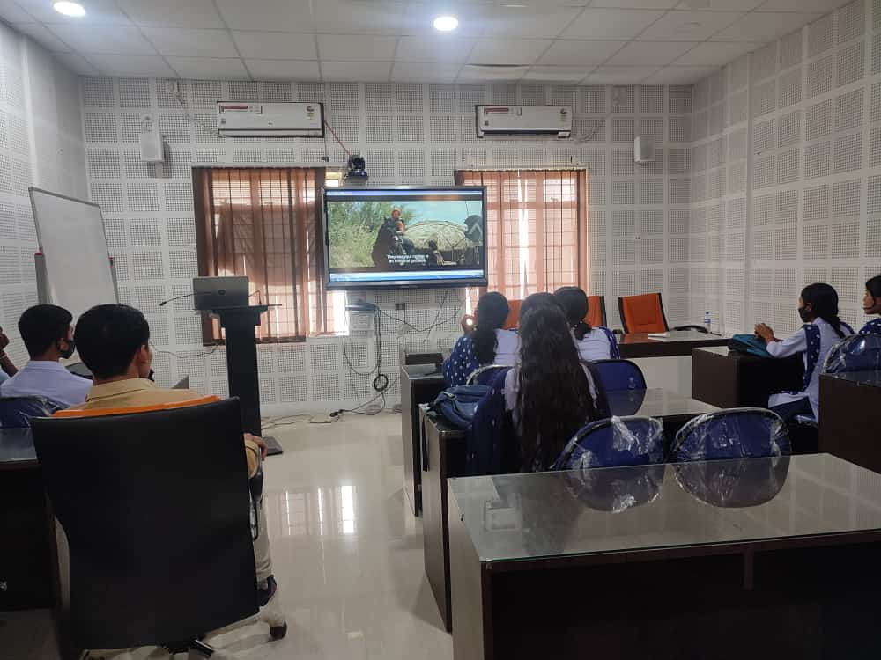
(MOVIE SCREENING FOR STUDENTS OF HISTORY DEPT)
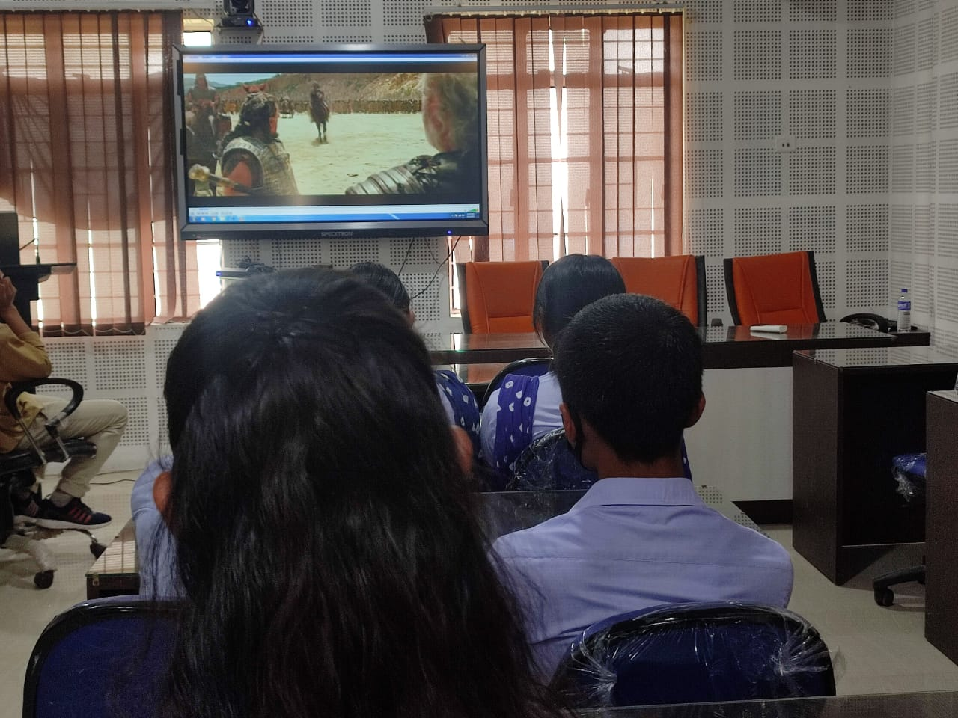
(MOVIE SCREENING FOR STUDENTS OF HISTORY DEPT)

02.04.2022- Distinguished Lecture programme
The Department of English in collaboration with the IQAC and the Srimanta Shankardeva Centre for Language,Literature and Media Studies organised a Distinguished Lecture programme By Renowned Film Maker Jahnu Barua . In this programme noted film Scholar Parthajit Baruah also presented a paper on Film Studies.
Distinguished Lecture programme By Noted Filmmaker Jahnu Barua

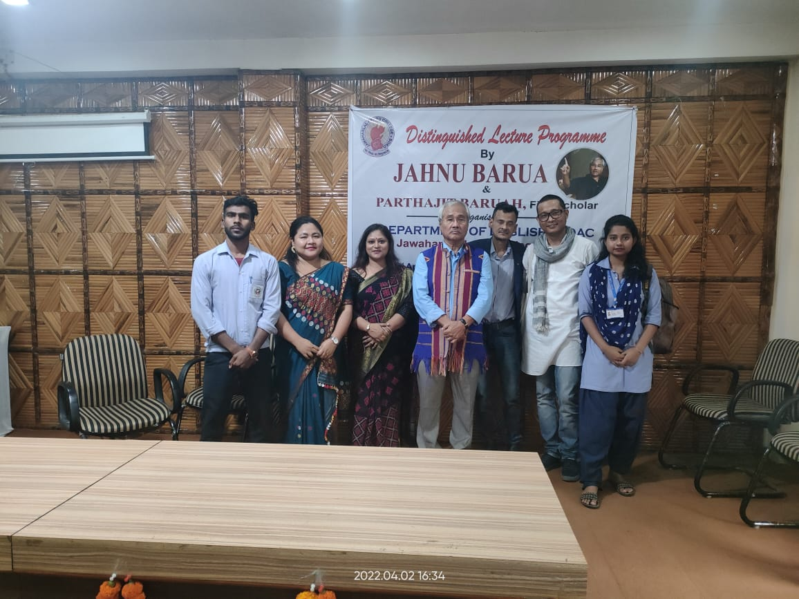

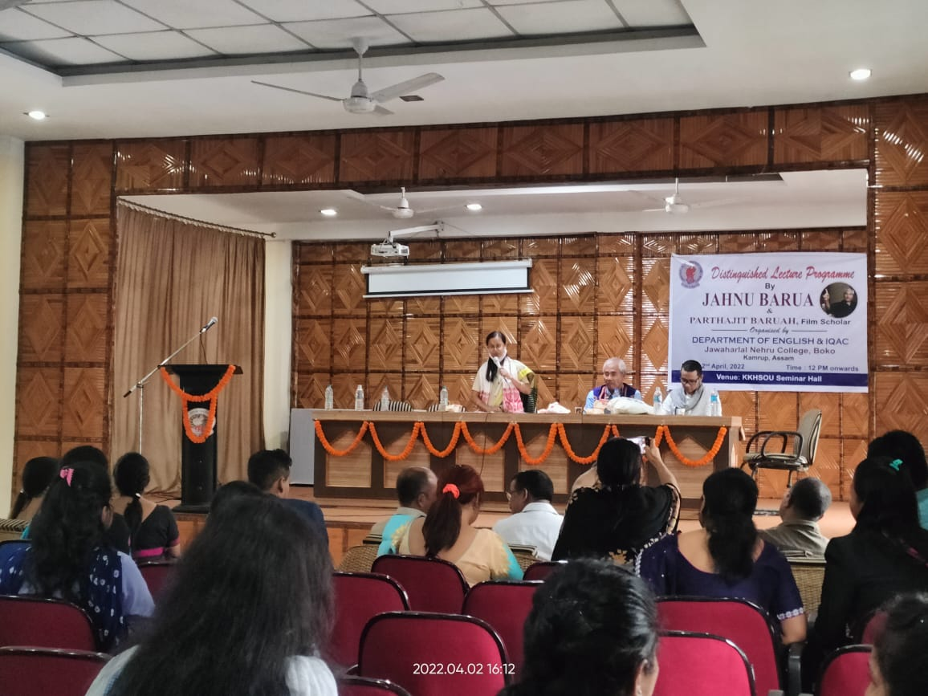

11.03.2023-Documentary film Release and Screening
An official film release function and screening of 'A Mystical Journey: Exploring the Tourist spots of Rabha Hasong Autonomous Council’ was organized by the centre in association with the IQAC in the KKHSOU Conference Room at 11.00 A.M on 11th March 2023. The film was officially released by the Honourable Chief Executive Councillor of RHAC, Er. Tankeswar Rabha, and the and the programme was attended by the President of the College Governing Body Sri L.K.Sarma,Sri Sumit Rabha EC Member of RHAC, The Principal Dr . Tapan Dutta,The Vice Principal Mrs. Bijaya Deka,Coordinator of IQAC Dr. Dhiraj Kr. Das, Faculty members of the college, Media persons and several noted persons of the community as well as the students of the college. The film had been made by an alumni of our college Lokapriya and there are few contributions from the Srimanta Shankardev Centre of the college in its preparation. This has been duly acknowledged in the title credits of the film too. The English subtitles of the documentary had been prepared by Mrs. Ratnamala Sarma,HOD of English and coordinator of the Centre.
Documentary film Release and Screening Programme
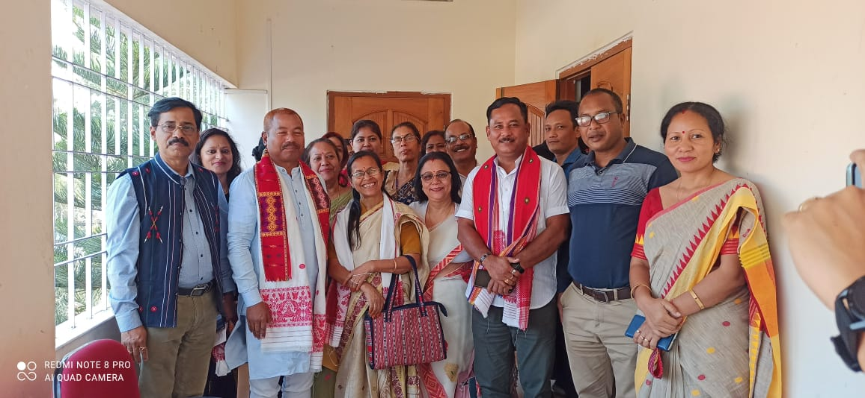
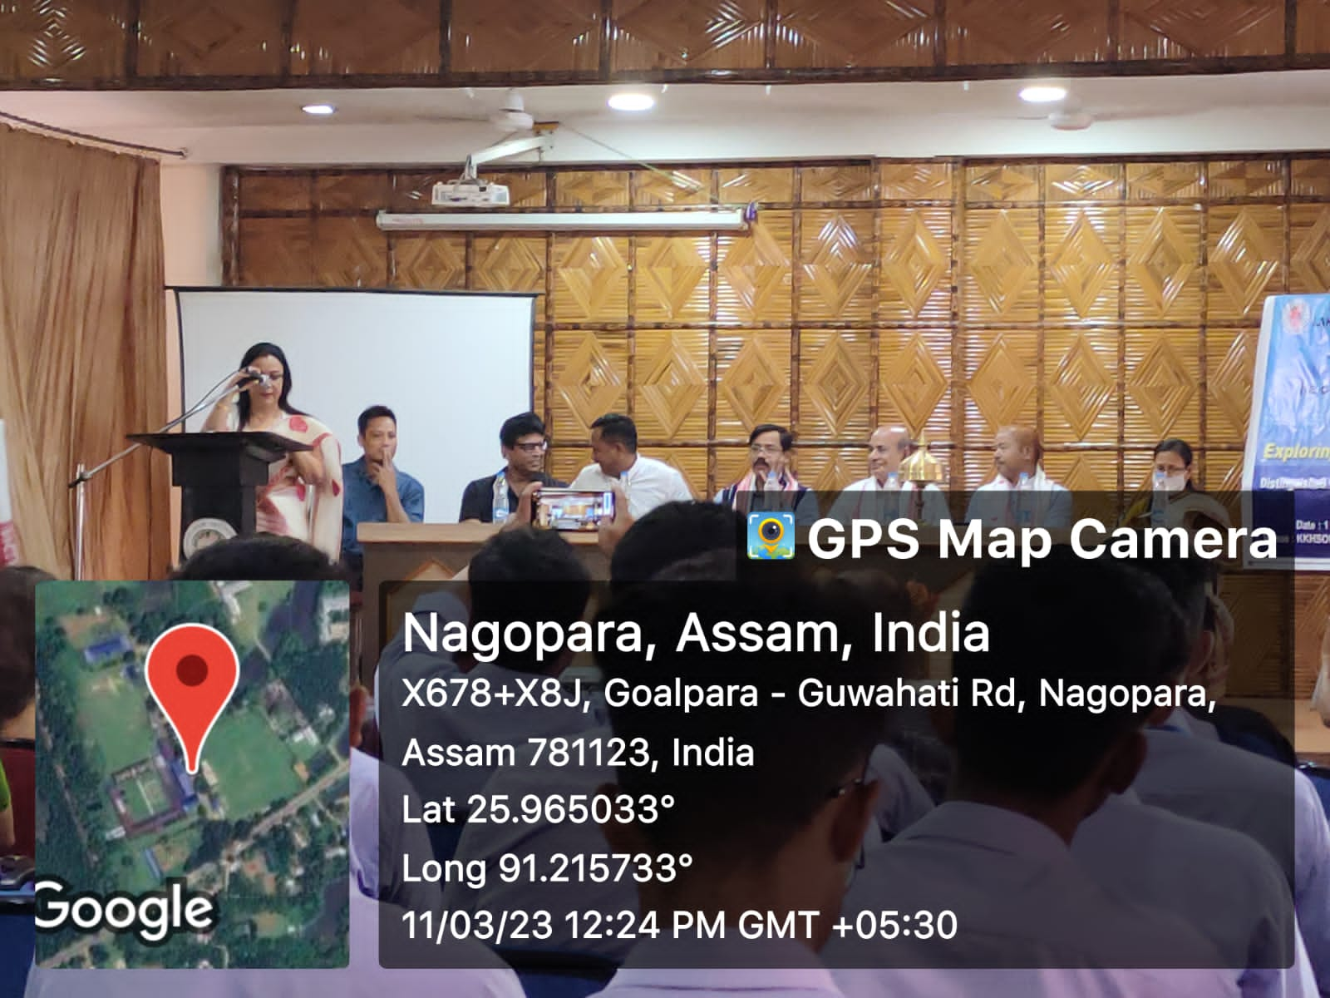
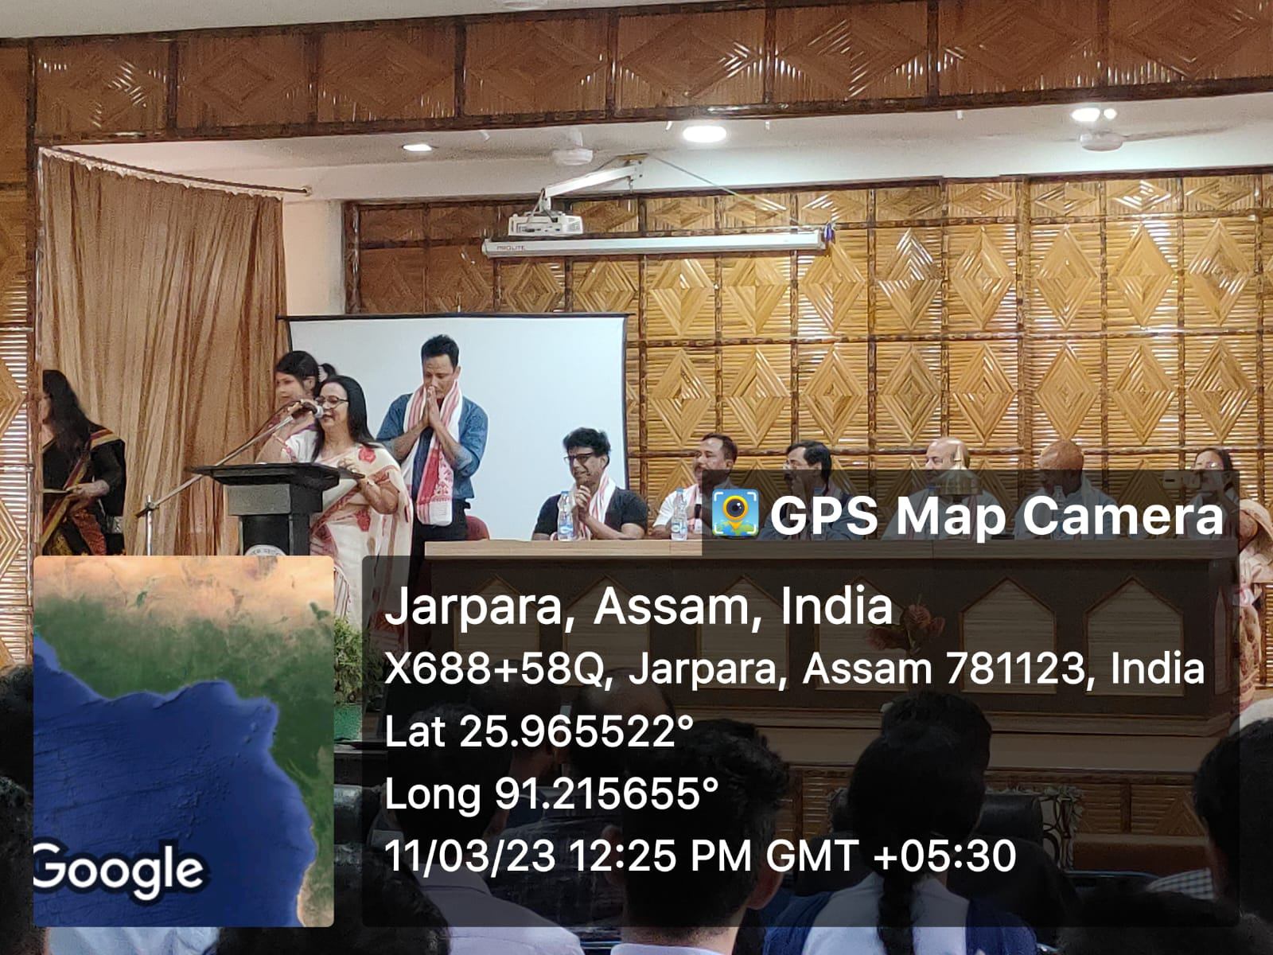

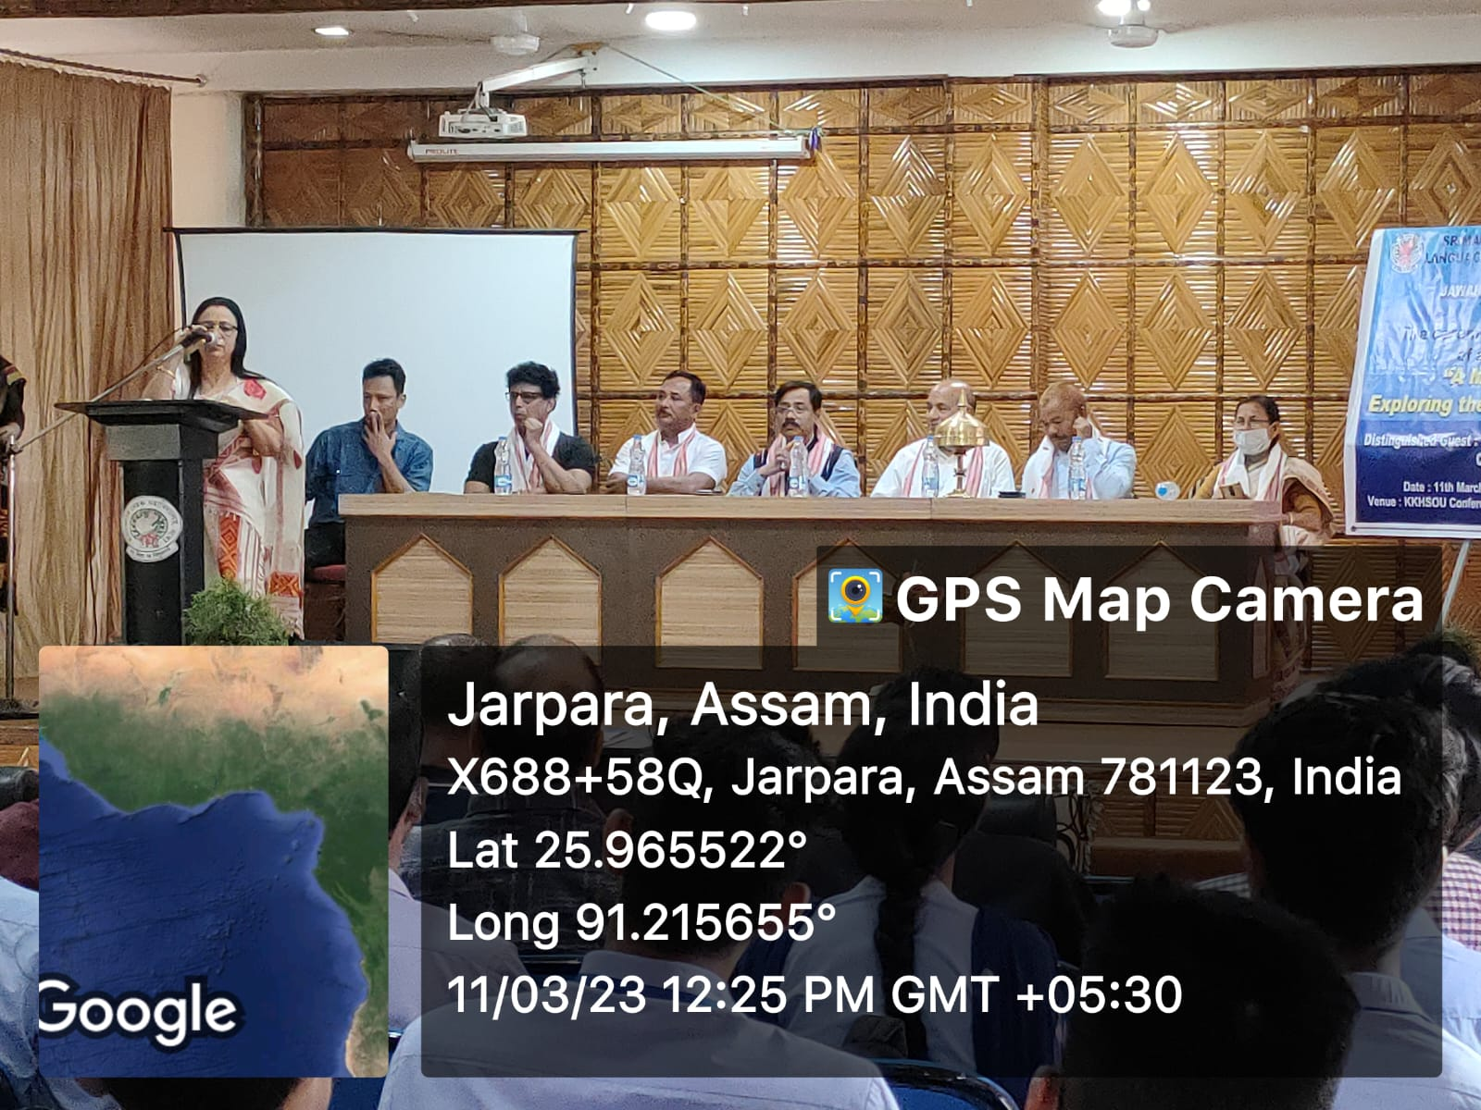
Coverage of Event in Etv Bharat TV News Channel –
https://www.etvbharat.com/assamese/assam/state/kamrup/documentary-launched-in-boko-to-attract-tourists/assam20230312223456388388324
Coverage of Event in NE Live TV News Channel –
https://www.facebook.com/100004444819005/posts/2476236225867847/?mibextid=nS636kBiAnZByu2K.
Published news clip in The Sentinel
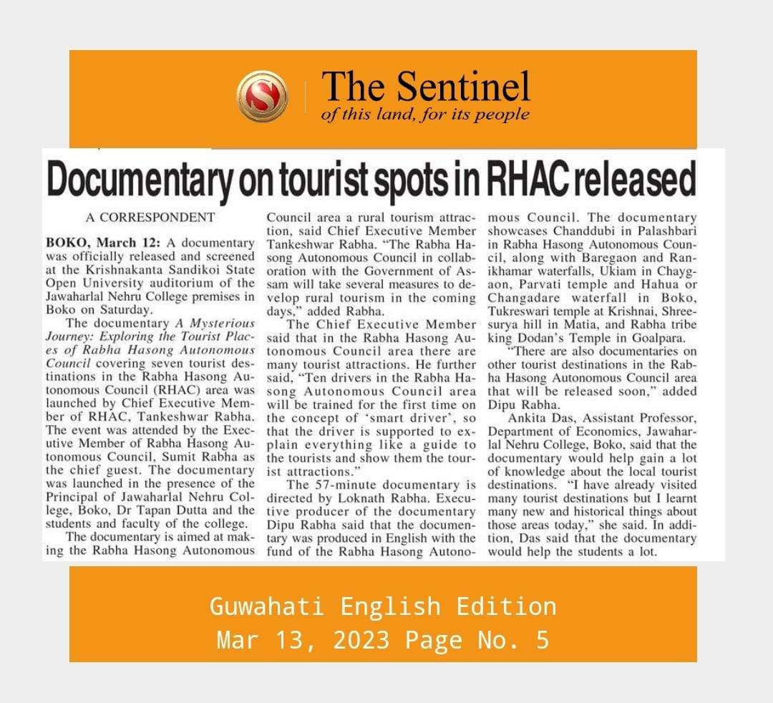

Published news clip in The Chronicle
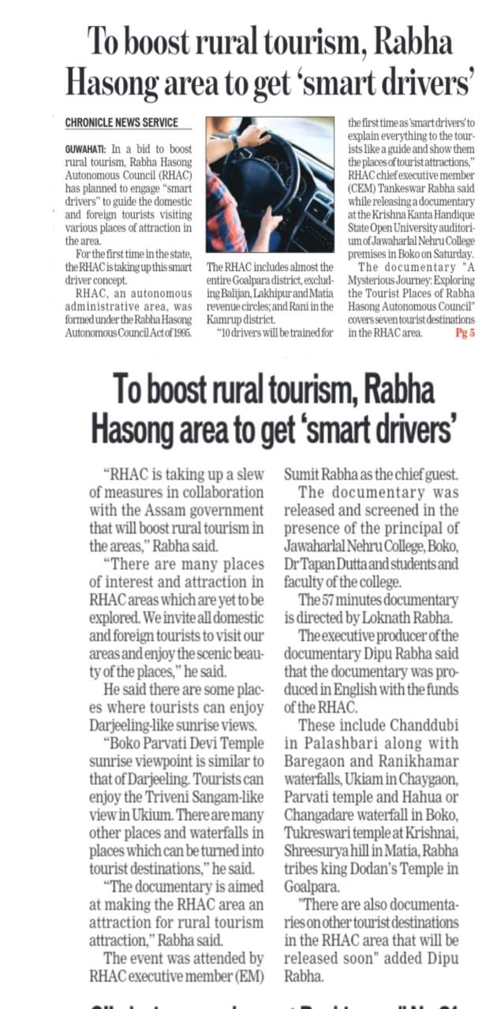
Its worthy of mention that on 29th March ,2023 ,The Documentary Film,’A Mystical Journey: Exploring the Tourist spots of Rabha Hasong Autonomous Council’ was officially uploaded to the youtube channel of the Lokapriya ,its creator. Link- https://youtu.be/kHj7jpGGZOY.
The centre is still in its fledgling stage and yet in a short time has successfully organized notable programmes and also done significant work in the concerned fields. There are several other plans in the offing which will be conducted in the future. In the near future a seminar has been planned and the proposal will be submitted in a short while, probably in Mid-April.

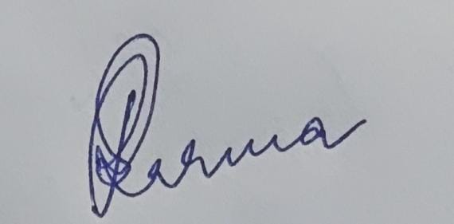
Ratnamala sarma
(Coordinator)
Srimanta Sankardev Centre
for Language Literature and media studies

