Inter College Bhupendra Sangeet Competition
Organized by Cultural Unit , Jawaharlal Nehru College and Bhupen Hazarika Centre for culture and creative Studies in Collaboration with Directorate of Students' Welfare, Gauhati University
DATE- 07-09-2024

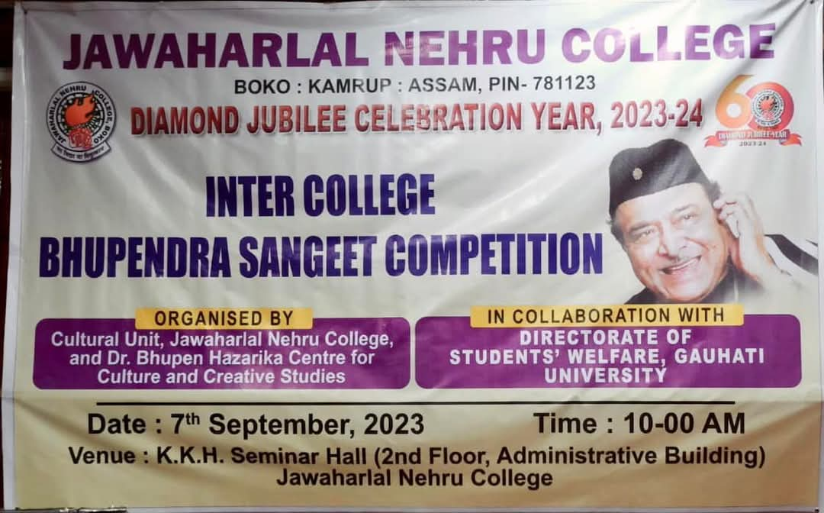
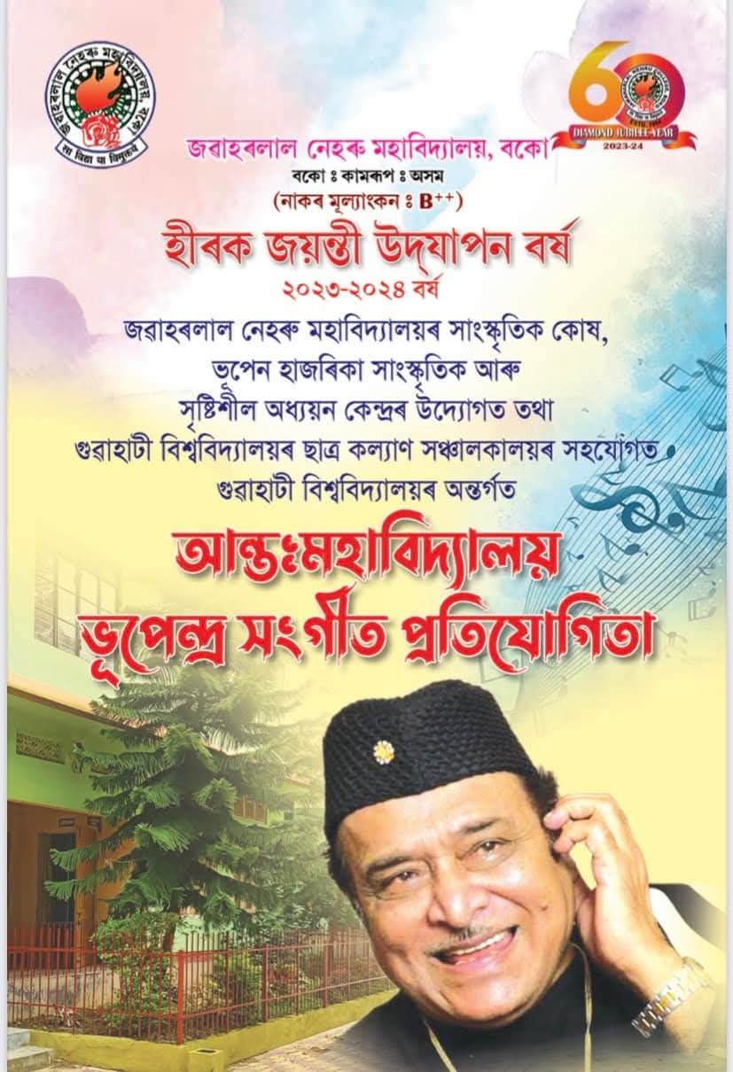
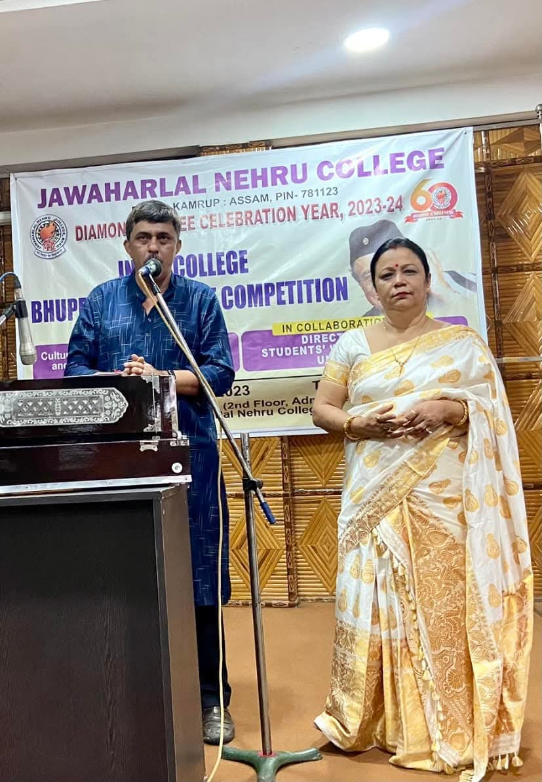
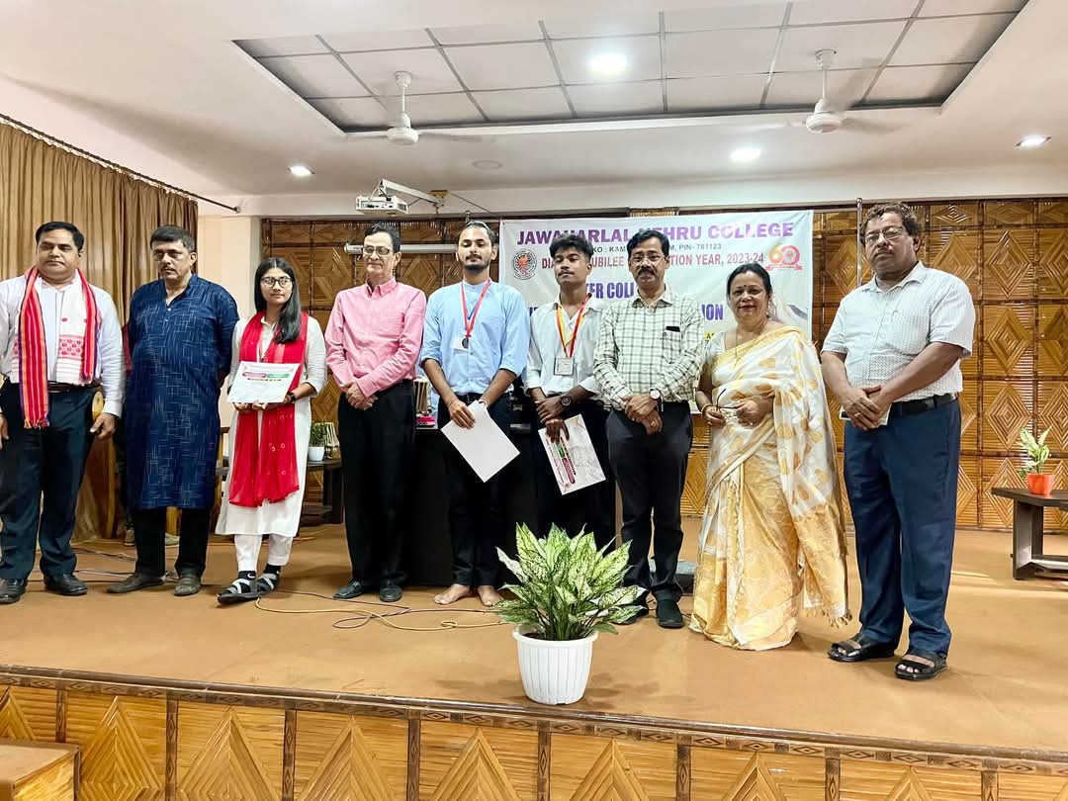
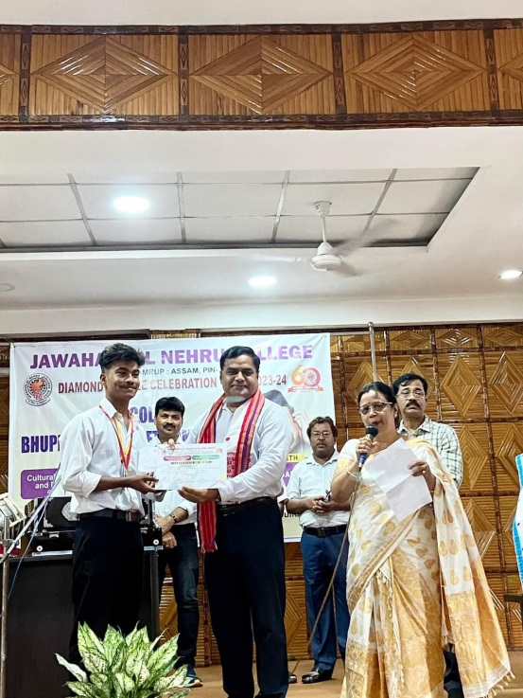

Winner :
1st Prize: Rohan Bora - BKB College , Purani Gudam Prize money - Rs7000/
2nd Prize : Barasha Das, Handique Girls College Prize Money –Rs-5000/
3 rd Prize : Khanjan Nath , Dudhnoi College Prize Money –Rs. 3000/

