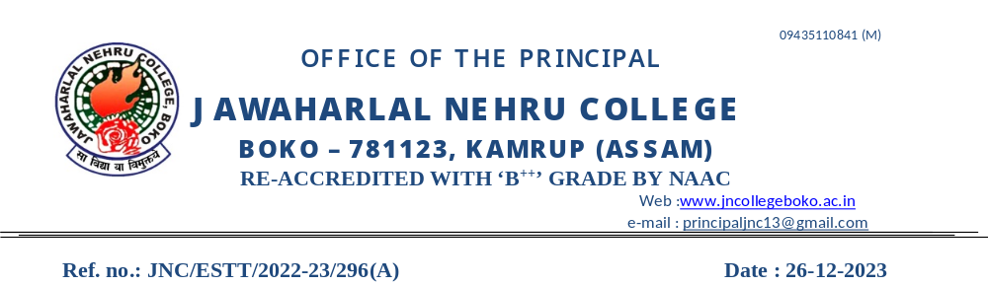
REPORT
DR. BHUPEN HAZARIKA CENTRE FOR CULTURE AND CREATIVE STUDIES
JAWAHARLAL NEHRU COLLEGE, BOKO
KAMRUP ASSAM

Inter College Bhupendra Sangeet Competition
Organized Bhupen Hazarika Centre for culture and creative Studies and Cultural Unit, Jawaharlal Nehru College in Collaboration with Directorate of Students' Welfare, Gauhati University
DATE- 07-09-2023

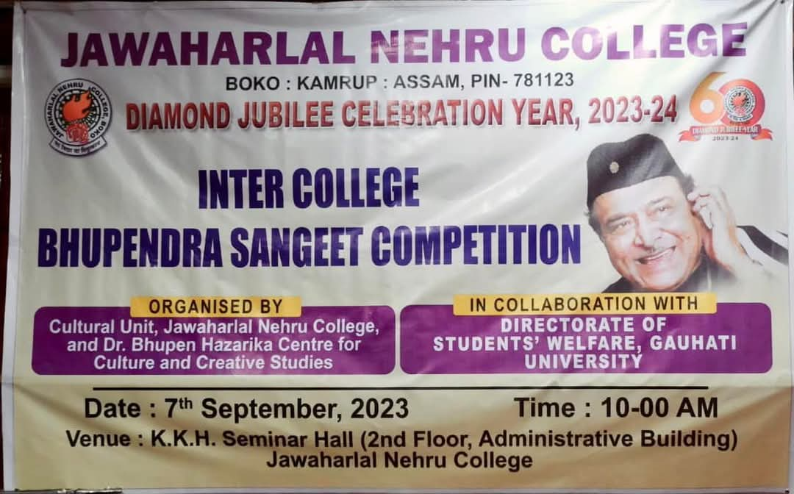
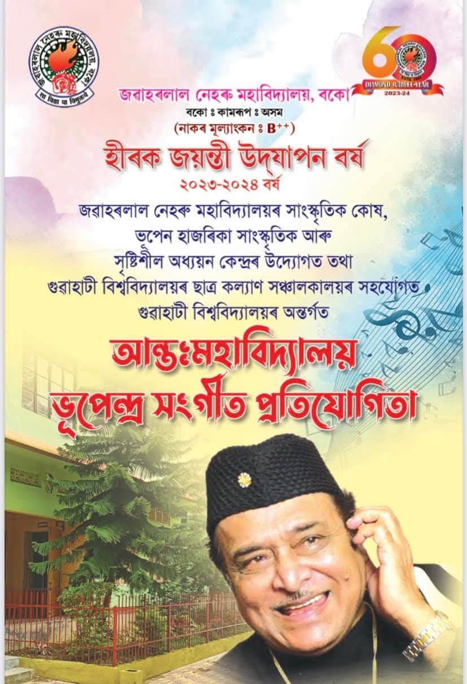
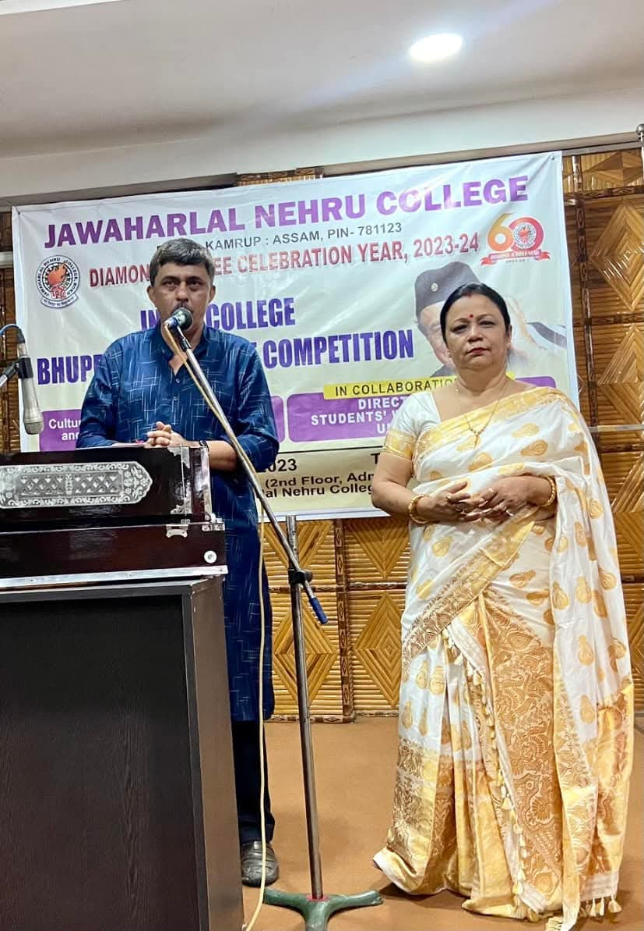

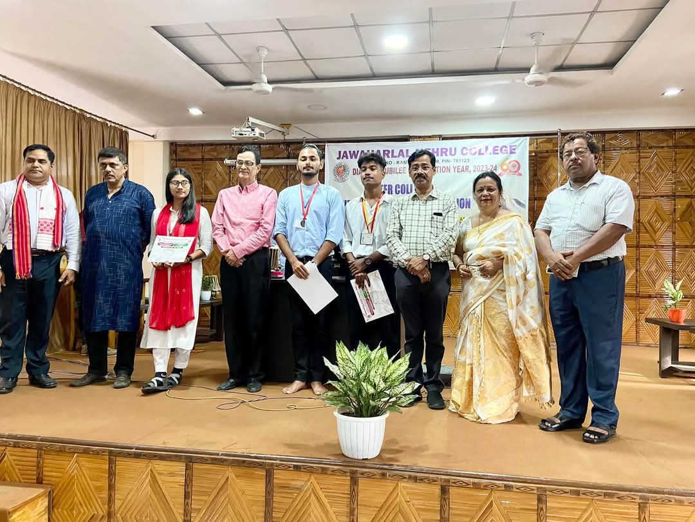
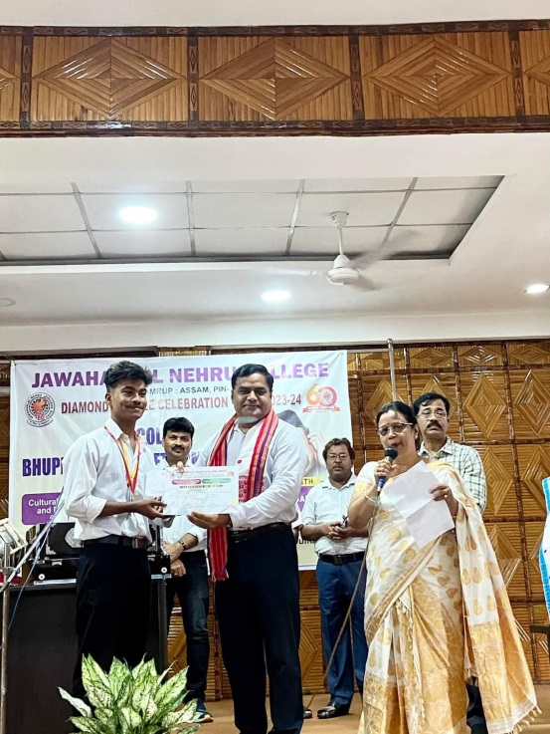

Winner :
1st Prize: Rohan Bora - BKB College , Purani Gudam Prize money - Rs7000/
2nd Prize : Barasha Das, Handique Girls College Prize Money –Rs-5000/
3 rd Prize : Khanjan Nath , Dudhnoi College Prize Money –Rs. 3000/

5 Days Workshop on Bihu Dance and Dholbadan
DATE : 1 st April to 5th April , 2024.
RESORCE PERSON :
- Bidhan Deuri
- Malicharan Ray
- Kankan Ray
- Udita Chakraborti
- Rebika Ray


