The Institute facilitates students in various extra curriculum activities. Like in the 2023-24 sessions, students participated in Inter- College and cultural Youth Festival. Also, students also encouraged to participate in the State and National Level Sports competition as well as in NCC competition along with Government organised Programmes like Sanskritik Mahasangram, Yuva Utsav, Khel Maharan. To promote their spirit of extra curriculum activities, the college authority provides special room as well as auditorium hall for rehearsal and institute brings experts to teach the students to progress in this direction.
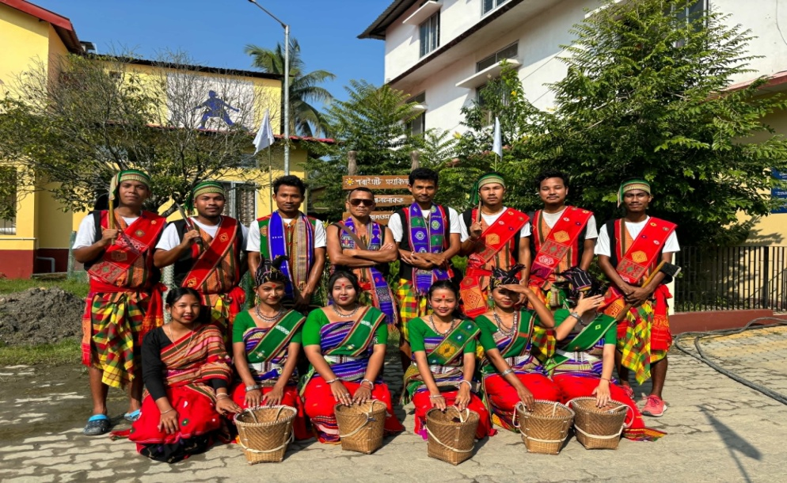
Zonal Inter-College Youth Festival of Gauhati University at Saraighat College,
16th & 17th October, 2023

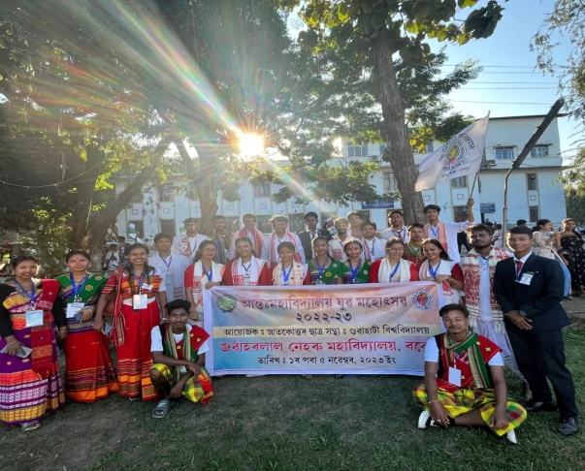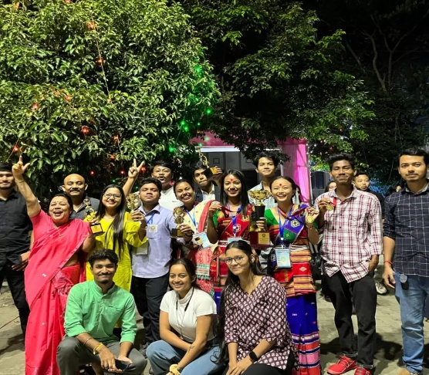

Inter- College Youth Festival under Gauhati University, 1st to 5th November, 2023

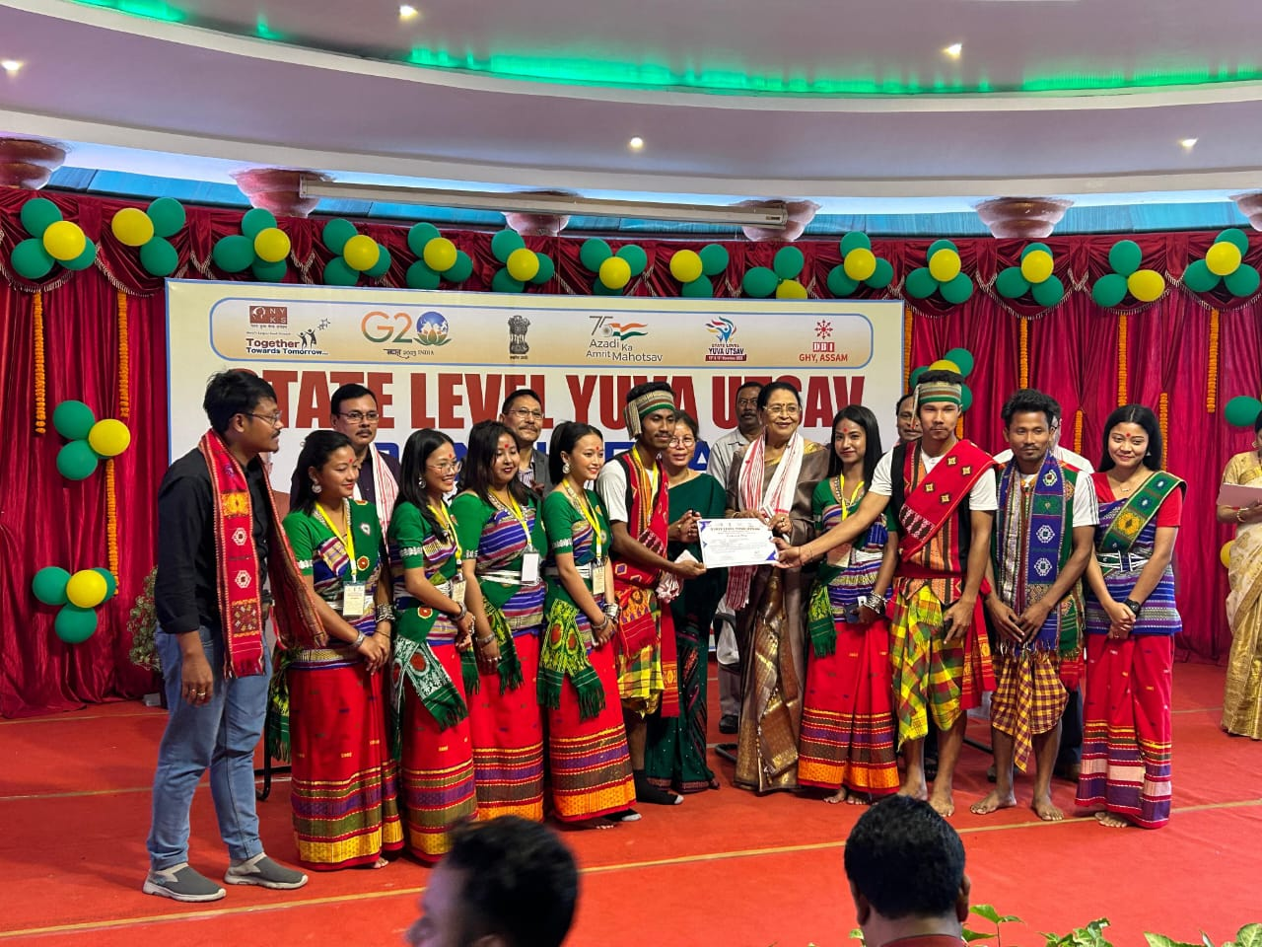
State Level Yuva Utsav under Nehru Yuva Kendra Sangathan at Don Bosco Institute, Guwahati

