Achievement

Franchish Boro- Athlete 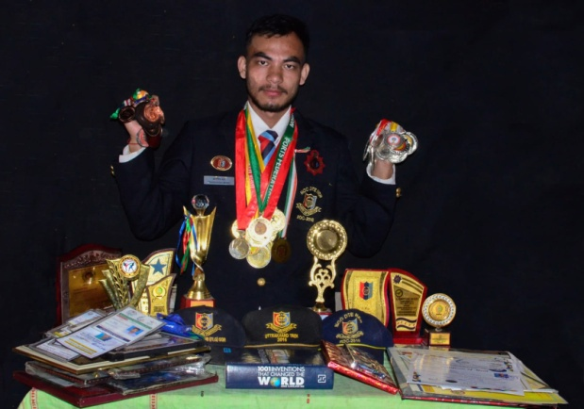
Master Degree in Indian Shaolin Kung Fu Academy, 2015
International Championship – Gold Medal (1 time)
5 Times National Championship- 2 Silver & 3 Gold
3 Time North- East Championship- 3 Gold
14 Time State- 10 time Gold in all style Martial Art Championship
2 Time State Thai Boxing Championship-1 Gold & 1 Bronze
10 Time District- 1 Time Silver
5 Time Gold
2 Time Inter-College Champion- 2 Gold

