DEPARTMENT OF BOTANY
JAWAHARLAL NEHRU COLLEGE, BOKO
SESSION: 2024-2025
Following students have been admitted to higher education after completing BSc Botany from the Department of Botany, Jawaharlal Nehru College, Boko-
- Miss Lizamoni Rabha:

Miss Lizamoni Rabha has enrolled at Manipur University for the course of MSc Botany.

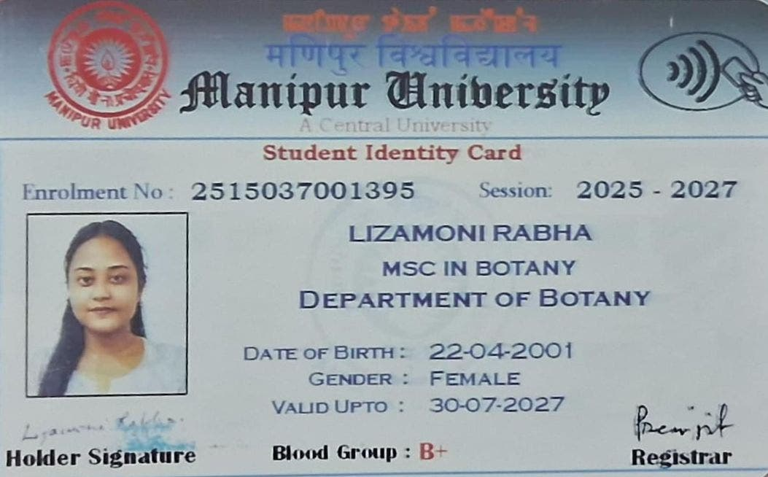

- Miss Barasha Kalita:
Miss Barasha Kalita has enrolled at College of Education, Boko for the B.Ed course.
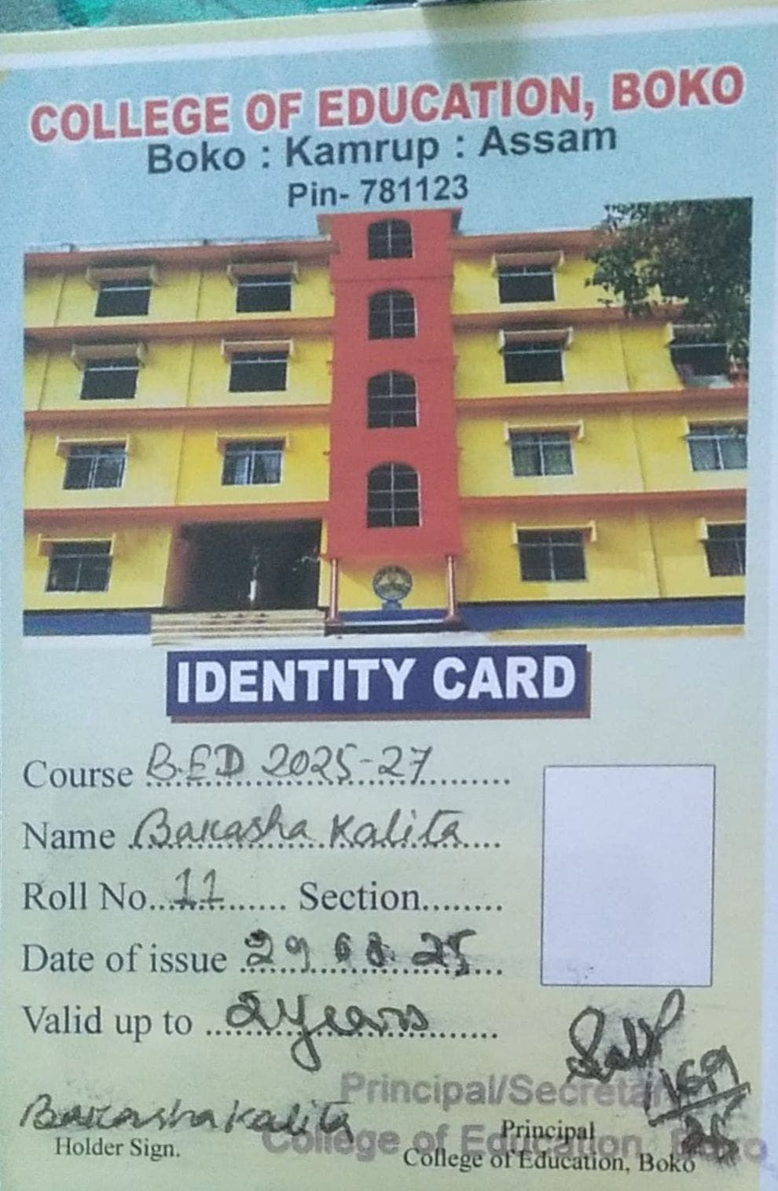

- Miss Hafija Begum:
Miss Hafija Begum has enrolled at Gobindapur Academic P.T.T.I for the B.Ed course.
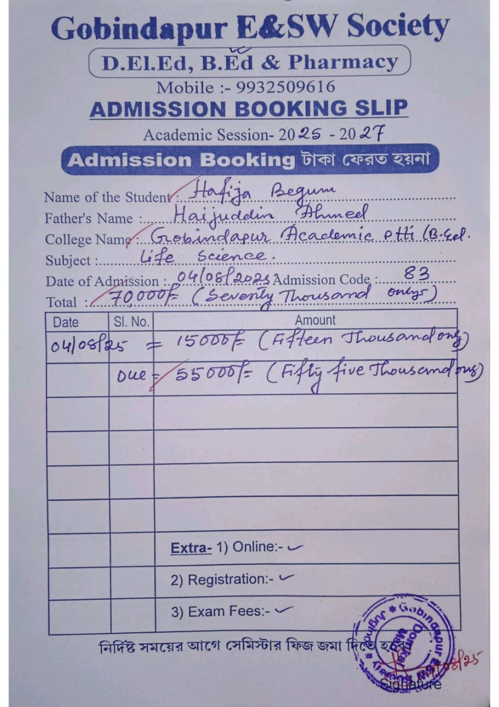
- Miss Queen Das:
Miss Queen Das has enrolled at DIET Goalpara, Dudhnoi for the D. El. Ed course.
