Field Trip to Madhupur Satra, Coochbihar, 2018
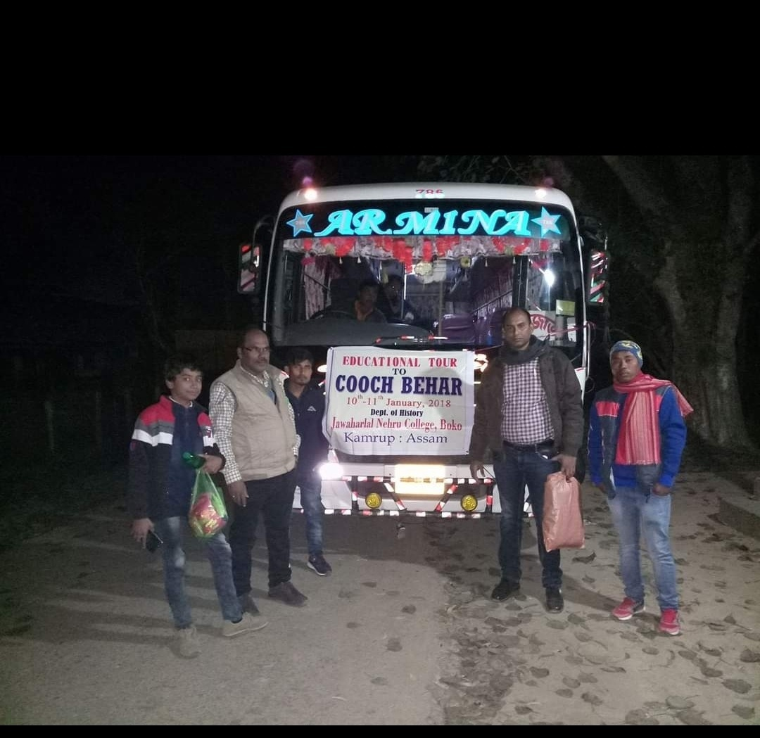
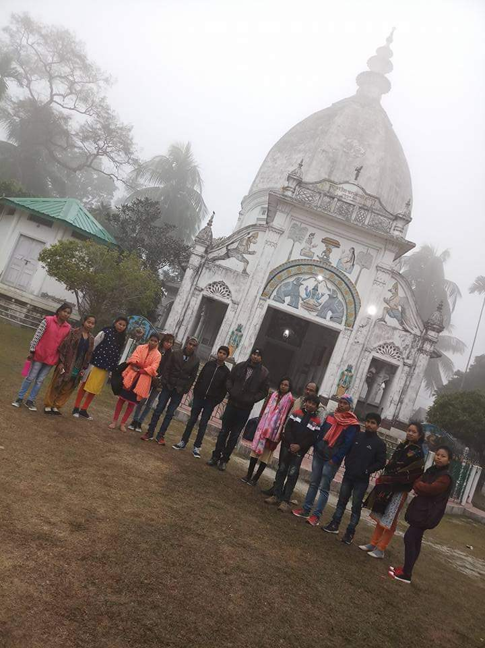
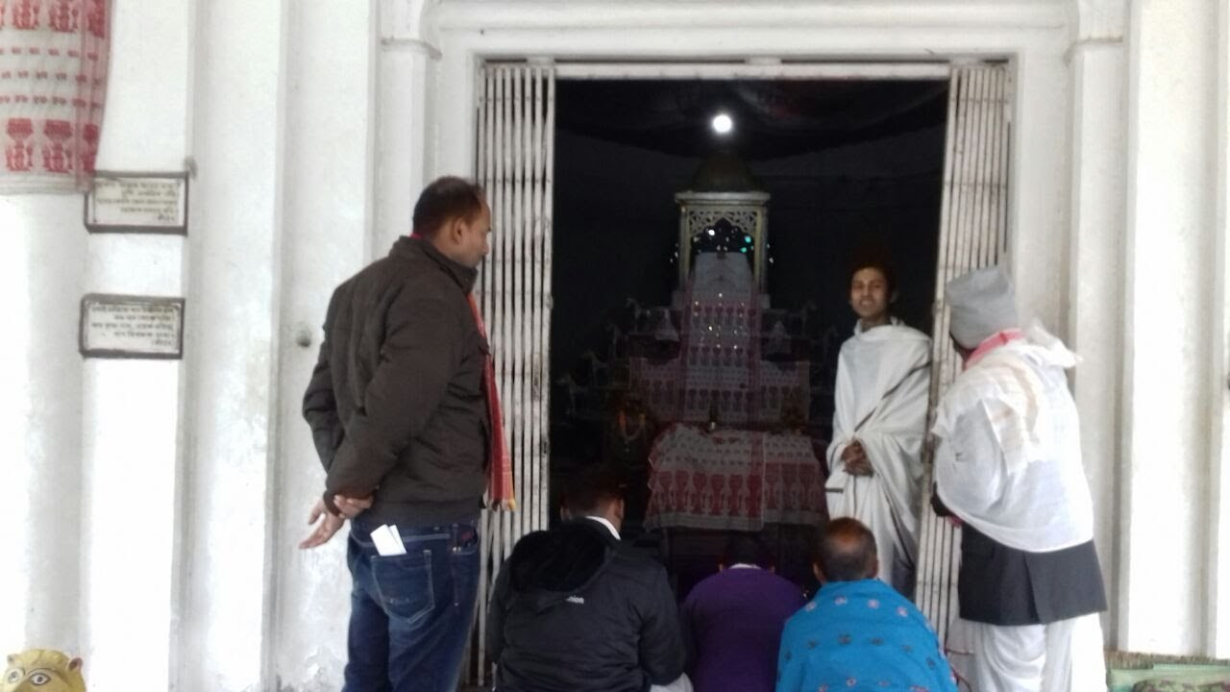
A Field trip was organized to Madhupur Satra on 11-01-2018 along with Department of Geography. Madhupur Satra is a religious institutional centre associated with the Ekasarana tradition of Vaishnavism, situated in Cooch Behar, the Indian state of West Bengal. It is established by Assamese Vaishnavite monasteries for religious practices in 16th century during Koch kingdom. The great Bhakti Saint Mahapurusha Srimanta Sankardeva (1449-1568 AD) and his disciple Mahapurusha Madhavadeva died here. In this journey, Satrasal also visited along the way. Satrasal is another important satra; situated in the border of Assam and Bangladesh.
Outcome of the Trip- The students came to know about the belief and practices and other religious performances associated with Madhupur Dham. On the basis of the findings of the study, students prepared project report under different titles.
Student’s name who attended the trip-
- Nabibul Ahmed
- Jonmoni Rabha
- Raspiya Ahmed
- Pallab Das
- Nengchiwalda Marak
- Rita Boro
- Ambika Rabha
- Rinku Rabha
- Dipika Boro
- Risaoni Rabha
- Utpala Rabha
- Aparajita Kaibarta
- Minaoni Rabha
- Deepjyoti Rabha
- Kartik Sarkar
- Kongkona Basumatary
- Gyanangkur Rabha
- Aarati Rabha
- Chandamita Dei
- Bitupon Boro
- Jayamoni Rabha
- Hemprabha Rabha

