Field Trip to Chandika Temple, Kamrup, 2019
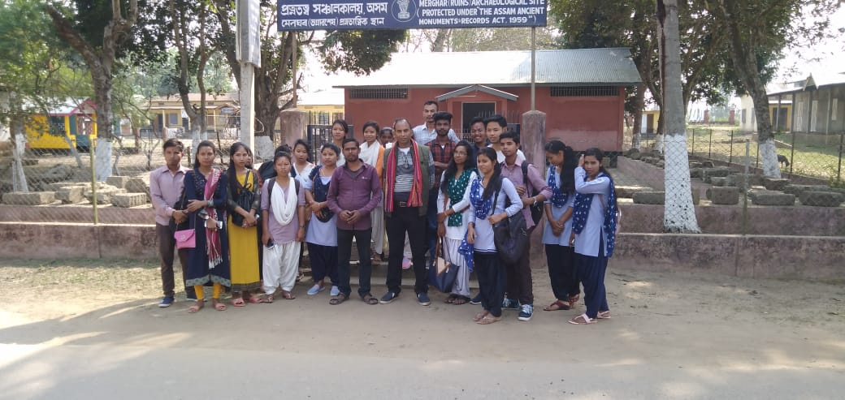
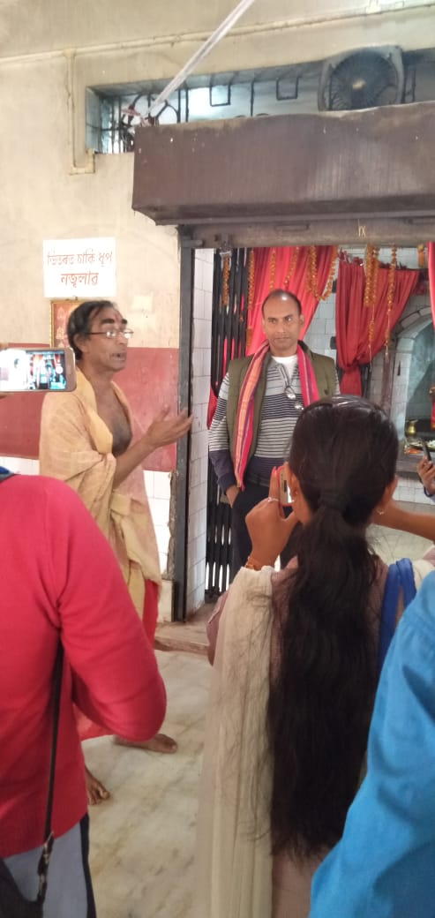

The Department of History organised a Field Trip to Chandika Temple and Merghar on 15-02-2019. Chandika Temple at Chhayygaon, Kamrup district is one of the most important and popular Shaktipeeths in Assam. The temple is full of legends and tales and carries a rich history and several myths- both from the pages of written history and also the oral pre-history. The temple was constructed to worship Chandika- an incarnation of Parvati. Shrouded by legends and myth, the glory of the temple spread all over and caught the eye of Swargadeo Shiva Singha, the then Ahom King of Assam. In 1647 he ordered Anuj Duara, the Borphukan of the Guwahati to build the Chandika Temple.
Merghar is a site with which mythological story attached to a merchant named Chanda Sadagar and his son Lakhindar and his daughter-in-law Beula.
Outcome- Students acquired the knowledge of Chandika as a shakti shrine. Similarly, they acquired firsthand knowledge about the Merghar. Students also came to know about different legends, customs and mode of worship of these two historical monuments of ancient Assam.
Name of the Students who attended the trip-
- Anjuara Begu
- Rajib Pathak
- Dhanjit Boro
- Rubul Tamuli
- Rinku Rabha
- Nabiul Ahmed
- Rekha Borah
- Nisharani Boro
- Sanjoy R Marak
- Lipika Rabha
- Dhanjit Boro
- Franchish Boro
- Bhupen Rabha
- Gayatri Adhikari
- Kartik Sarkar
- Raspiya Ahmed
- Hemprabha Rabha
- Pranjal Boro
- Dipankar Rabha

