Field Visit to Chamaria Satra, Kamrup, 2021
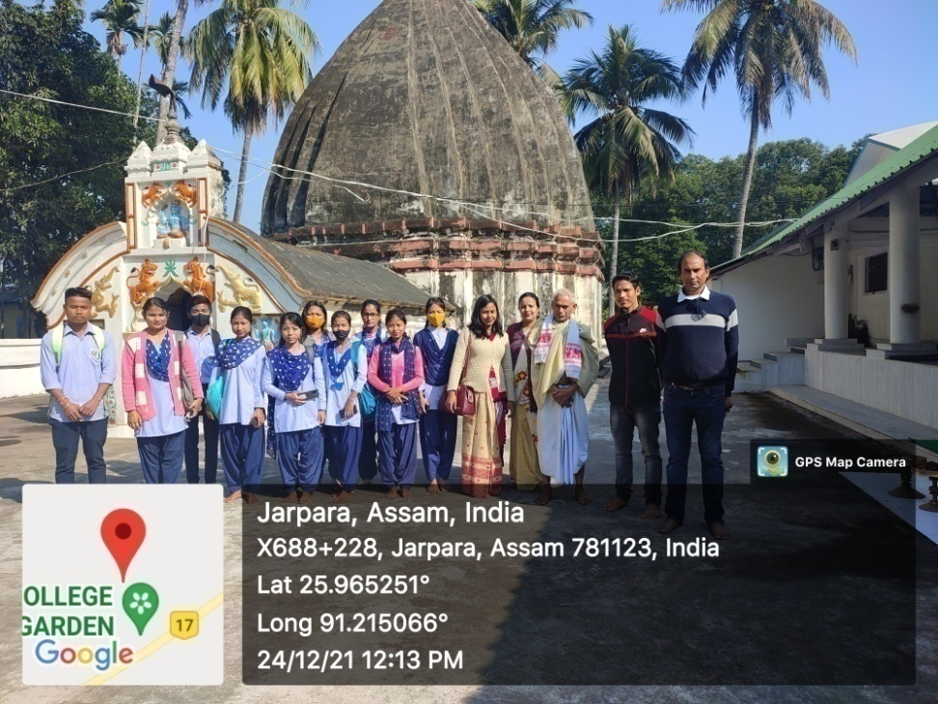
The Department of History made a visit to Chamaria Satra on 24/12/2021 with all the three semester students including students from regular course. It was established in 1588 and located in Chamaria, a locality in Kamrup district of Assam. The religious head of the institution delivered the importance of the satra and its history during the visit. Students also asked various questions regarding the remains of Sashi-Pat (special leaf which was used to write) in the store house of the institution.
Outcome- Students gathered the firsthand knowledge about the historic satra institution of Assam. Students along with the teachers visited different monuments like Sashipat (manuscripts), unique creation of material culture and knew about different religious programme throughout the year. Students interacted with the active bearer like Vaishnavite scholar.
Students those who attended the trip-
- Grikma N Sangma
- Supriya Rabha
- Deepanjali Boro
- Sangita Boro
- Amina Khatun
- Loknath Rabha
- Dhritimoni Das
- Madhusmita Boro
- Pranjal Boro
- Juli Boro
- Hirambika Boro
- Hiranmoy Rabha
- Moromi Boro
- Mamoni Boro
- Nilanjana Boro
- Lakshima Boro
- Rahul Rabha
- Barasha Boro
- TenyPaulush J Sangma
- Basanta Boro
- Hemsikha Boro
- Nandita Rabha
- Debojit Boro
- Namita Boro
- Supriya Rabha

