Knowledge Exchange Programme, 2021
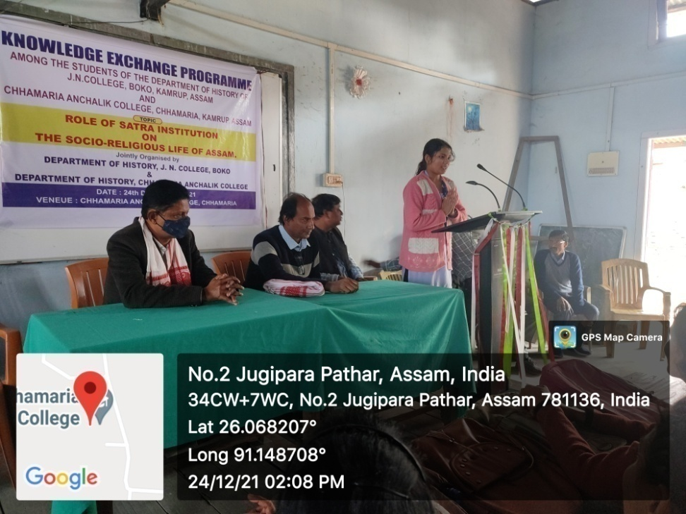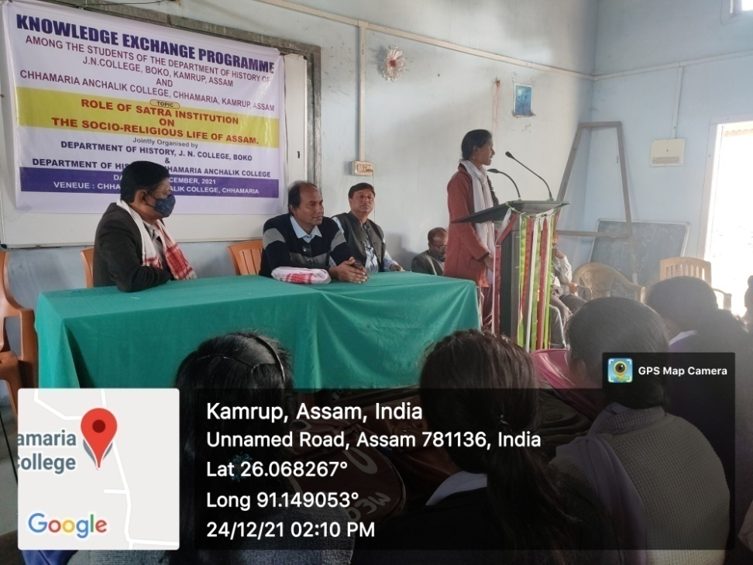
A knowledge Exchange Programme was organized with Chamaria Anchalik College, Chamaria (Kamrup) on 24/12/2021. In that programme, students from both of the department participated in a Group Discussion regarding the Teaching- Learning structure by the faculties and each student placed his/her view on a board scale on History as a subject. The programme ended with a resolution to work on a common ground to develop a sense of Historical knowledge in the neighbouring areas.

Students attended the Programme-
- Pranjal Boro
- Juli Boro
- Hirabika Boro
- Loknath Rabha
- Dhritimoni Das
- Madhusmita Rabha
- Grikma N Marak
- Supriya Rabha
- Sangita Boro
- Amina Begum
- Deepanjali Rabha

