MOU SIGNED BETWEEN HISTORY DEPARTMENT, CHAMARIA ANCHALIK COLLEGE
AND
HISTORY DEPARTENT, JAWAHARLAL NEHRU COLLEGE
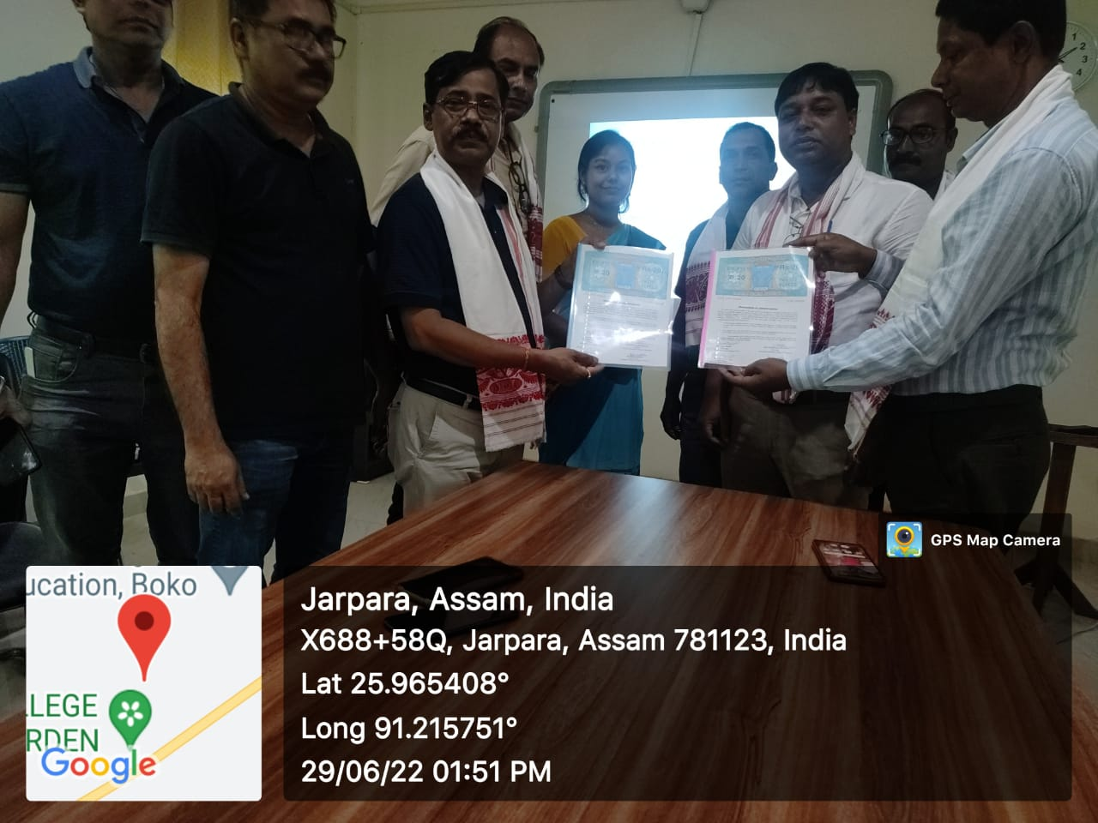
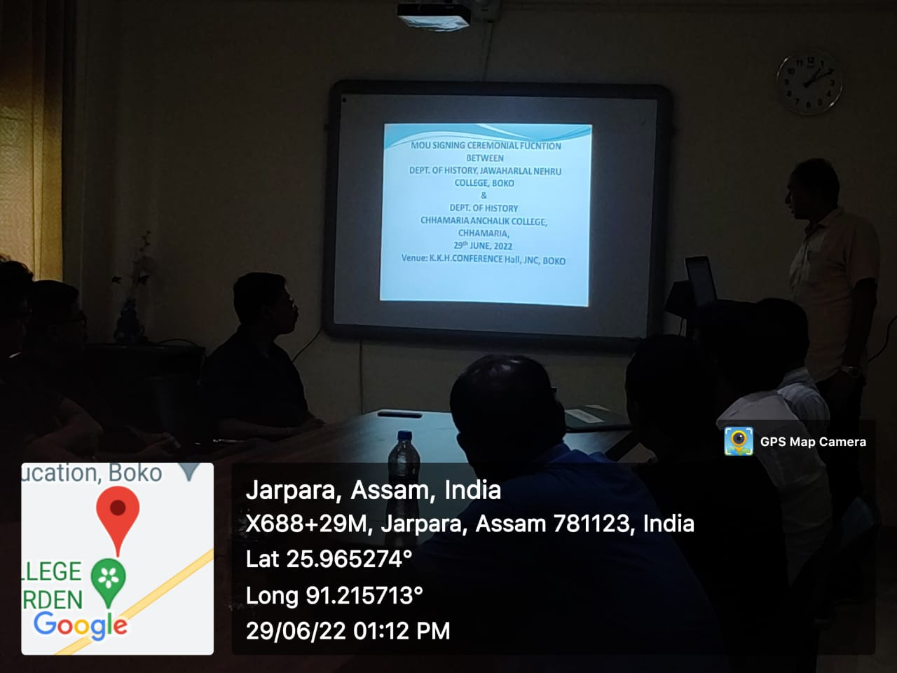

To make the student aware of the historical knowledge in a border sense and to make history as a popular subject to pursue a bright career as well as to make the teaching factulty and the students acquaint with the recent trend of historical study. The authorities’ of the concerned colleges come to the mutual understanding on the following terms:
- All the honours students and the faculty members of the signatory colleges will have the right to access and use library and borrow books of both the colleges as per rules of the concerned college.
- The colleges will carry out faculty/knowledge exchange programmes taking special classes or the better understanding of the students of the signatory colleges.

