REPORT
ON
FIELD STUDY ON, “ORAL HISTORY ASSOCIATED WITH MOUMAN ASHRAM”
ORGANIZED BY
DEPARTMENT OF HISTORY
DATED: 05/07/2022
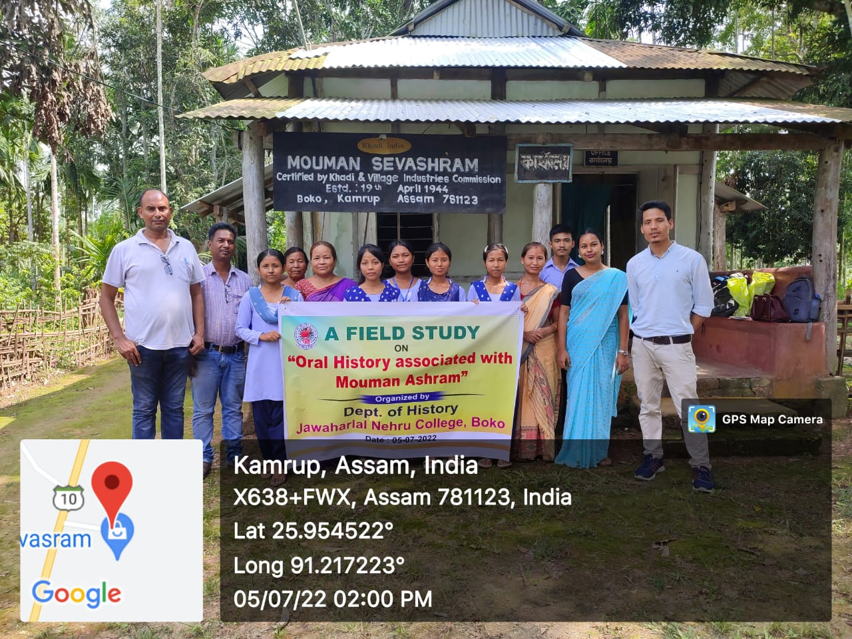
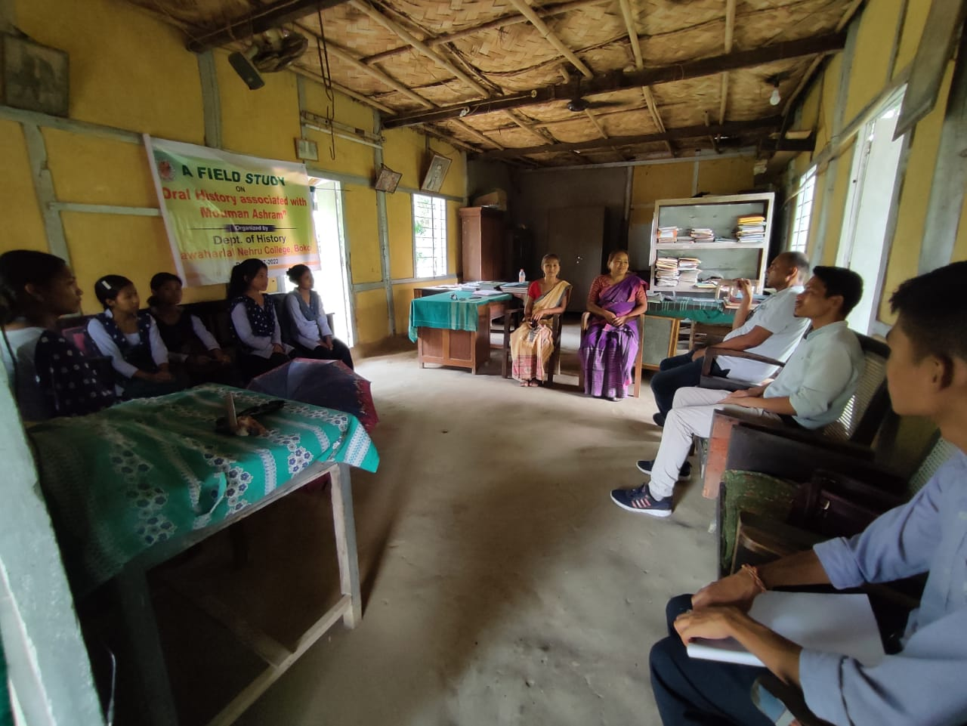

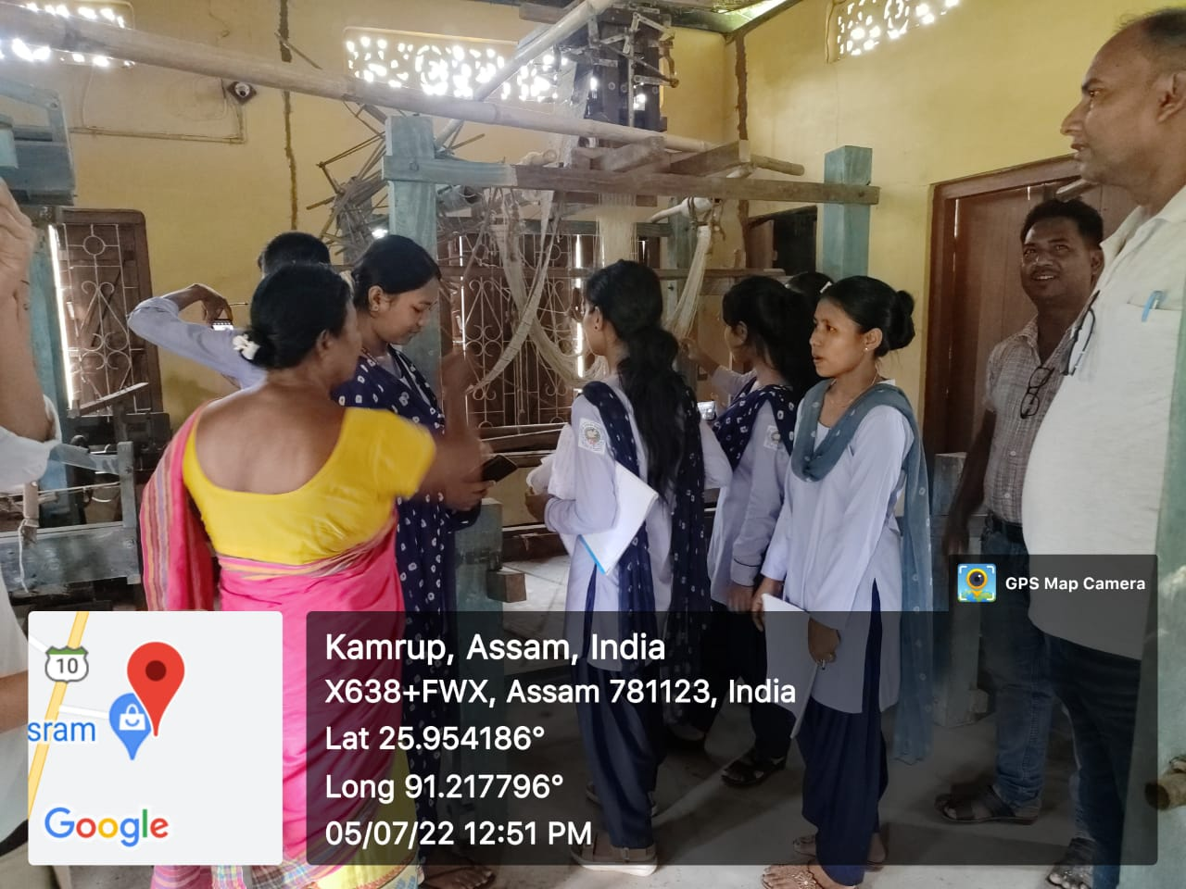


Objective of field study: 1. To study about the history of Mouman sevasram, an institution founded in 1944 on the ideology of Gandhi.
2. For partial fulfilment of the SEC paper of 4th semester (honours) associated with oral history.
Outcome: 1. Students were acquainted with different phases of growth and development of the historic Mouman ashram.
2. Students came to know about the economic concept of Swadeshi propounded by Gandhiji for the self sufficient of the mass people. Similarly national education system, Bhudan movement etc. some aspects of modern Indian history that students got primary information.
3. Perceptible outcome of this field study is the students acquired the technique of collection of data for the writing of projects, history etc.

