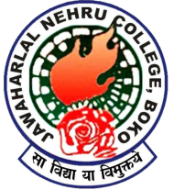
LANGUAGE LABORATORY
(Estd.-2012)
Department Of English
Jawaharlal Nehru College, Boko
A DETAILED REPORT (2012-2023)

The Multilingual Digital Language Laboratory was established on 27.09.2012 with software from ORELL Technosystems India ltd with a capacity of 1 teacher and 10 students. It was started following the recommendations by the NAAC peer team visit in the year 2004.The purpose of this laboratory is to acquaint the learners with basic communication skills of English language. The Language Laboratory was inaugurated by the then Principal of the college Dr. Nripen Goswami . The Head of the department was Shri U. C Kar during that period. Almost all the faculties of the college attended the Inaugural Function which was held in a small function in the Temporary Language Laboratory set up in Room No.2 of the Old arts Building of the college.

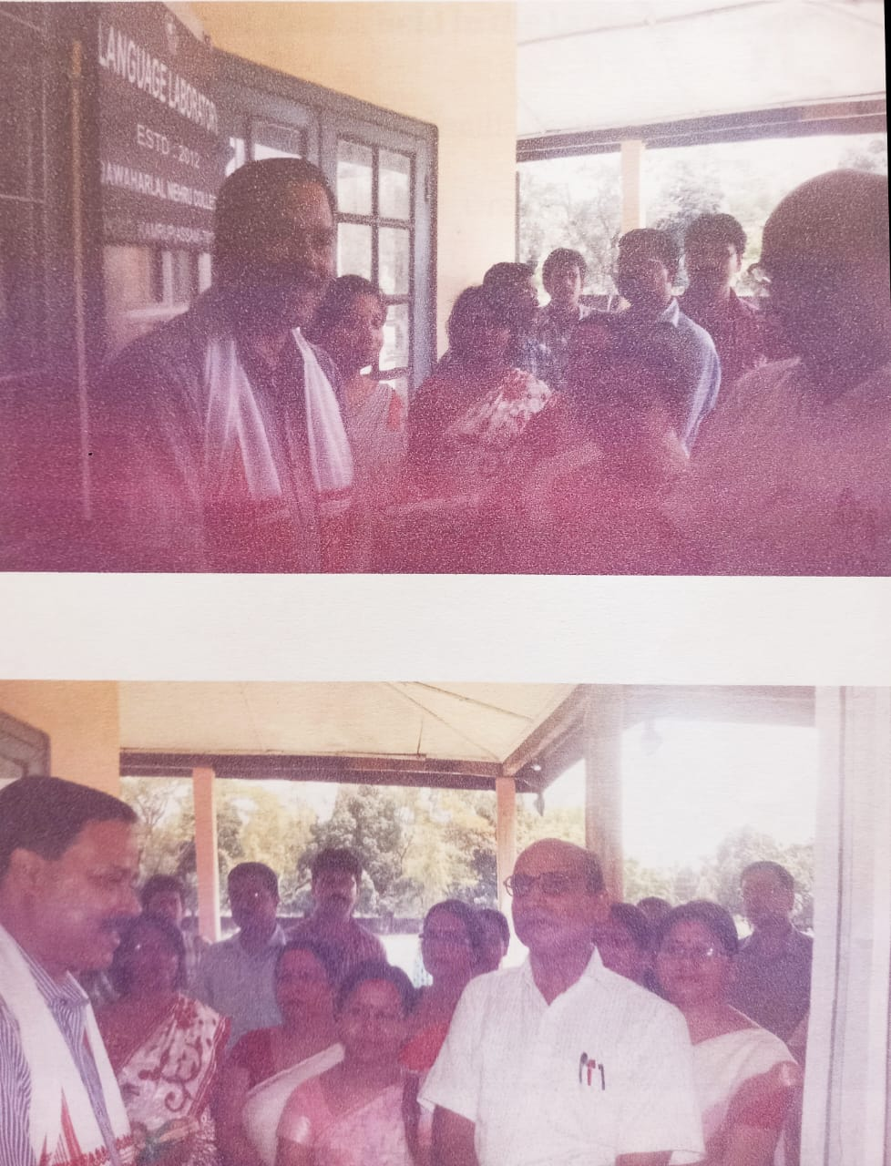

2013-
On 15.05.2013 a one day familiarization programme was held amongst the faculty of the college to introduce the use of the language laboratory to the teachers of the college.
From 3-12-2013 to 13-12-2013 a 10 days course on communicative English and Soft Skill development was held amongst the faculty members of the college. Many teachers took part in this programme and were benefitted by it.
2014
The language laboratory was used for students of the English department for practice of phonetics lesson and communicative skills practice.
2015
The students of Bsc 1st Sem were given exposure to the use of the language laboratory on 04-02-2015.
2016
In 2016 a proposal was presented to the principal on 09-09-2016 detailing a 3 month course on communication and soft skill development among degree level students. The principal gave assurance to extend full cooperation and all necessary help for the conduct of the same. Further he also directed the undersigned to discuss the requirements and details for undertaking the course with the IQAC Coordinator Dr D.K. Das in a informal discussion assured that the matter would be put up in a formal meeting of the IQAC.
2017
On 04-02-2017 an Introductory Workshop on Learner Central Methodology was held in the K.K. Handique Study Centre Conference Room. The resource person was Mrs. Aparajita Bharadwaj, Academic training consultant, British Council. On 11-05-2017 an upgradation of software was done by the service provider ORELL Technosystems India ltd. Also in 2017 some repair work was carried out in the Language laboratory and defective UPS and monitors were removed. Presently the Language laboratory has a shortage in the number of student computers. There is one teacher computer and two student computers in a usable condition. There are several monitors and CPU’s and UPS lying in the language lab but in a disposable condition as declared by the Professionals who came for the repair work.
2021-
In 9.4.2021 a Proposal was submitted to the college Principal to submit to the NEILIT,Guwahati for conducting NSQF approved Certificate course in ITeS BPO Soft Skills And Communicative English in association with NEILIT and IQAC for the benefit of students of the backward classes . Due to lockdown being clamped all over from 30th April 2021, this course could not be commenced.
2022
New Language Laboratory Software from software provider Sanako Study was installed on 19th December 2022.
Two day Workshop on Communication Skill organised by Department of English on 23rd & 24th December,2022 immediately after the installation of the new software.

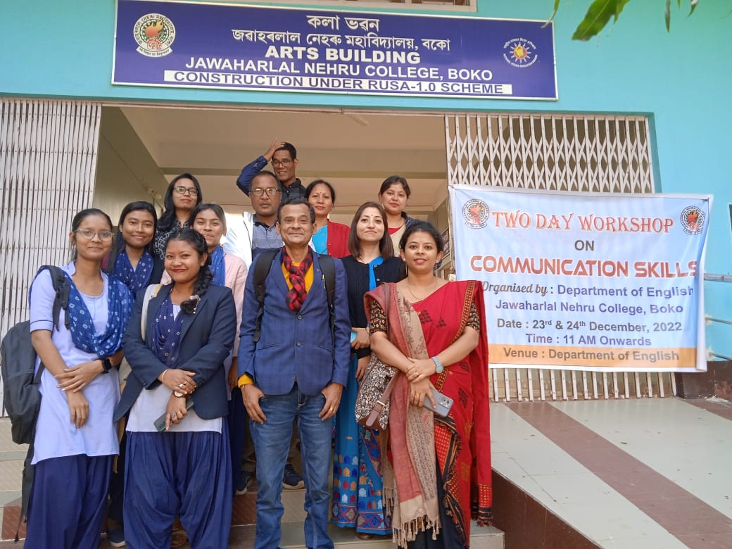
A 3-day workshop on communicative skills was organized for the office faculty from 13-02-2023 to 15-02-23 by the Department of English at the KKHSOU Seminar Hall. The resource person for the workshop was Mr P.Talukdar , Asst. Professor of the Department.
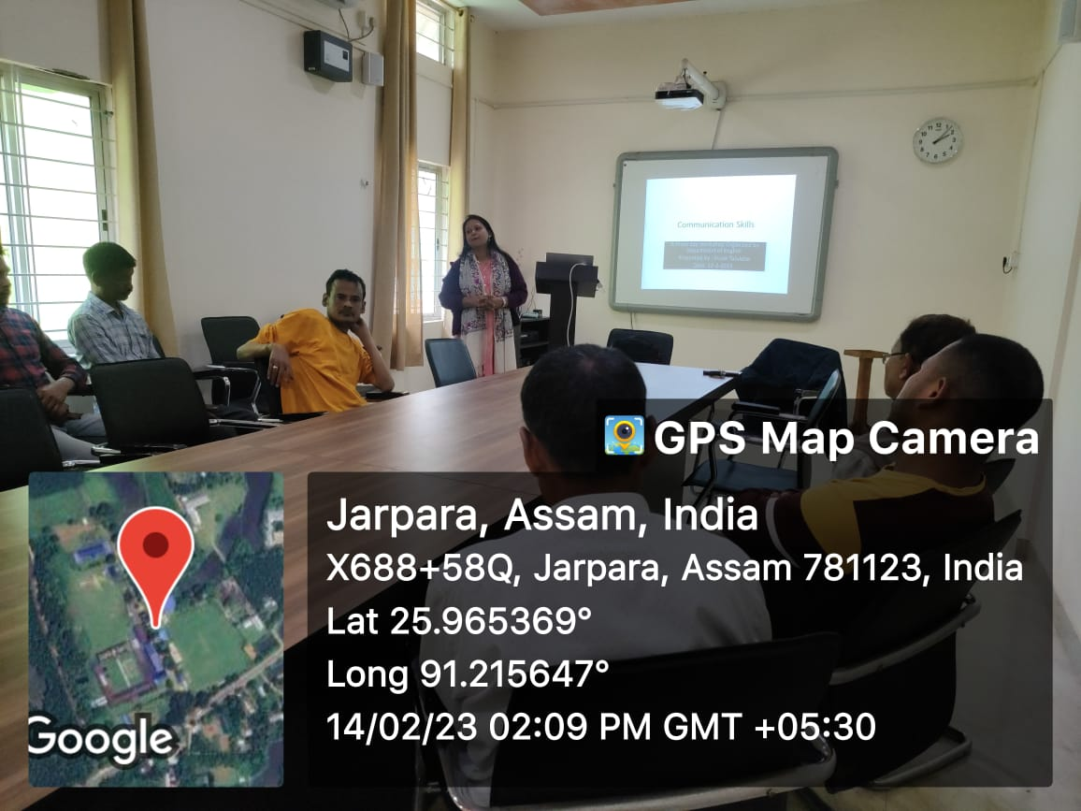
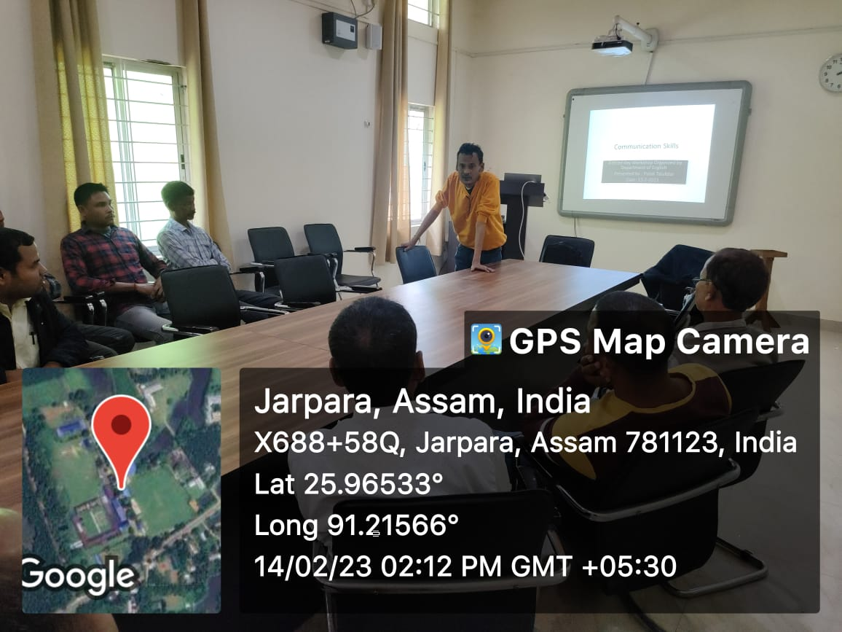
3-day workshop on communicative skills
for Office Faculty

A 3-Month course on English Comunicative Skills Has been started for the interested Students of the college from 14th March 2023 onwards with an intake Capacity of 20 students. The course is presently going on in the Language Laboratory and the Classes of the English Department.
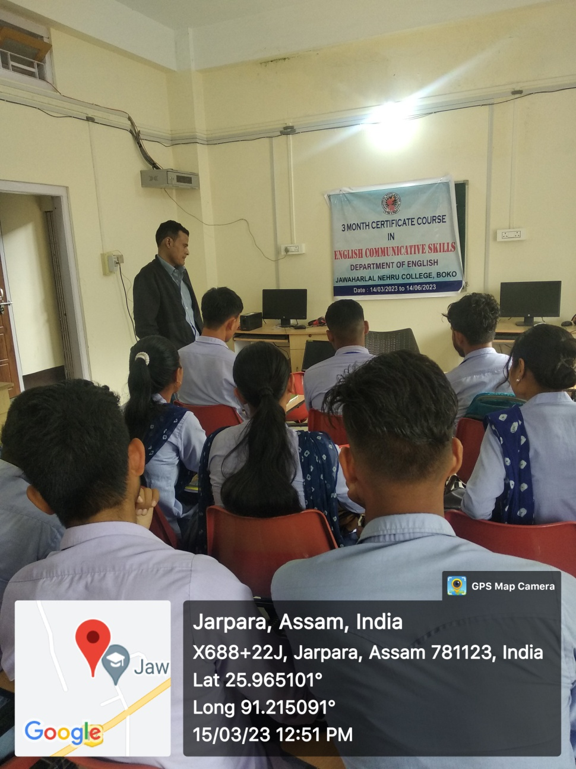
Students during class of Ongoing
3-Month course on English Comunicative Skills

The Department of English has recently decided to conduct a 1-year Certificate Course in ITesBPO training.
The course will be conducted in association with NIELIT,Guwahati
Course Component- Computer Skills,Soft Skills and Communicative English.
The Training will be given to increase employability as per job requirement of IT firms & MNCs and will be mainly aimed at our alumni and outgoing students to make them Job-ready. Full placement guarantee has been assured by the NIELIT. No of seats will be 20 No.’s
The course will be started from mid- April 2023. Already the enrolment process has been completed and the processing and finalisation of the course and classes is going on.

Ratnamala Sarma Pulak Talukdar
HoD, English. Coordinator,Digital Language Laboratory

Jawaharlal Nehru College, Boko

