Invited Talk on Forest and Forestry in Assam
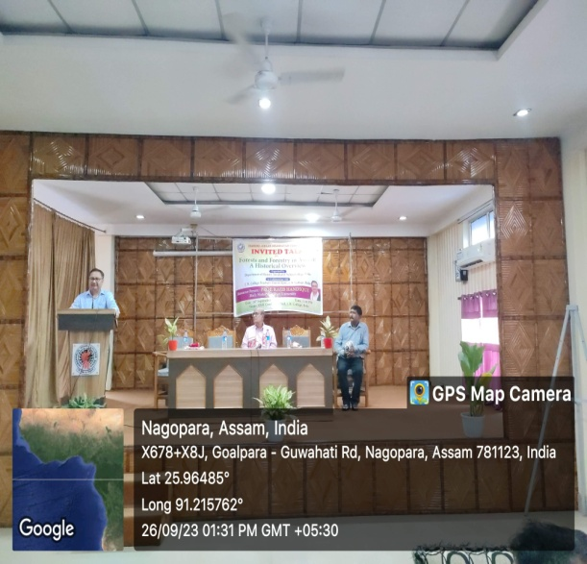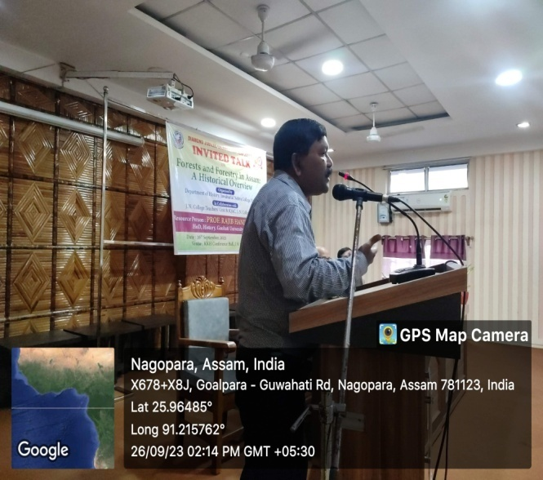
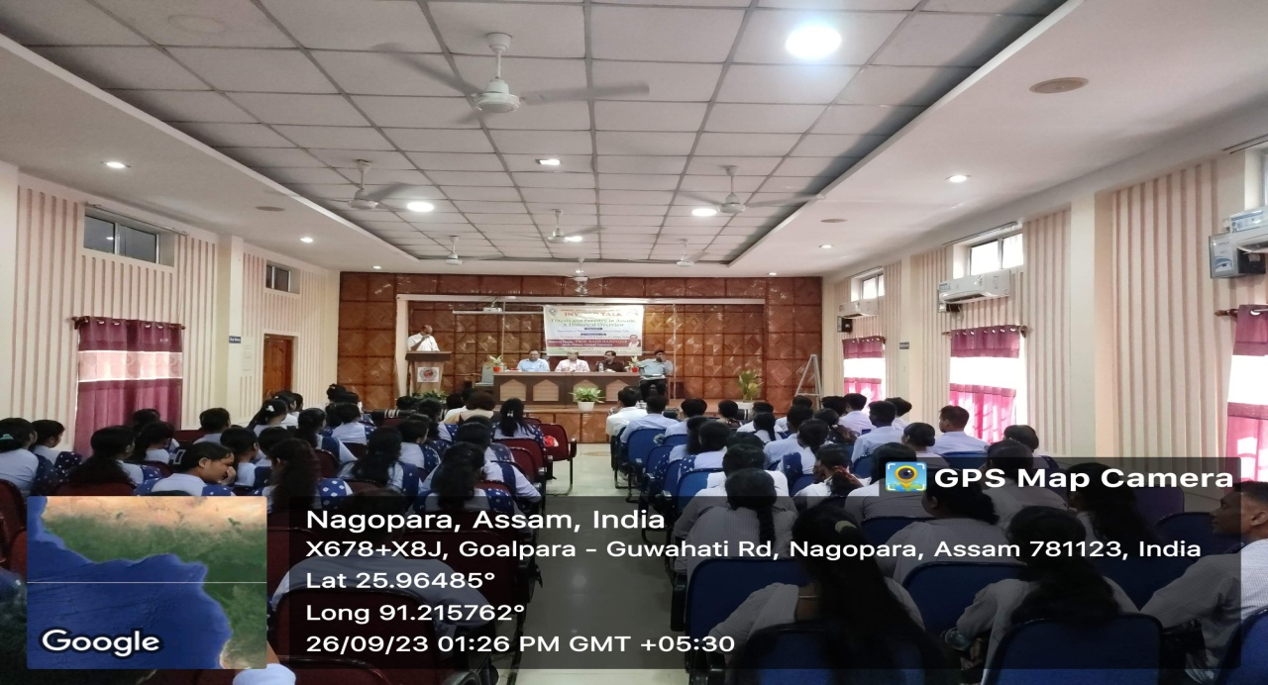
An Invited talk was organized by the Department of History ,Jawaharlal Nehru College, Boko on 26/09/23 in collaboration with J. N. Teachers' Unit ,Boko and IQAC, J.N. College,Boko.The topic of the invited talk was "Forest and Forestry :A Historical Overview. Prof(Dr.) Rajib Handique HoD, History Gauhati University delivered very insightful speech on the topic. Dr. Dhiren Shrutikar, HoD, History, KRB Girls' College, Guwahati also delivered an informative lecture on the topic.
Objective of the talk
1. To make students as well as teachers aware historically about issues relating to Forest policies of the colonial period adopted by British in Assam.
2. To explore on what level British plundering of forest resources led to the deforestation in Assam

Outcome of the study:
1. Students as well as participant faculties took active participation in the interaction with the resource person at the end of deliberation. From the deliberation different unknown facts like the introduction of forest administrative system came into light.
2. Similarly participants came to know what development took place in the name of transport and communication system in India for proper functioning of British forest policy. Resource person also discussed in detail on what level British exploited the, People of Assam in the execution of their forest policy. People gradually lost their rights over different valuable tress and wild life.
Attendees:
