Field Trip to Selected Historical Places of Guwahati
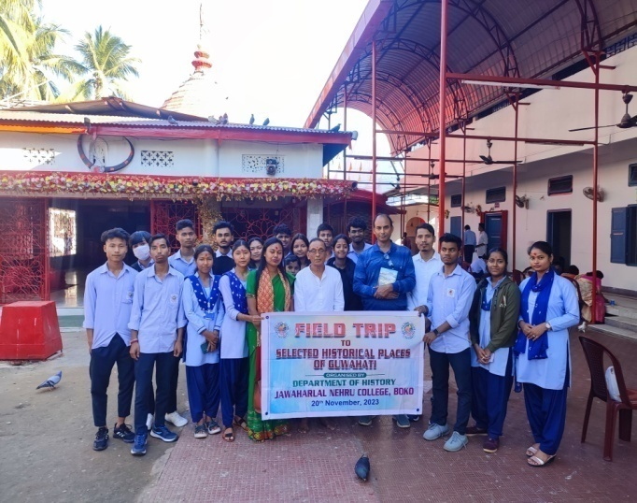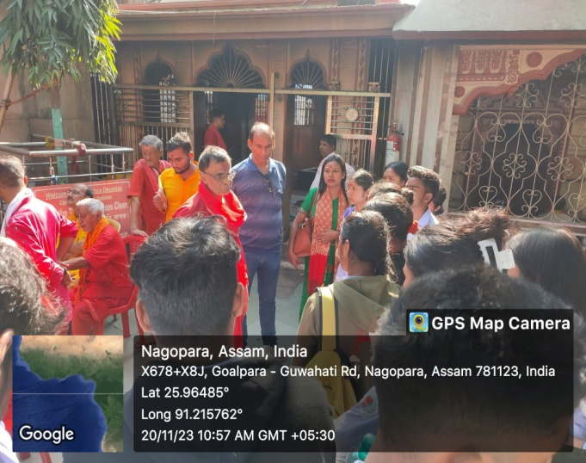
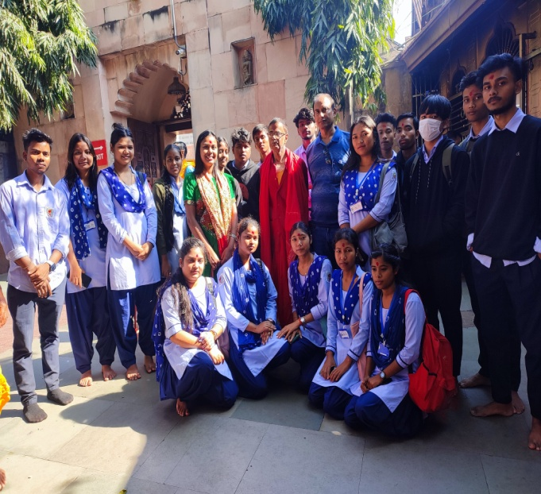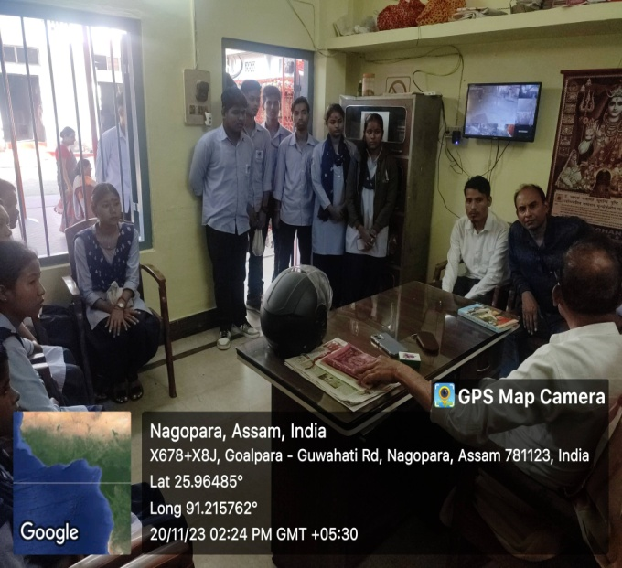

Objective of the study:
1. To make students well acquainted with the concept of saktism.
2. To disseminate students the different belief and practices in regards to worship of the sakti deities.
Outcome of study
1. Students in their direct interaction with the priests called Doloi of the two sakti shrines came to know about the management system of temple.
2. Concept like belief, legend, belief and practices associated with the worship of mother Kamakhya and Ugratara were cleared among the students.

Attendees:
- Anupam Das
- Mrinmoy Musahary
- Nabajyoti Kalita
- Supriya Rabha
- Sunita Rabha
- Grikma D Sangma
- Mitali Choudhury
- Chinmoy Nath
- Jeniva Deka
- Anurag Choudhury
- Priyanka Ghosh
- Dhanmoni Das
- Jahidul Ali
- Chimpy Choudhury
- Himashree Kalita
- Priyojit Das
- Chonakhi Rabha
- Dipanjali Rabha

