Celebration of 818th Vijay Divas of Maharaja Prithu of Kamrupa
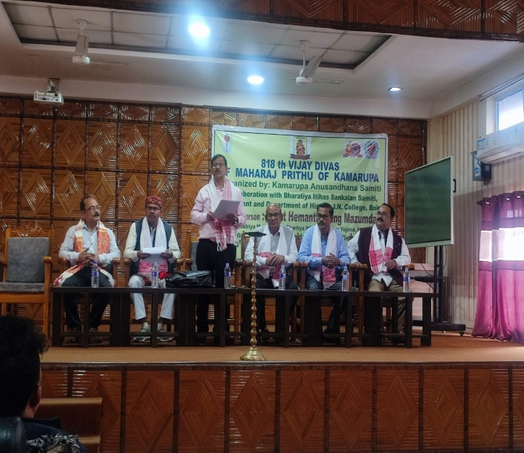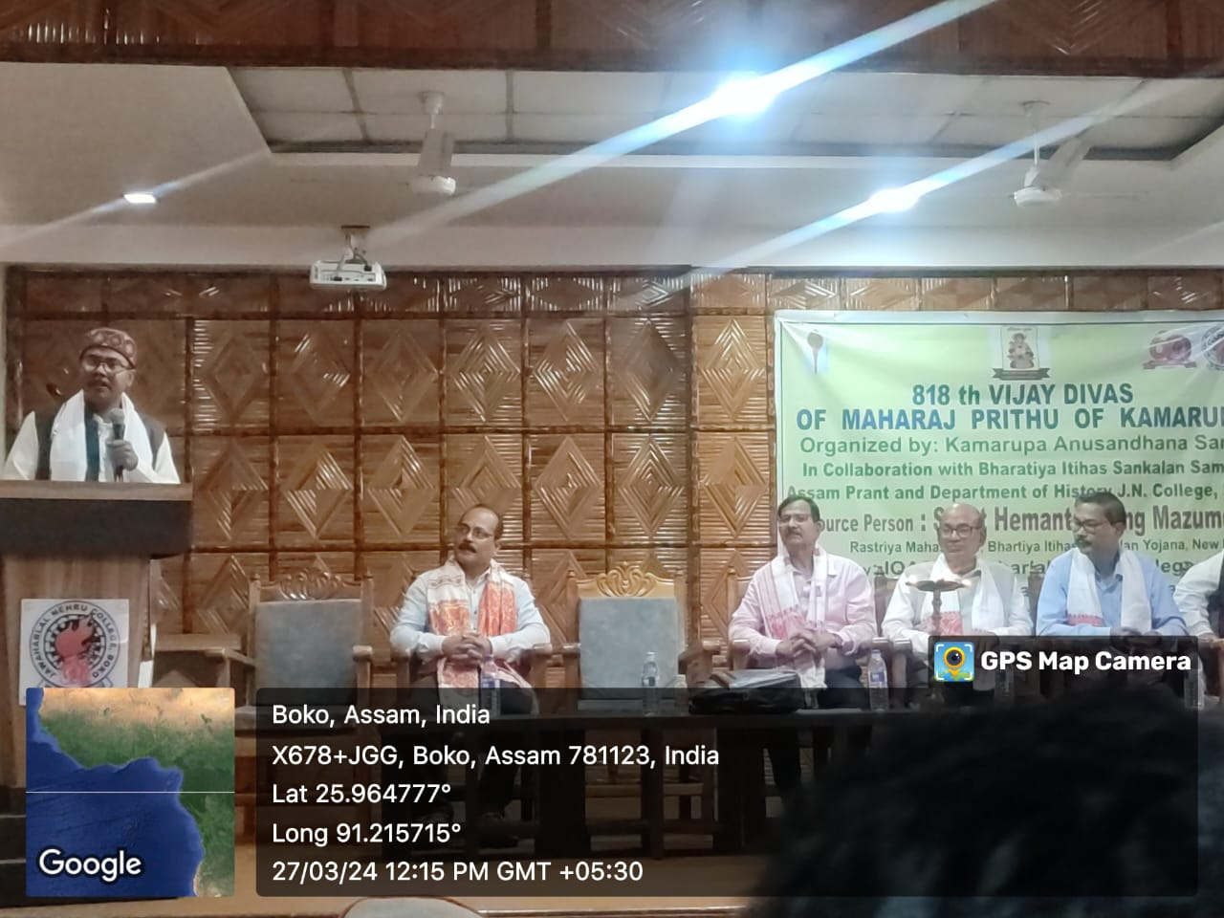
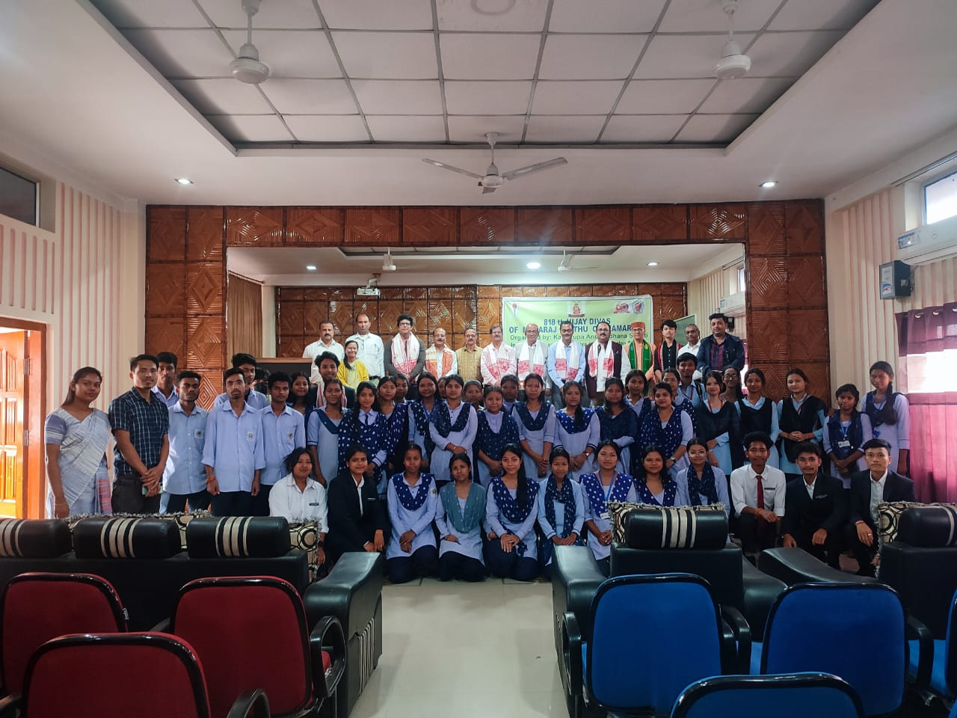

Objective of the study:
- To observe the 818th Vijay Divas of Maharaja Prithu of the early medieval ruler of Kamrupa against his victory over Bakhtiyaar Khalji, the ruler of Bengal.
- To make awareness about the Kamrupa Anusandhan Samiti the premier Historical research organization of Assam among the students and faculties of J. N College, Boko and other neighboring colleges.
Outcome of the study:
- Students along with faculties came to know about the myth of ancient Kamrupa kingdom which was not highlighted in the mainstream of the history of India.
- Students and faculties as a whole came to know about the Kamrupa Anusandhan Samiti and its different opportunities offered in the field of knowledge and research activities.
Attendees:
