Field Trip to Batadrava Than
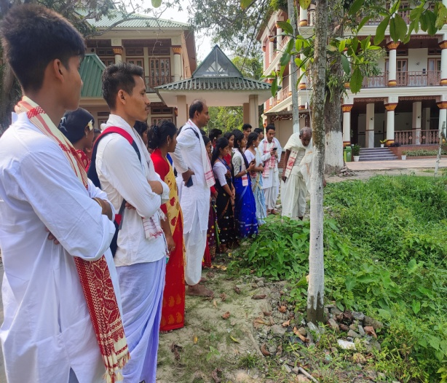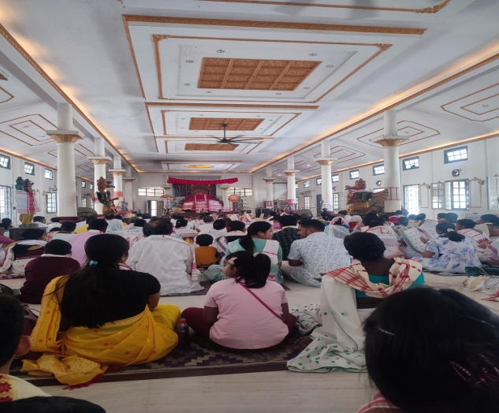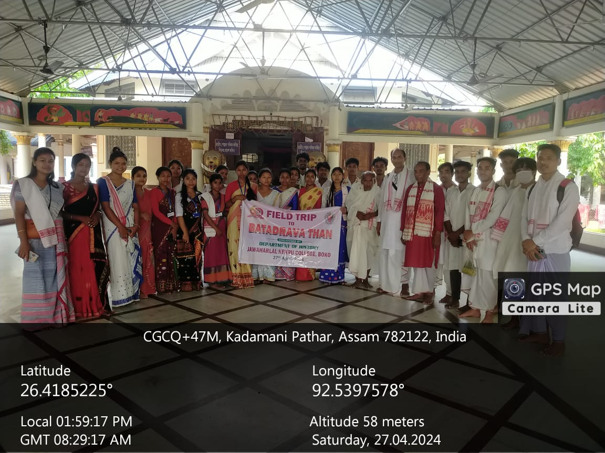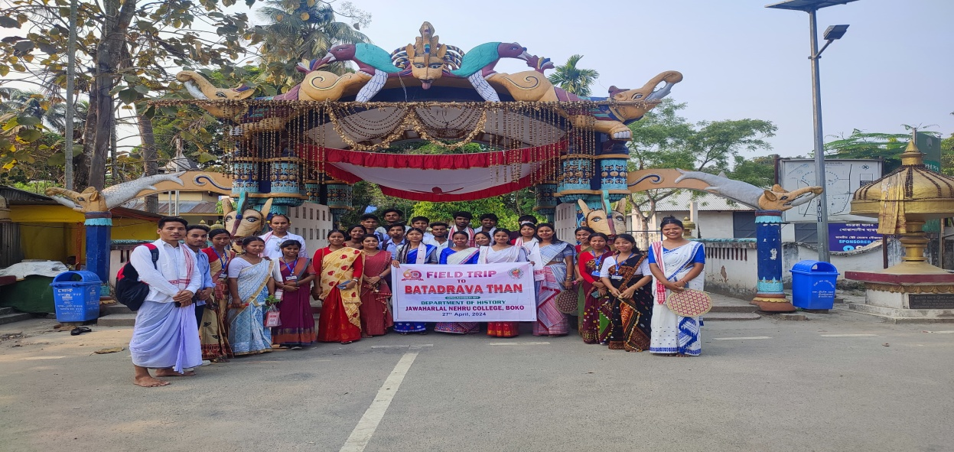

Objective of the study:
- To make students aware about the Batadrava than the birth place of Srimanta Sankardeva.
- To give the students about the primary religious knowledge associated with Neo-Vaisnavism propagated by Srimanta Sankardeva.
Outcome of the study:
- Students acquired first hand information regarding the different rituals and customs observed throughout the year in the Batadrava Than.
- Students also benefited in getting different Vaisnavite cultural knowledge after direct interaction of the Vaisnava resides in the premise in the Than.
Attendees:
- Mitali houdhury
- Dipanjali Boro
- Supriya Rabha
- Sukanya Rabha
- Chimpi Choudhury
- Vanshikha Shah
- Priyanka Ghosh
- Sunita Rabha
- Himashree Kalita
- Harima Das
- Sikha Choudhury
- Chonakhi Rabha
- Rabina Rabha
- Anupam Das
- Anurag Choudhury
- Dhanmoni Das
- Johidul Ali
- Prasanta Buragohain
- Chinmoy Nath
- Mrinmoy Musahary
- Nabajyoti Kalita
- Runumi Boro
- Dipsikha Rabha

