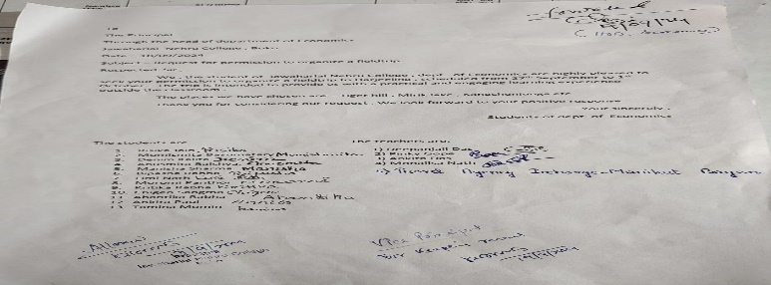
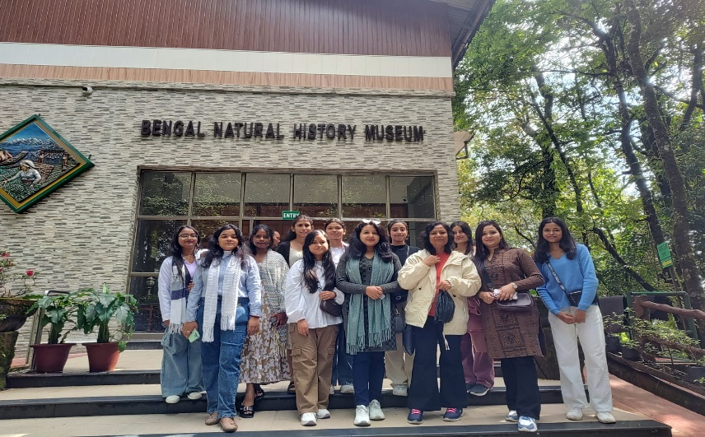

Date of Visit: 27th Sept. to 1st Oct. 2024

Brief report on a field trip to Darjeeling, West Bengal
The Department of Economics organized a field trip to Darjeeling, West Bengal from 27th September 2024 to 1st October 2024 with four faculty members as supervisors - Mrs. Deepanjali Das, Associate Professor, Miss. Ankita Das, Assistant Professor, Miss. Pinky Gope, Assistant Professor, and Miss. Monalisa Nath, Assistant Professor (Pol. Sc. Dept.). Thirteen students participated in the Visit. The students were asked to submit a project report on “Darjeeling as a Tourist Destination” from their own experience. The trip was an enjoyable and successful one.
The objective of Visit: To experience real-life situations of the tourism sector and learn how tourism boosts the
revenue of the local residents.
Outcome of Visit: The visit has fruitful outcomes some of which are listed below:
- Students could learn how the tourism sector has a great potential to create job opportunities either directly or
indirectly
- Students could get first-hand information on how the tourism sector creates profit for local restaurants and
shopping centers.
- After interacting with the local residents, it is learned that tourism is one of the most profitable sectors in today’s
market-driven society with low investment but highly sustainable.
A visit to tourists being a part of learning in a natural setting outside the classroom, gives students a major exposure to the tourism sector in its practical economic perspective which allows students to view the world through a different lens and broaden their horizon of the tourism industry.
Participants
Sl No | Name | Designation |  | Sl No | Name | Designation
1 | Mrs. Deepanjali Das | Associate Professor |  | 10 | Bipasha Rabha | Student
2 | Miss. Ankita Das | Assistant Professor |  | 11 | Limi Nath | Student
3 | Miss. Pinky Gope | Assistant Professor |  | 12 | Moromi Panthoi | Student
4 | Miss. Monalisa nath | Assistant Professor |  | 13 | Kritika Rabha | Student
5 | Risika Jain | Student |  | 14 | Chigen Sangma | Student
6 | Momismita Basumatary | Student |  | 15 | Abantika Rabha | Student
7 | Denim Kalita | Student |  | 16 | Ankita Paul | Student
8 | Anusmita Bhaishya | Student |  | 17 | Tamina Momin | Student
9 | Manisha Sarma | Student

