DEPARTMENT OF BOTANY
JAWAHARLAL NEHRU COLLEGE, BOKO
WORKSHOP ON VERMICOMPOST TECHNIQUES
DATE- 22/05/2024. TIME- 10AM TO 4.30PM

RESOURCE PERSON- DR. KAMAL LACHON BARMAN, MSc, PhD
Assistant Professor (C), Department of Botany, J.N College, Boko
TECHNICAL SESSION I- THEORY & PRACTICES
TECHNICAL SESSION II- HANDS ON TRAINING

AIM- To recycle solid organic waste into nutrient rich organic manure for sustainable Agricultural practice.

OBJECTIVES- The main objectives are-
A) Recycling of organic waste
B) Improve soil health
C) Reduction of chemical uses
D) Prevent environmental pollution

OUTCOME - Vermicompost helps in the improvement of soil structure, texture, porosity, water holding capacity, drainage and aeration as well as the reduce erosion. A total of 126 participants including Students and Faculty Members Participated in the workshop. Hands on training programs also conducted during the second technical session of the workshop.

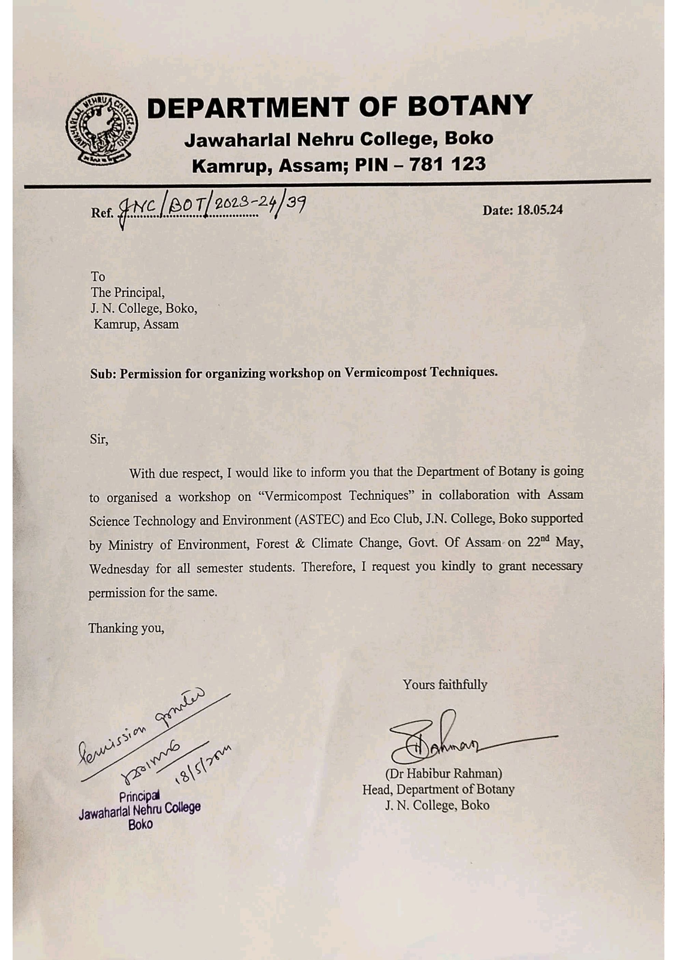
PERMISSION LETTER FOR CONDUCTING THE WORKSHOP FROM PRINCIPAL, J.N COLLEGE, BOKO
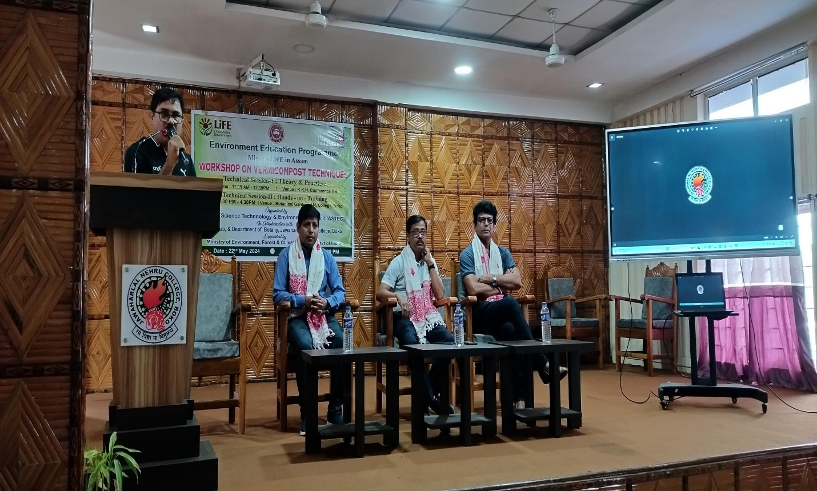

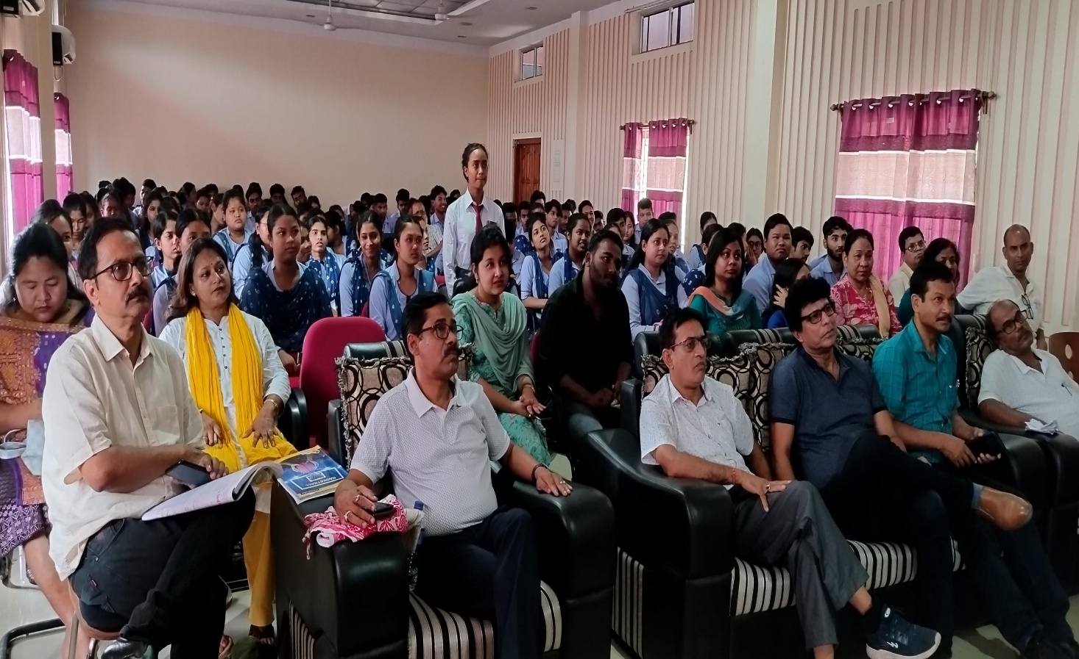
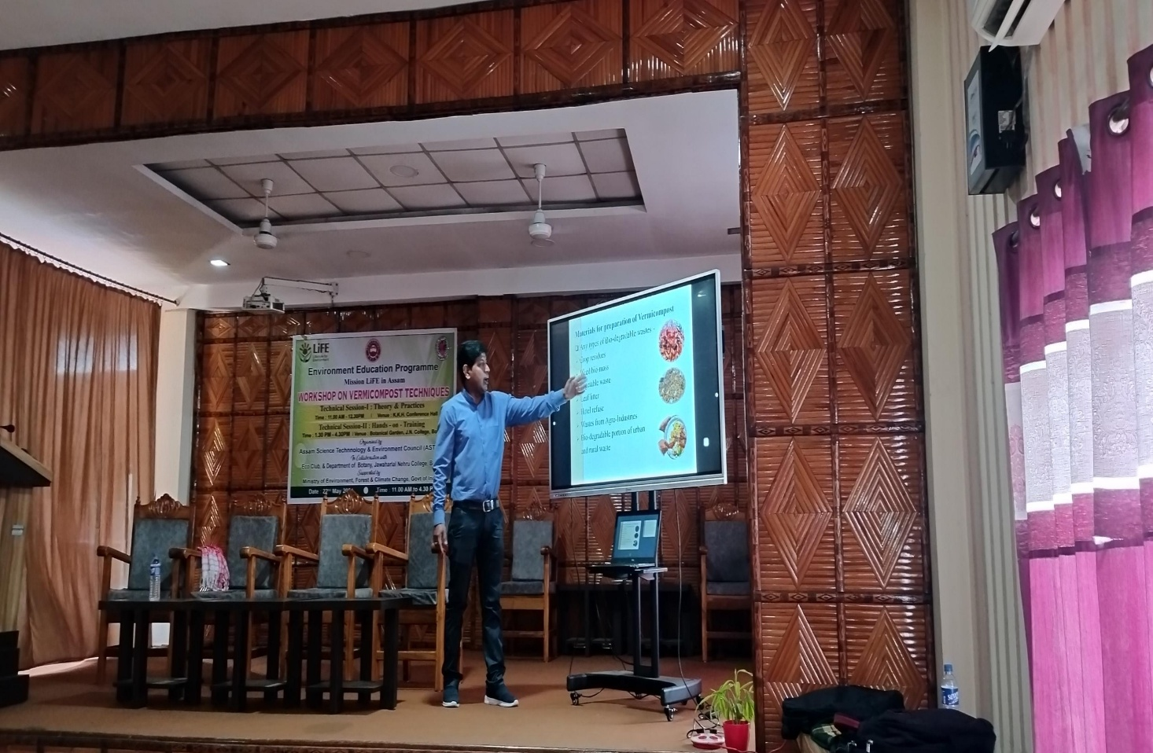
IMAGES FROM THE TECHNICAL SESSION- I
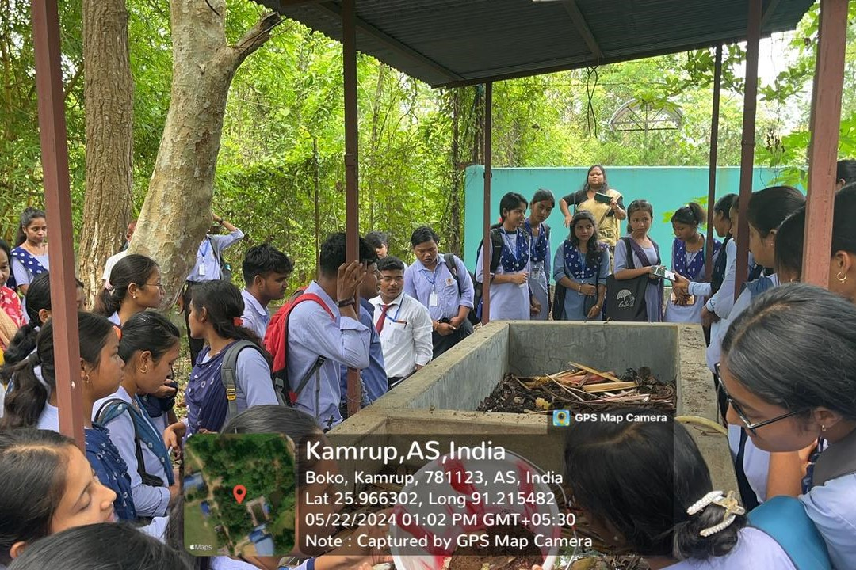
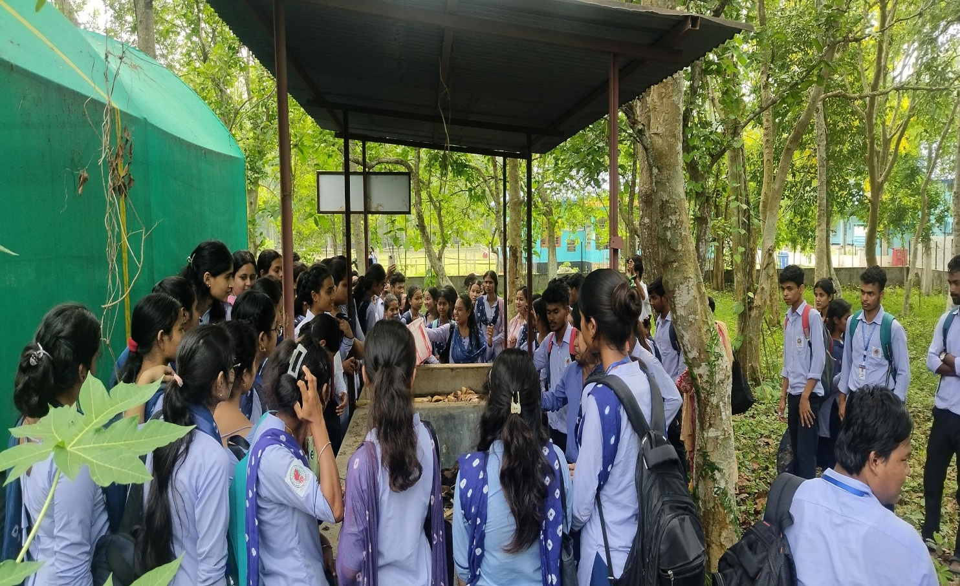
IMAGES FROM THE TECHNICAL SESSION-II
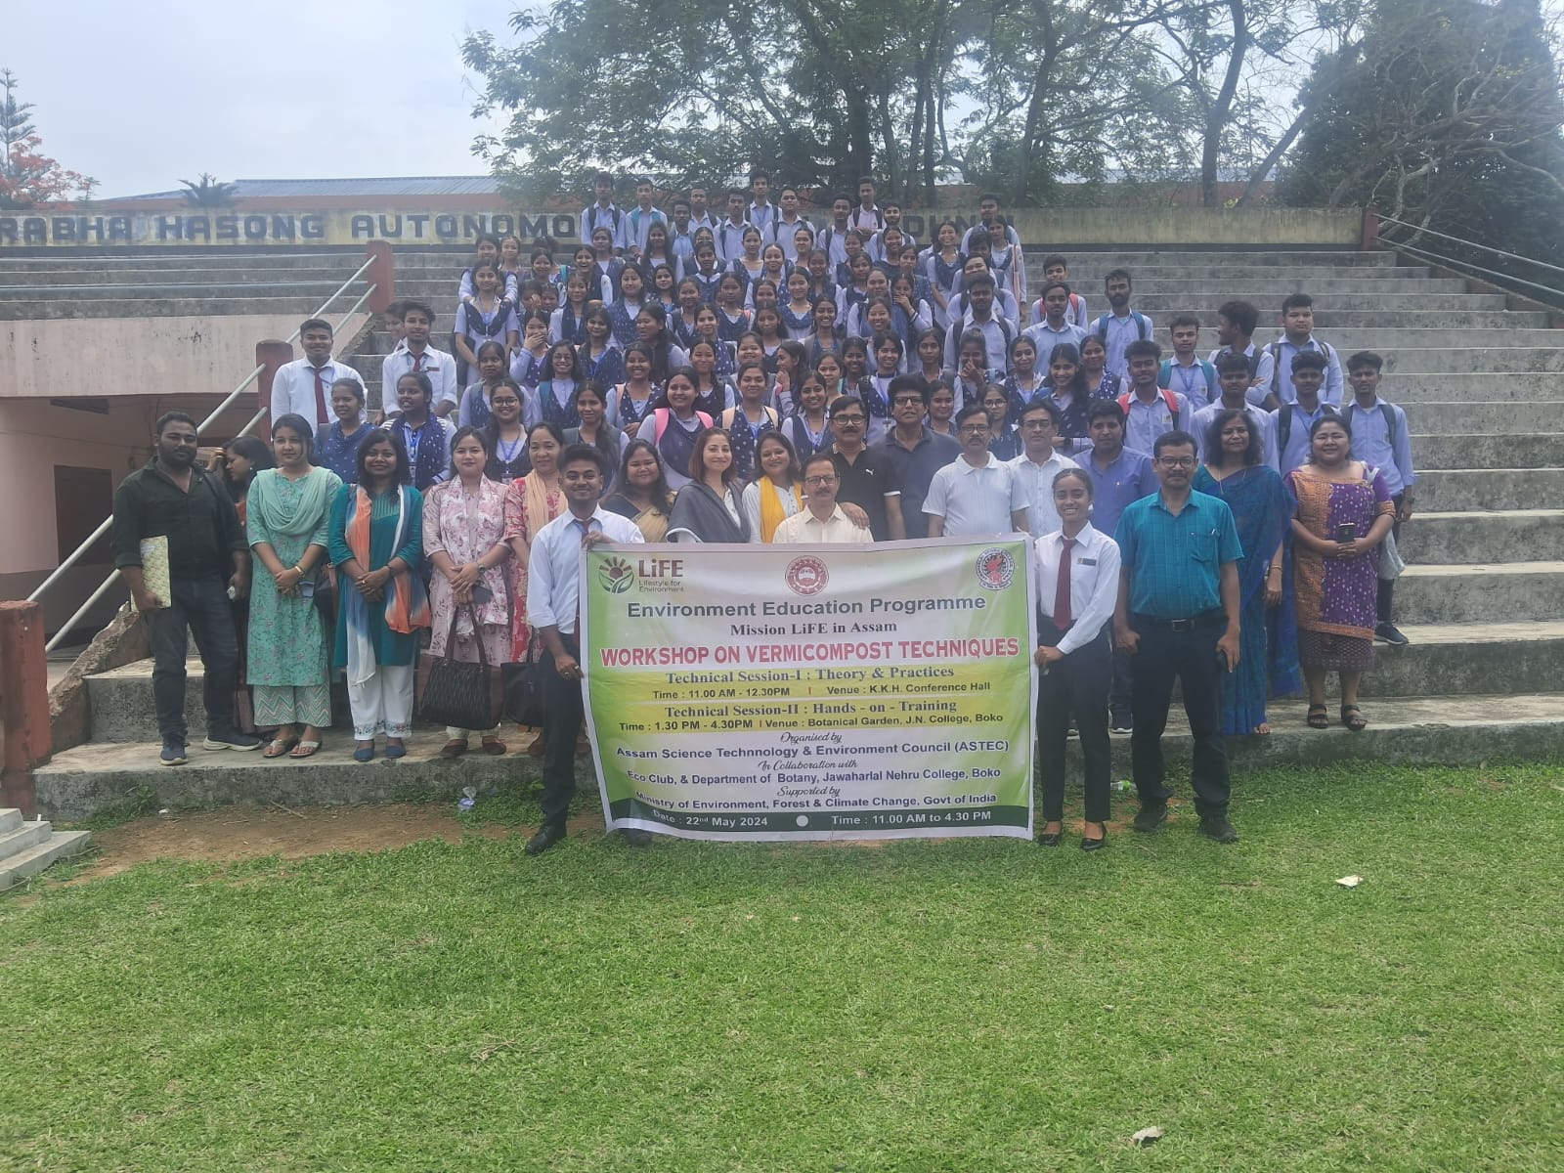
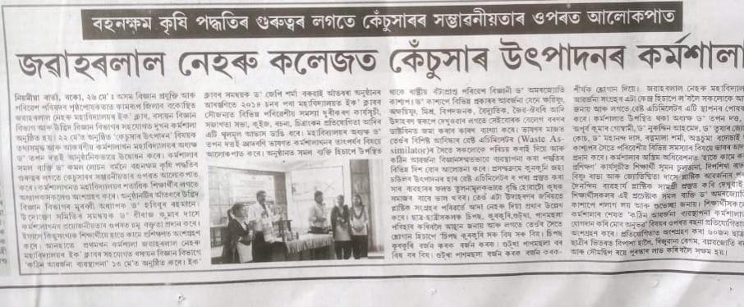
MEDIA PUBLICATION ON THE EVENT-
LIST OF STUDENTS AND FACULTY MEMBERS PARTICIPATED IN THE WORKSHOP-
