Field Trip to Mawphlang, Shillong, Meghalaya (11-11-2024)

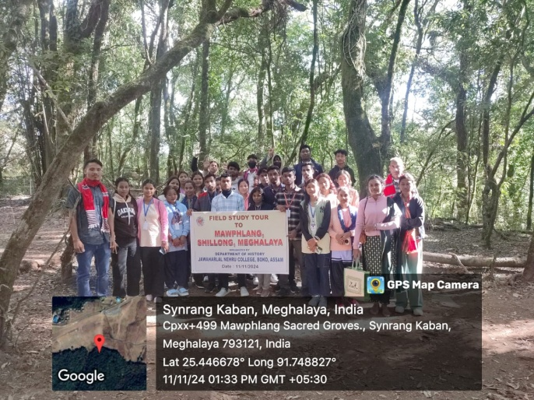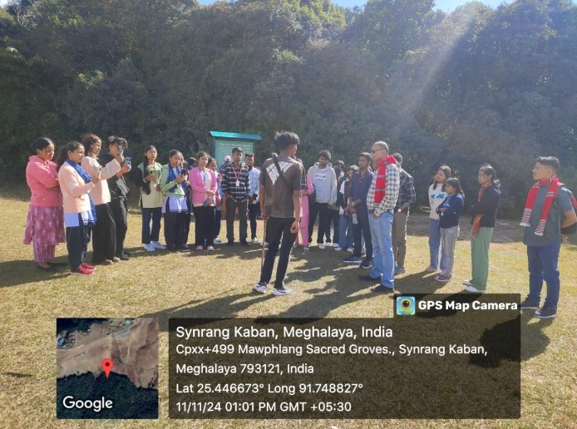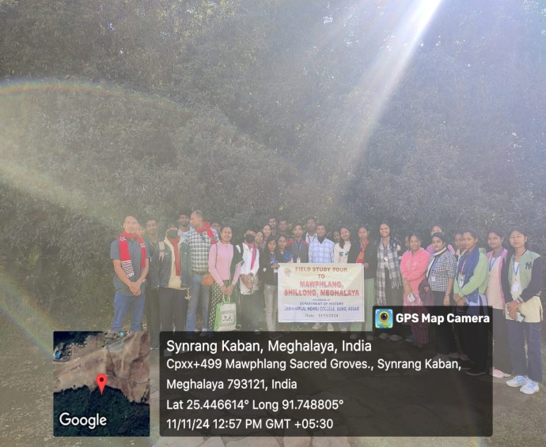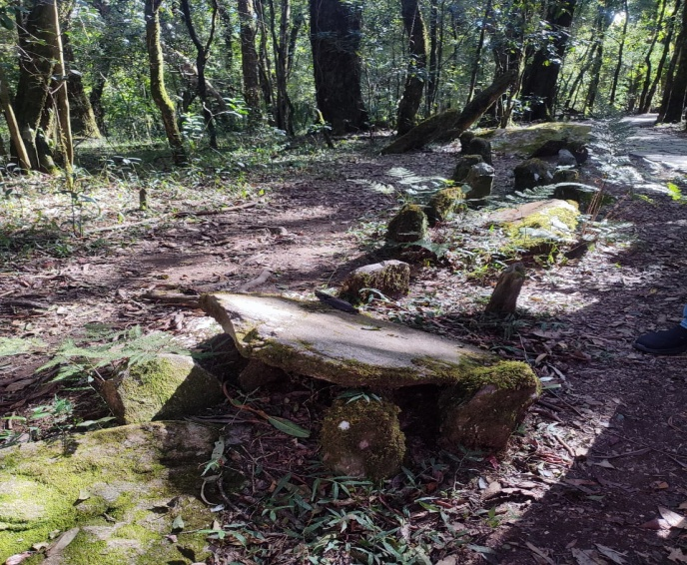

Objective of the Study:
1. To make students aware about the importance of tourism as a discipline.
2. To motivate students in regards of preservation of heritage forest for the greater interest of society.
Results of study
1. Students acquired firsthand knowledge regarding job prospects and opportunities from study which directly deals with tourist spot like Mawphlang sacred forest.
2. Secondly participating students came to know about different beliefs associated with the Mawphlang sacred forest proper practice of which makes one conscious about the preservation of forest area and its resources.

