Interaction program with the students of Baguriguri HS School
Date- 23rd August, 2025
Venue – Department of Botany, JN College, Boko
A group of 17 students of Class X from Baguriguri Higher Secondary School, accompanied by two teachers, Mr. Sofikul Islam and Miss Drishti Bora visited the Department of Botany, J.N. College, Boko on 23rd August, 2025.
The purpose of the visit was to provide the students with hands-on skill training on the use of various instruments commonly utilized in a plant science laboratory. During the training session, the students were introduced to and practiced handling different instruments such as microscopes (of various types), autoclave, hot air oven, and water distiller. They were also guided through the process of herbarium preparation and its scientific significance.
The training and demonstration sessions were conducted by Dr. Habibur Rahman, Miss Nilakshi Ramchiary, Dr. K. L. Barman, and other faculty members of the Department of Botany. The students actively participated and interacted with the faculty, gaining valuable practical knowledge and exposure to laboratory techniques essential for plant science studies.
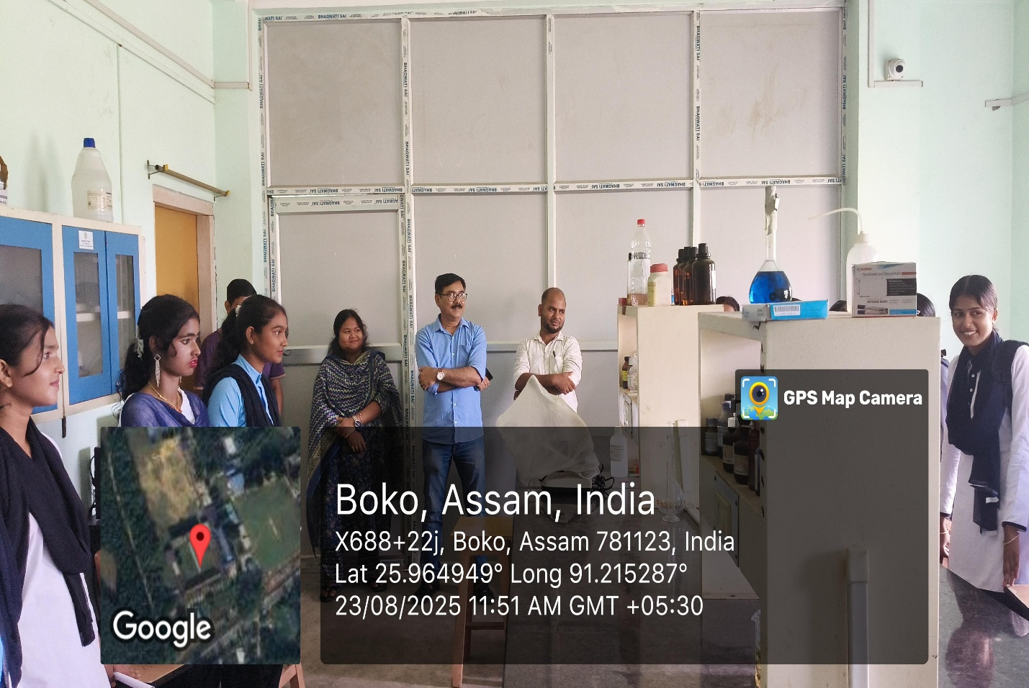
Photo-Data
