Field Trip to Khatara Satra, Patharughat and Madan Kamdev, 28-04-2025 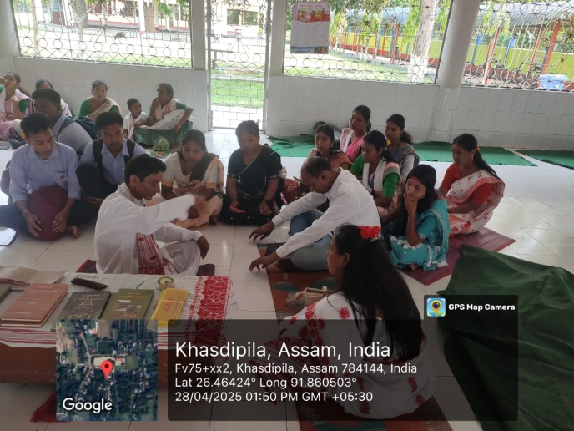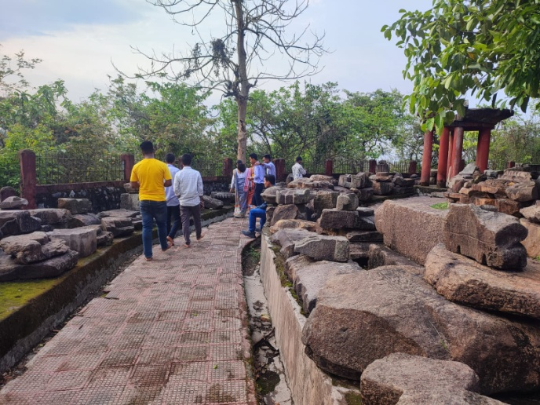

Objective of the Study:
1. To acquaint students of IV Semester having SEC paper entitled "Oral Culture and Oral History” in few historical sites of Present Darrang district and Kamrup district.
2. Study also aimed at giving an insight to one of most tragic event of India's resistance movement in the form of Pathorughat rebellion.
3. Study also carried out in historic Khatara Sara of the 16th century AD.
Result of Study:
1. Aspirants students were given an opportunity to visit three important historical sites embracing three ages i e. Ancient, Medieval and Modern Age. Thus it was a new experience for all of them.
2. Students came to know about the unsung heroes of Pathorughat rebellion who laid their lives for the nation.
3. Students got an opportunity for direct interaction with people concerned with all the historical sites. They gathered knowledge Vaisnavism practised at Khatara Satra. Similarly they came across with different archaeological remains scattered I'm Madan Kamdev. Thus it was a fruitful field study from the academic point of view.
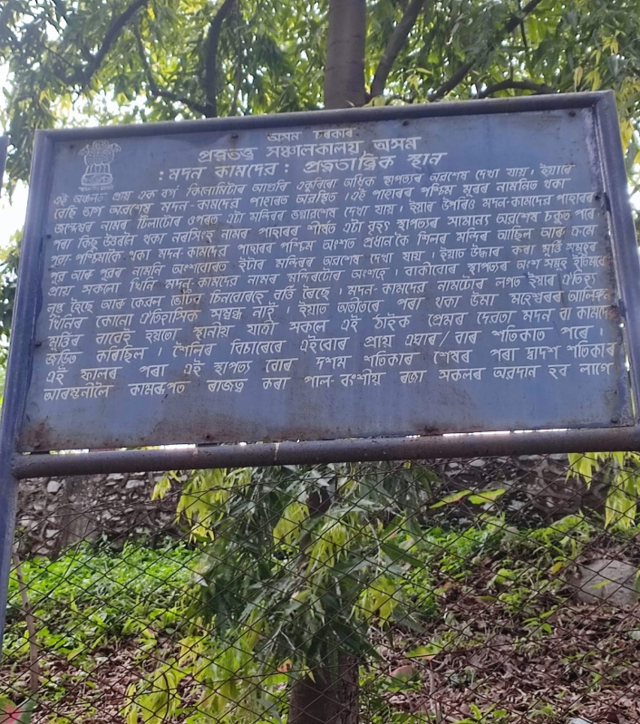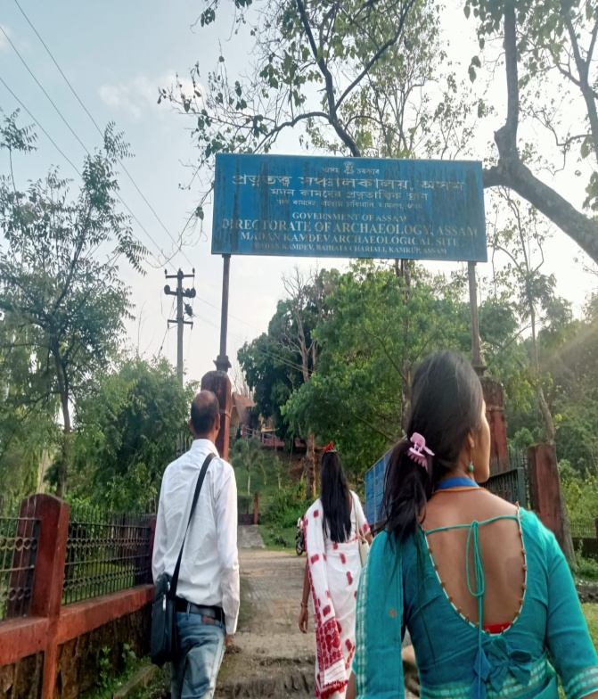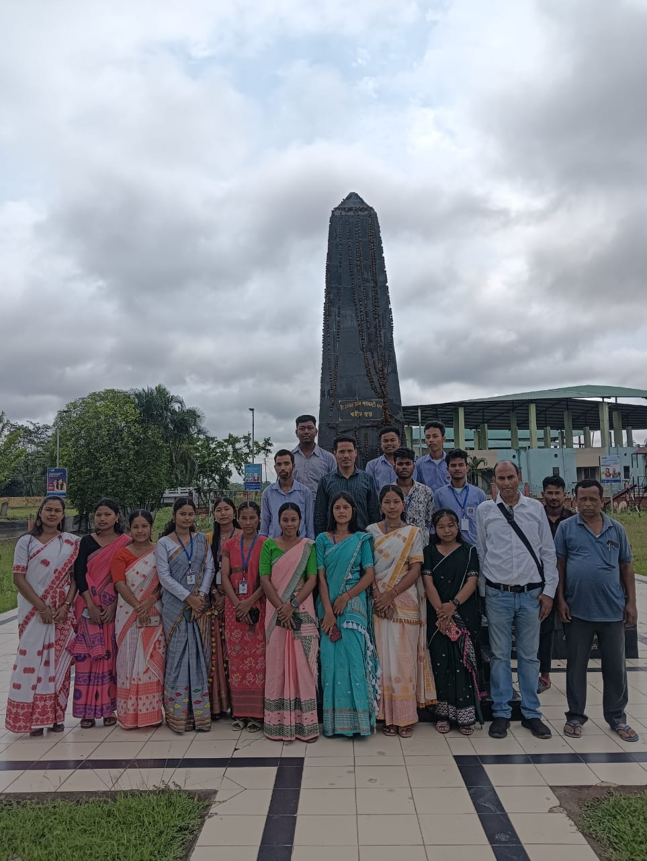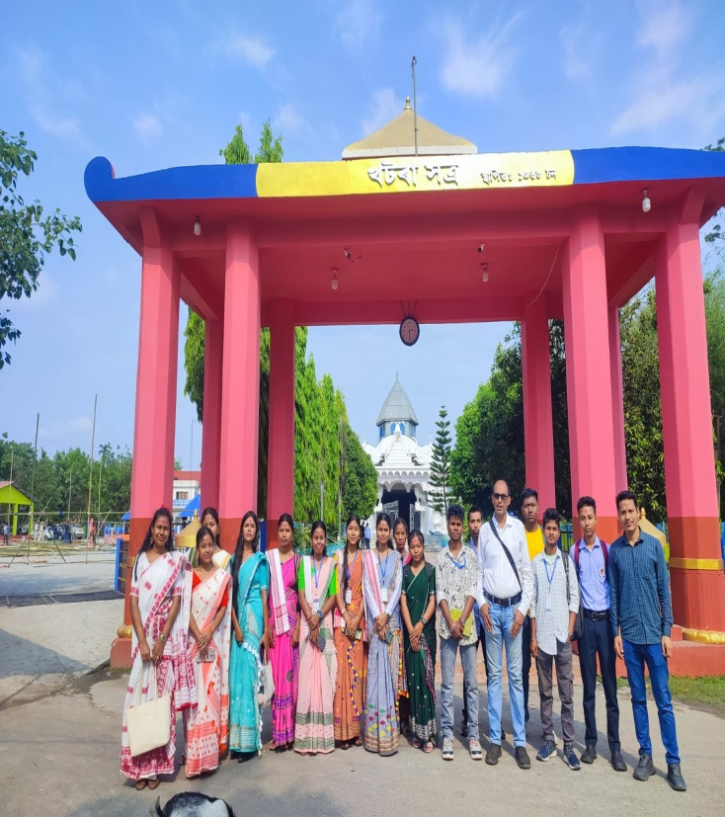
Attendees:
- Jahidul Ali
- Mrityunjay Sanyal
- Sunita Rabha
- Lanu Bhaba Rabha
- Anupam Das
- Sikha Chakrabharti
- Harima Das
- Himakshi Kalita
- Ferintha Sangma
- Pratima Rabha
- Ebhasmita Boro
- Rupali Mandal
- Neelkamal Rabha
- Bhumika Rabha
- Ritupranab Boro

