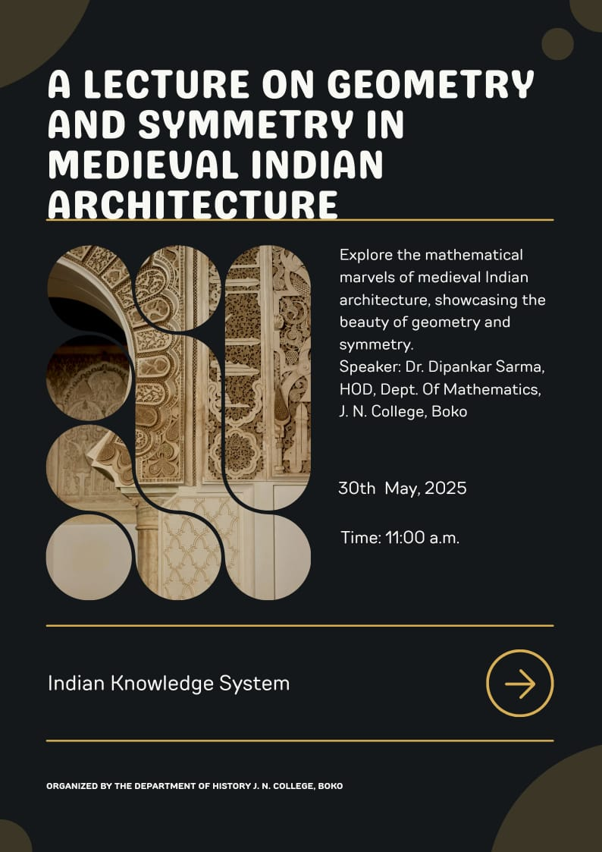

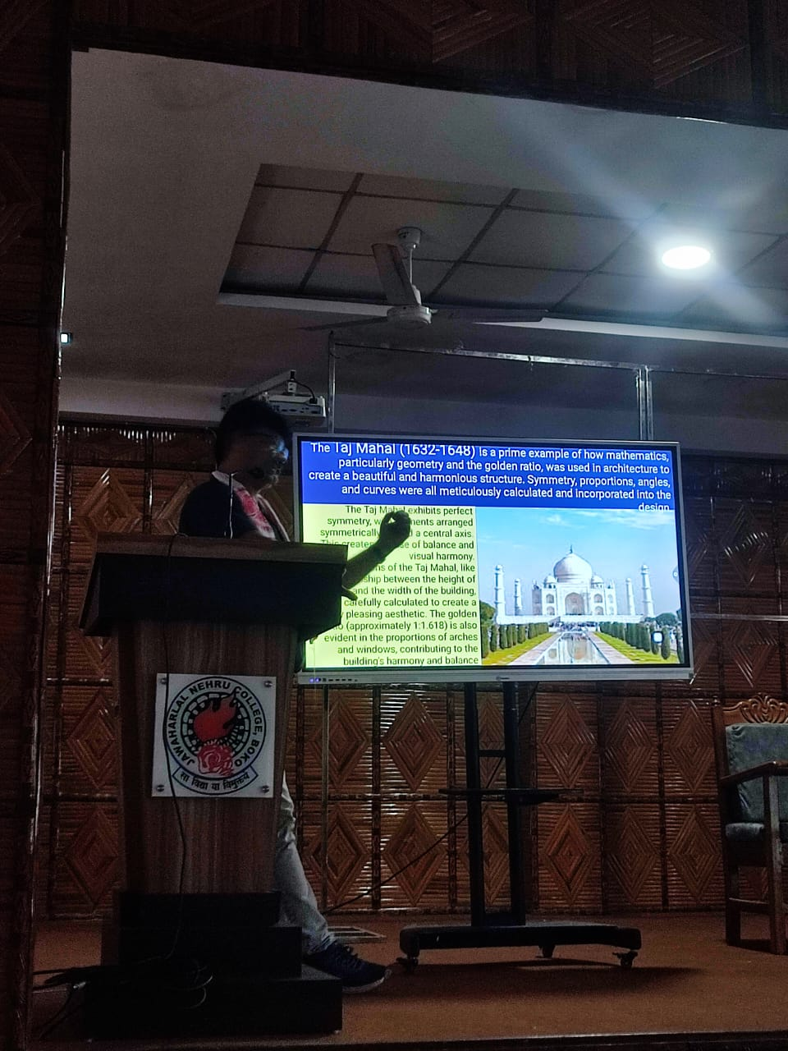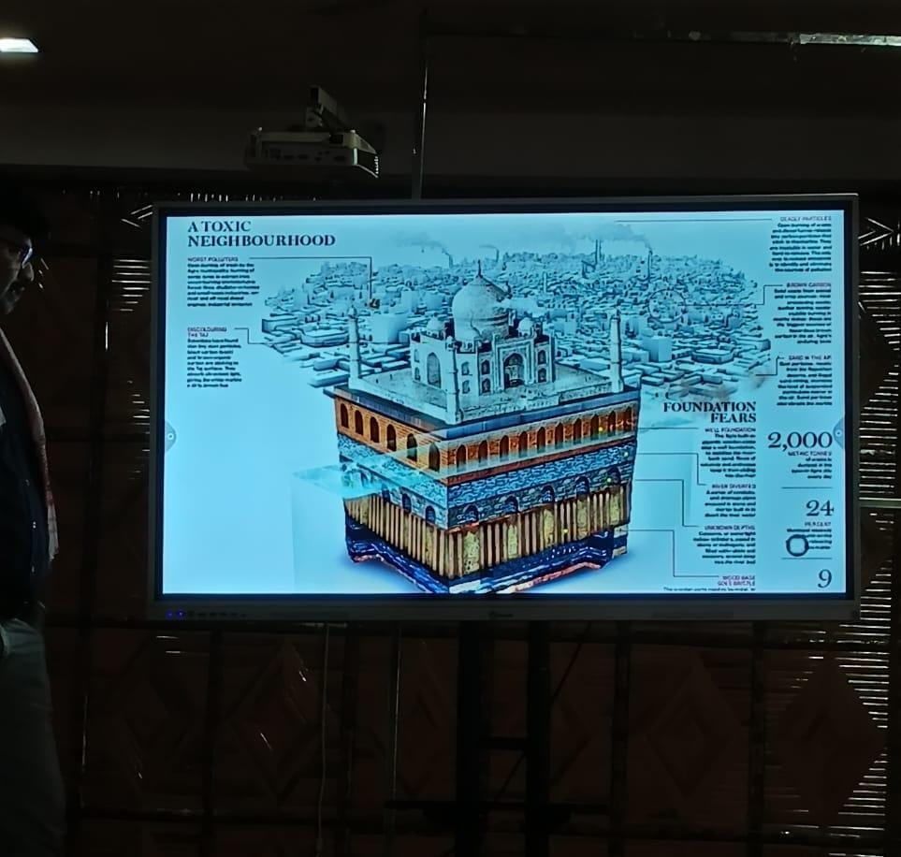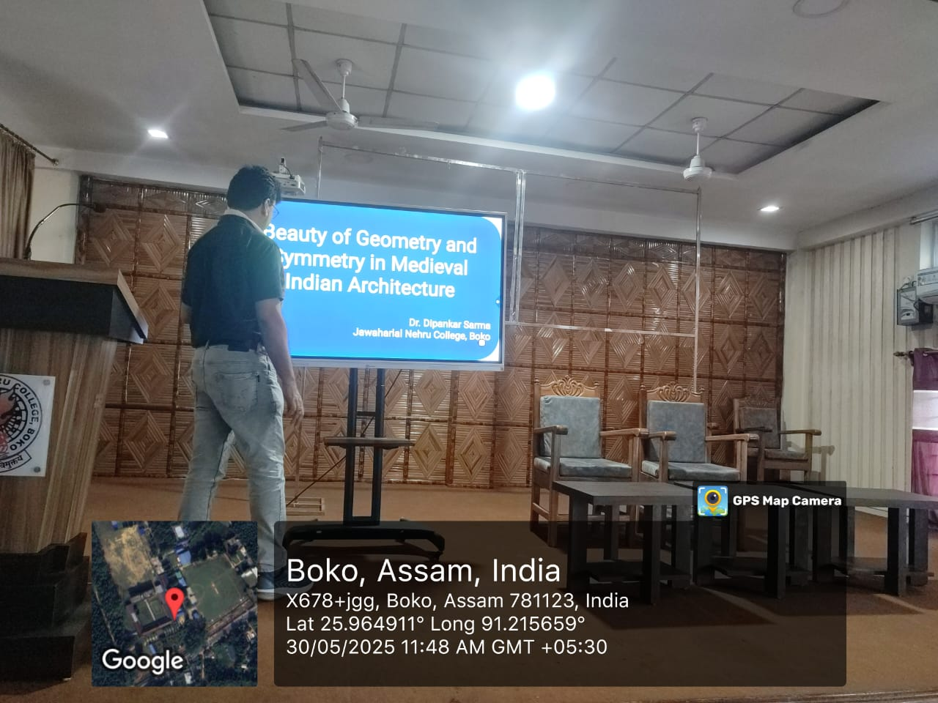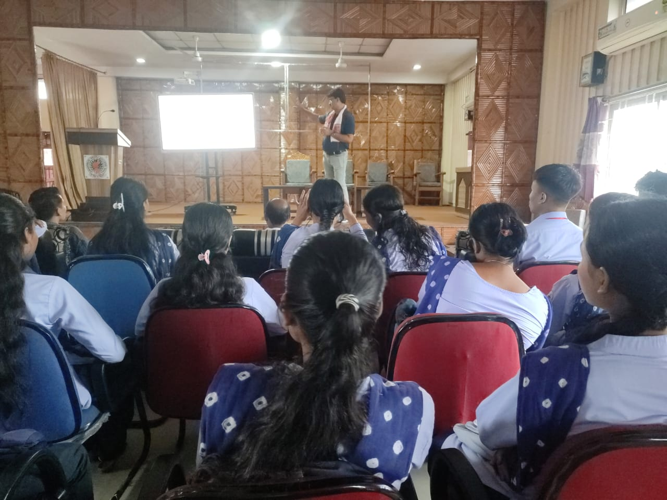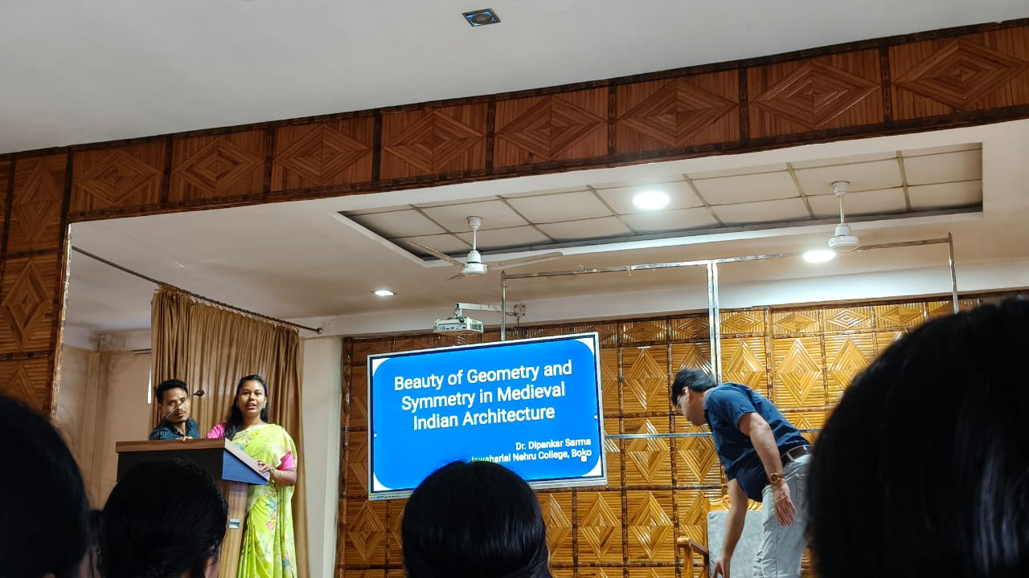
Objectives-
- Through this programme, knowledge will be shared across Fields to bring people from different areas together to share ideas and learn from each other.
- This will also help students to broaden their perspectives on diverse viewpoints and approaches, helping them think more creatively.
Results of this Programme-
- Students able to learnt about how Medieval Indian Architecture were built on the basis of Mathematical knowledge.
- Also learnt about how students can study and calculate the architectures of local areas.
