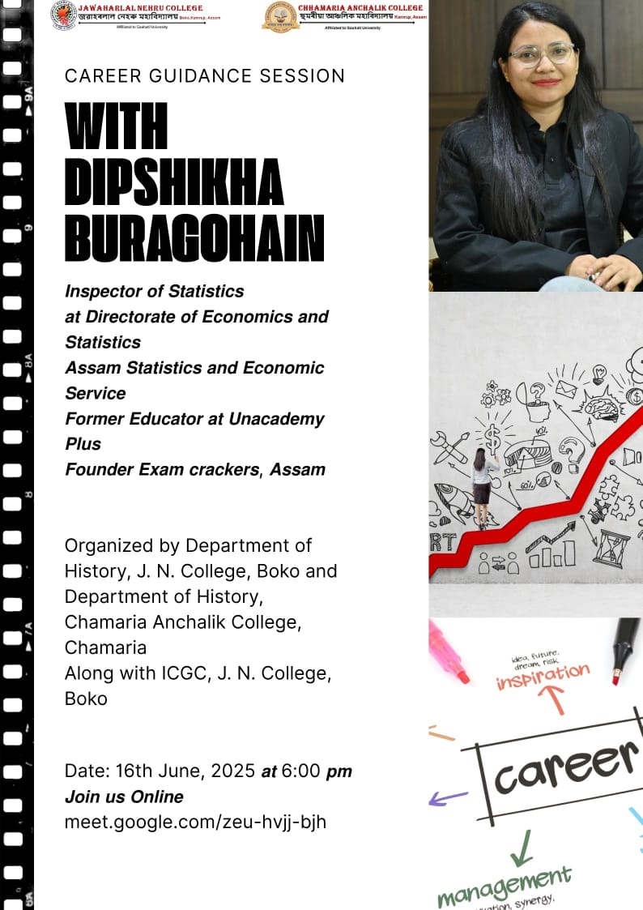

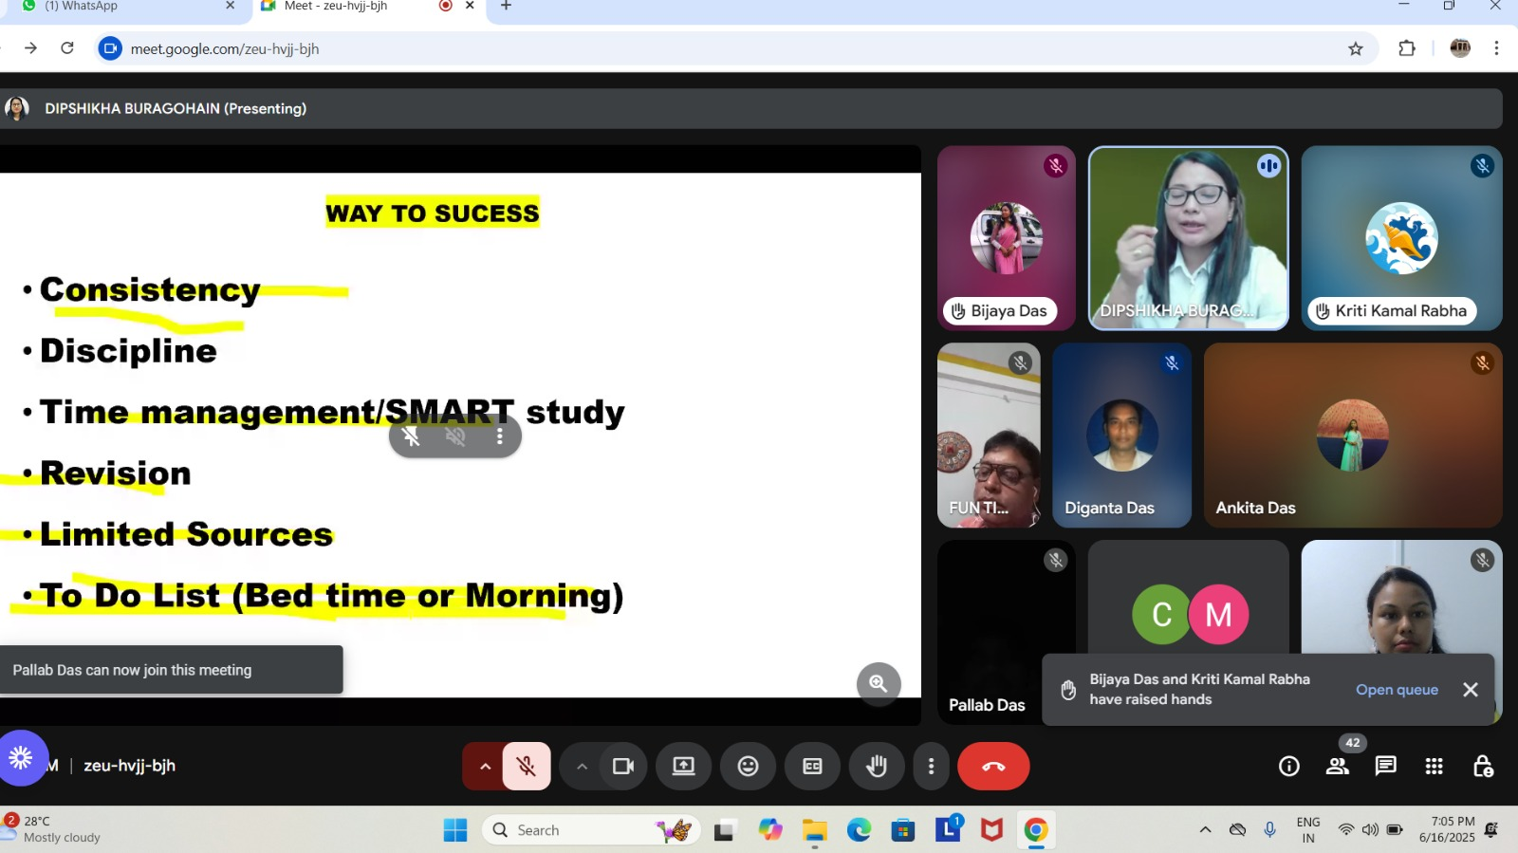

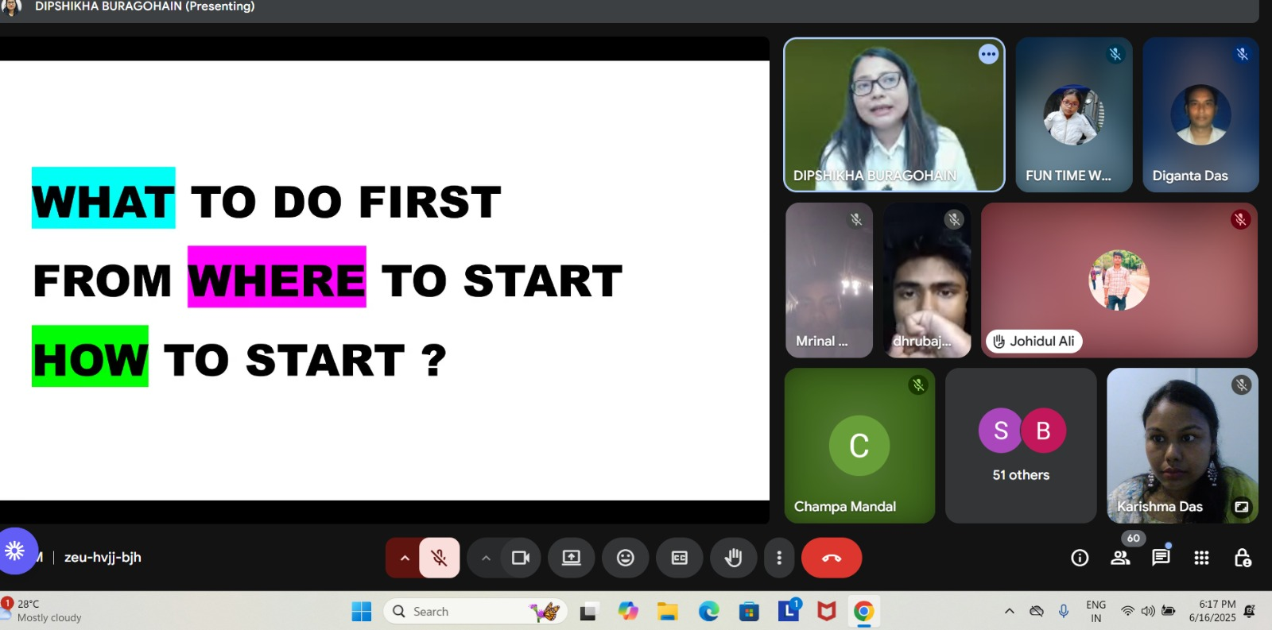

Objective:

- To provide detailed information about various competitive exams like APSC, ADRE, UPSC, TET/CTET, including eligibility criteria, exam patterns, and syllabus, helping aspirants make informed decisions about their career paths.
- To offer guidance on effective preparation strategies, study materials, and resources for these exams, enabling participants to enhance their chances of success and achieve their career goals in government services or teaching.
Results of this Programme:
- Increased Exam Preparedness: Participants gain a clearer understanding of exam requirements, leading to improved preparation and increased confidence in tackling competitive exams.
- Informed Career Choices: Aspirants are better equipped to make informed decisions about their career paths, aligning their goals with the specific requirements and opportunities offered by these exams.

