Department of Botany
Jawaharlal Nehru College, Boko
Session: 2024-2025

A Glimpse of the Popular Scientific Talk on Oyster Mushroom Cultivation and Spawn Culture Technology:
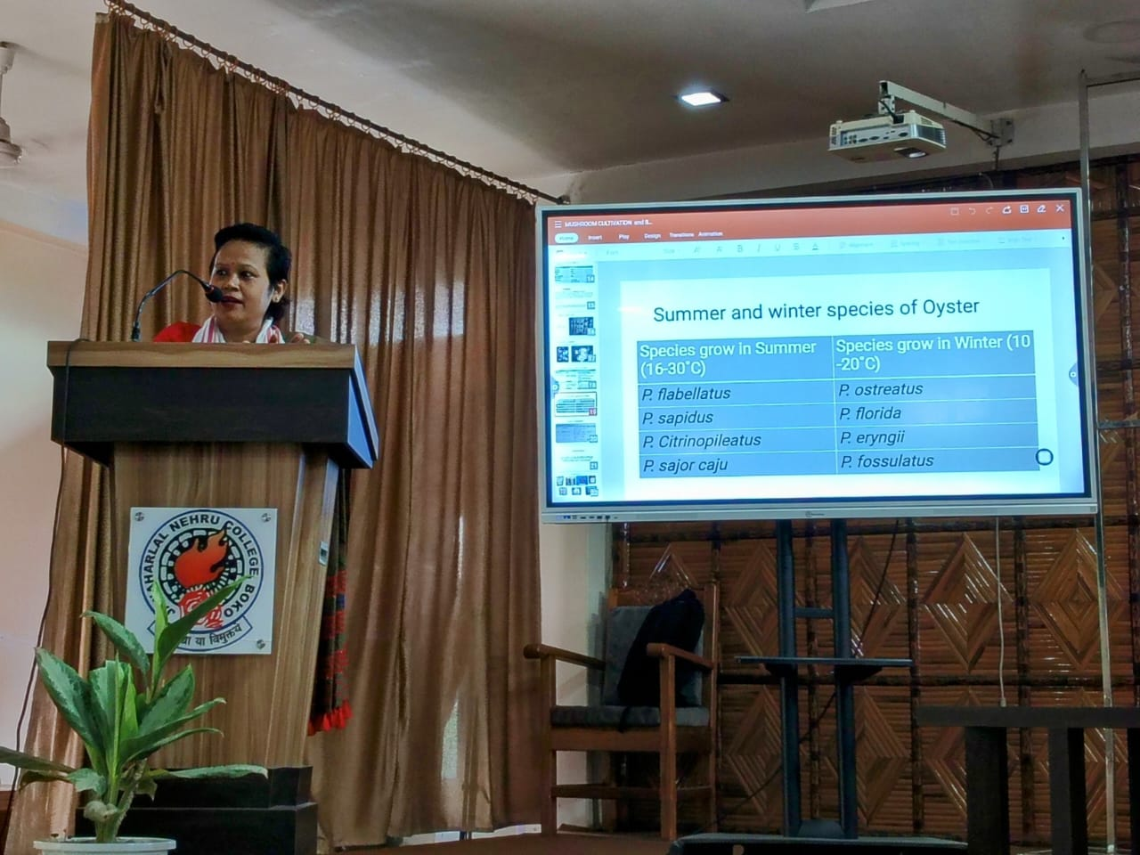
The Department of Botany, in association with the Internal Quality Assurance Cell (IQAC) of J.N. College, Boko, organized a popular scientific talk on “Oyster Mushroom Cultivation and Spawn Culture Technology on 30th June, 2025. Dr. Habibur Rahman, Head of the Department of Botany, elaborated on the objectives behind organizing the talk and offered felicitation to the resource person of the program. The program was inaugurated by Dr. Dhiraj Kr. Das, Associate Professor, Department of Mathematics. The keynote speaker for the event was Dr. Aparna Jyoti Rabha, a renowned entrepreneur and founder of Rabha Agrotech, Boko.
In her engaging and insightful address, Dr. Rabha highlighted the nutritional benefits of mushrooms, their significance in sustainable food systems, and their commercial potential as value-added products. She also provided a detailed overview of mushroom cultivation techniques and spawn culture technology, aiming to inspire and inform participants about practical applications that can lead to entrepreneurial ventures.
The event saw enthusiastic participation from faculty members across various departments and approximately 100 students. The session proved to be highly motivational, particularly for students, many of whom showed a strong interest in exploring self-employment and entrepreneurship in the field of mushroom cultivation.
The faculty members and students also actively interacted with the resource person during the session, engaging in meaningful discussions and queries. The program concluded with a vote of thanks delivered by P. K. Rabha, on behalf of the Department of Botany, extending heartfelt gratitude to the dignitaries, the Principal of the college, the resource person, and all participating students.
