Department of Botany
Jawaharlal Nehru College, Boko
Session- 2024-25

Students Project/ dissertation 2024
Group A- 9 Students
Name of Supervisor- Dr. K L Barman
Name of students-
- Lizamoni Rabha
- Queen Das
- Radhamoni Boro
- Jitu Malo
- Chakradhar Kalita
- Dhanjit Das
- Mizanur Rahman
- Monika Ahmed
- Miss Shirin Siddika
Title of the Dissertation/Project- A Study on Indigenous Fermented Food and Beverages of Boko Areas of Kamrup (R) District, Assam.
Group B- 8 Students
Name of Supervisor- Miss Nilakshi Ramchiary
Name of Students-
- Hafiza Begum
- Reshmina Nahar
- Jerifa Tabassum
- Sabina Yashmin
- Arzina Parbin
- Kapil Pathak
- Shahanur Rahman
- Monowara Khatun

Title of the Dissertation/Project- Study and Documentation on Angiospermic Flora of J N College Campus.
Sample copies of Dissertation:
Group-A

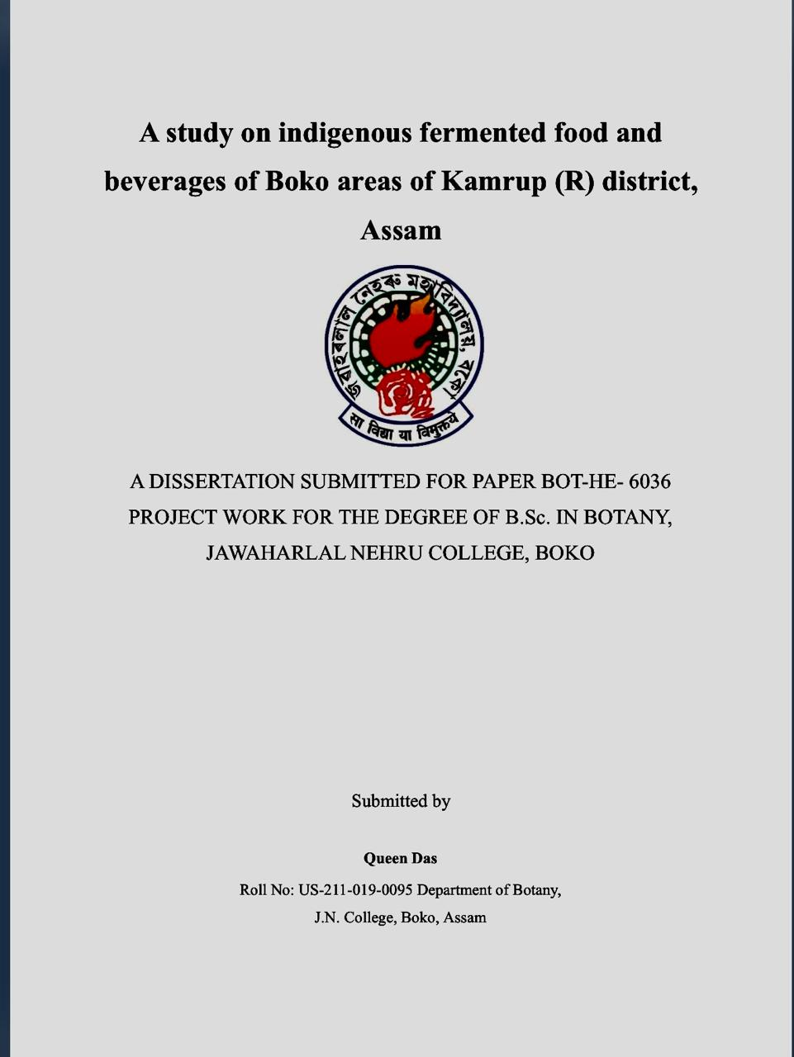

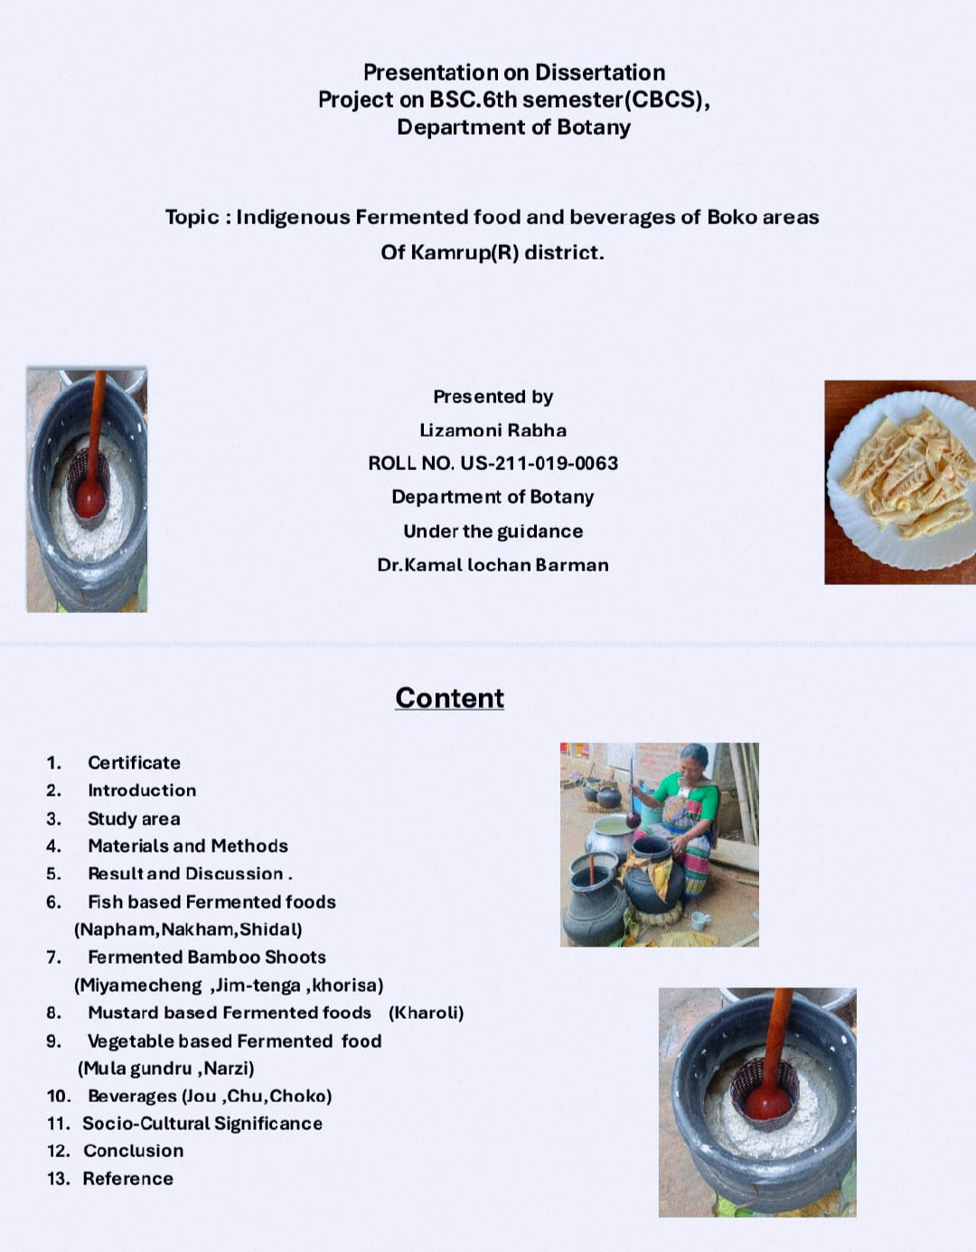

- Photographs taken by the students of group A during their field visits in the
nearby villages of Boko areas-

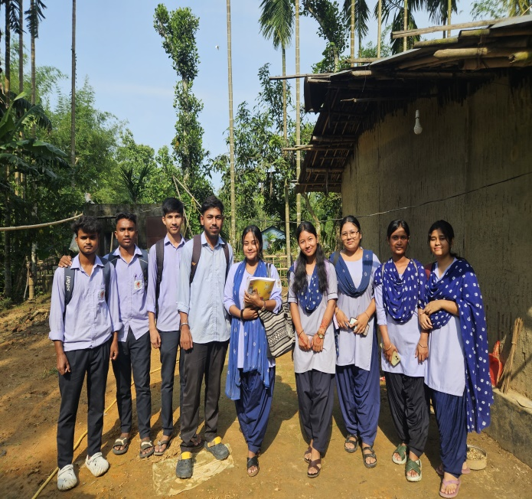
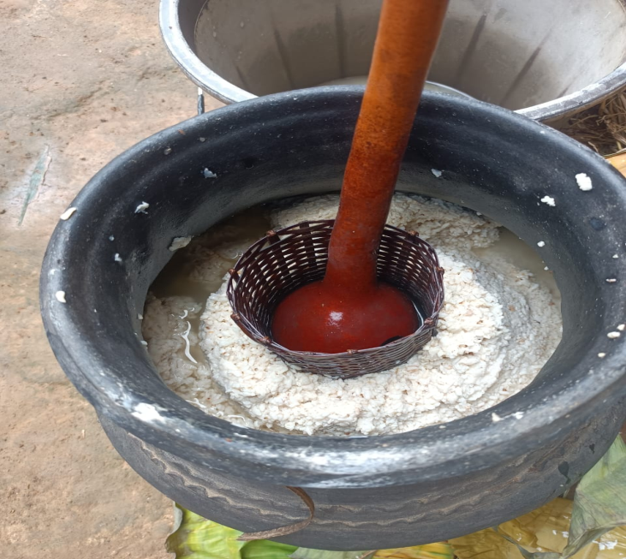
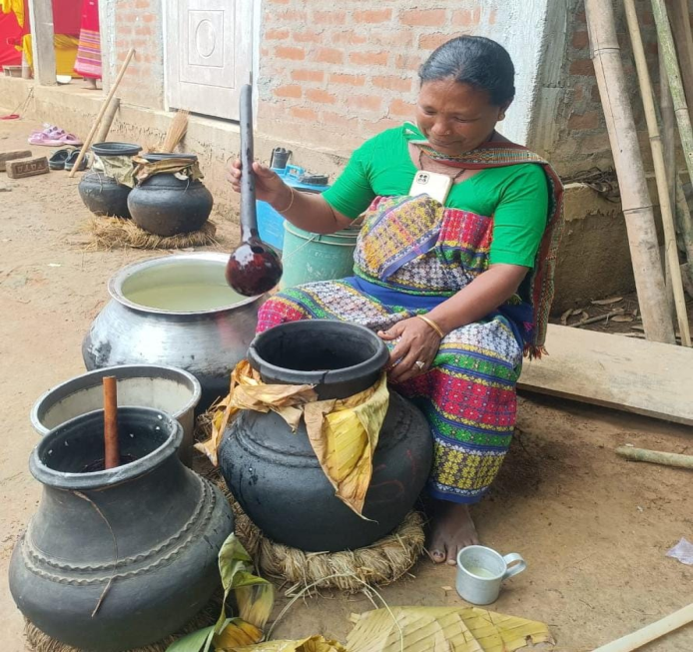
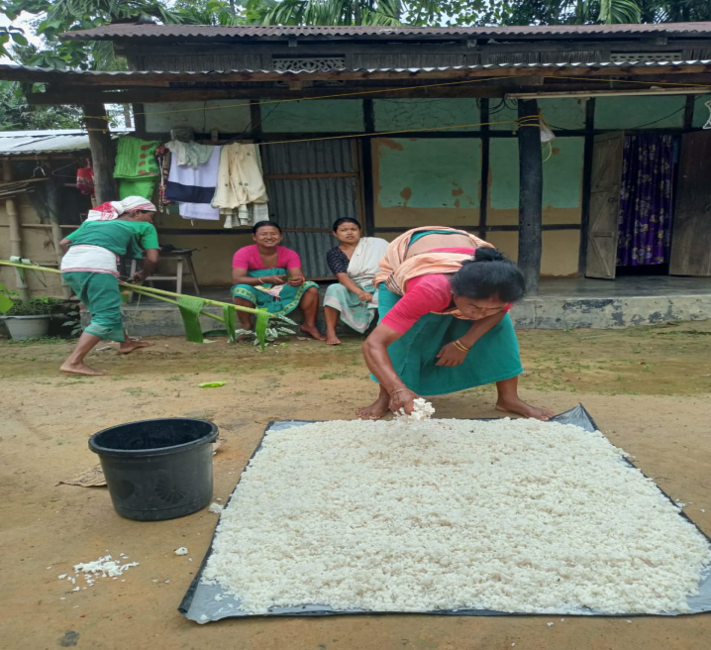

Sample copies of Dissertation:
Group- B
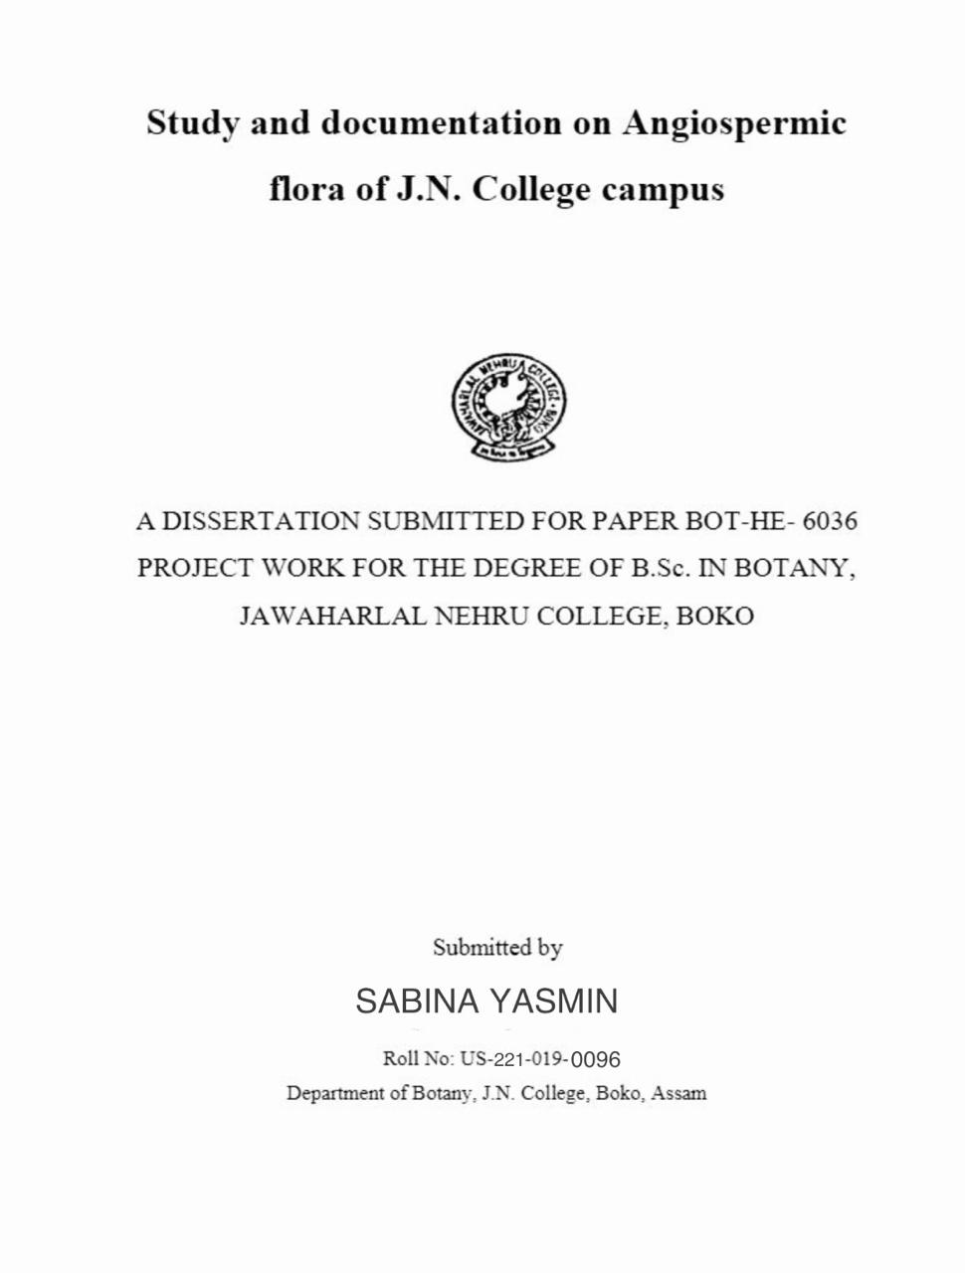

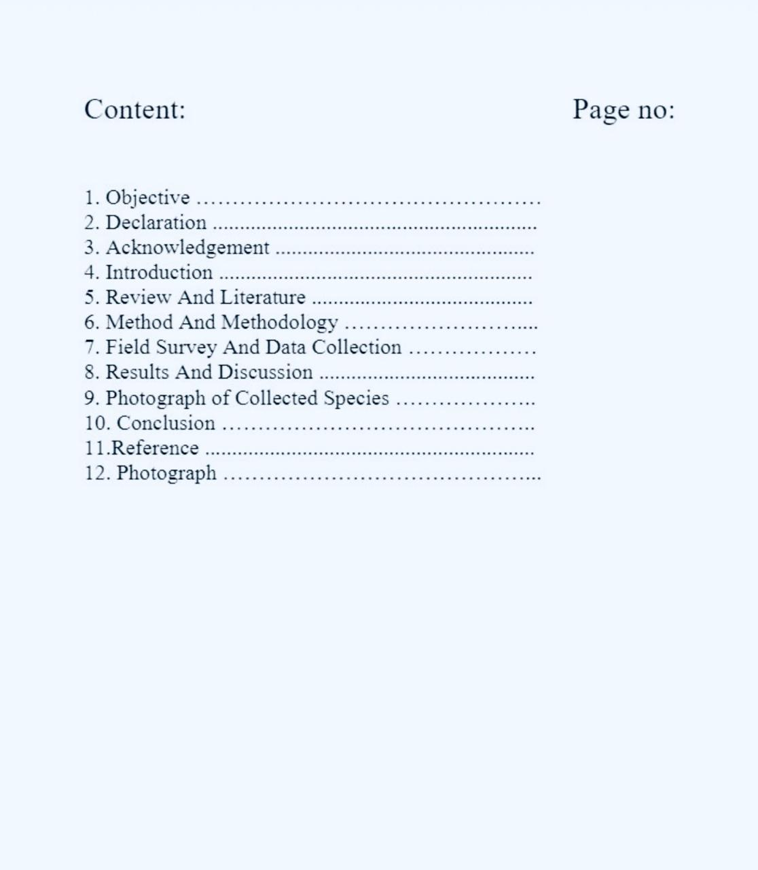

- Photographs taken by the students of group B during their field visits in the different areas of J N College campus -

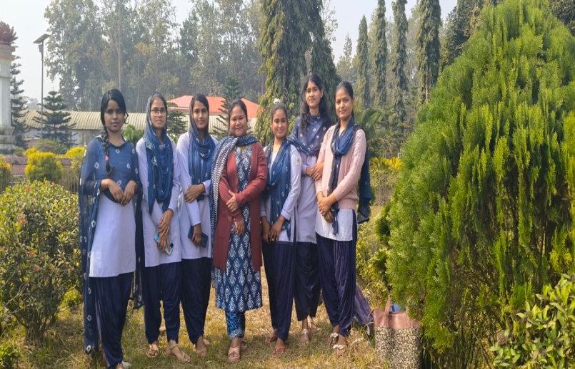

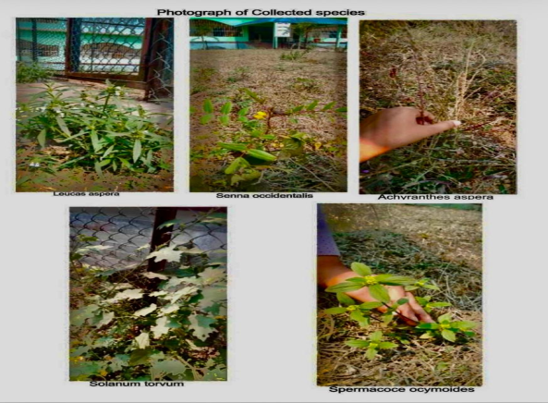

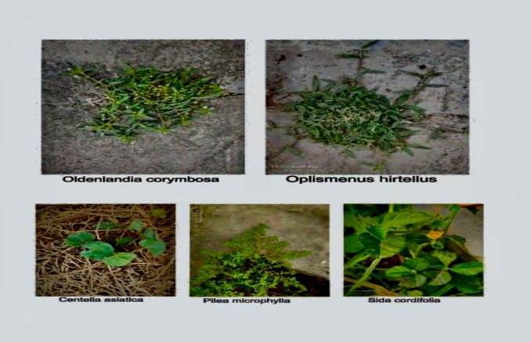
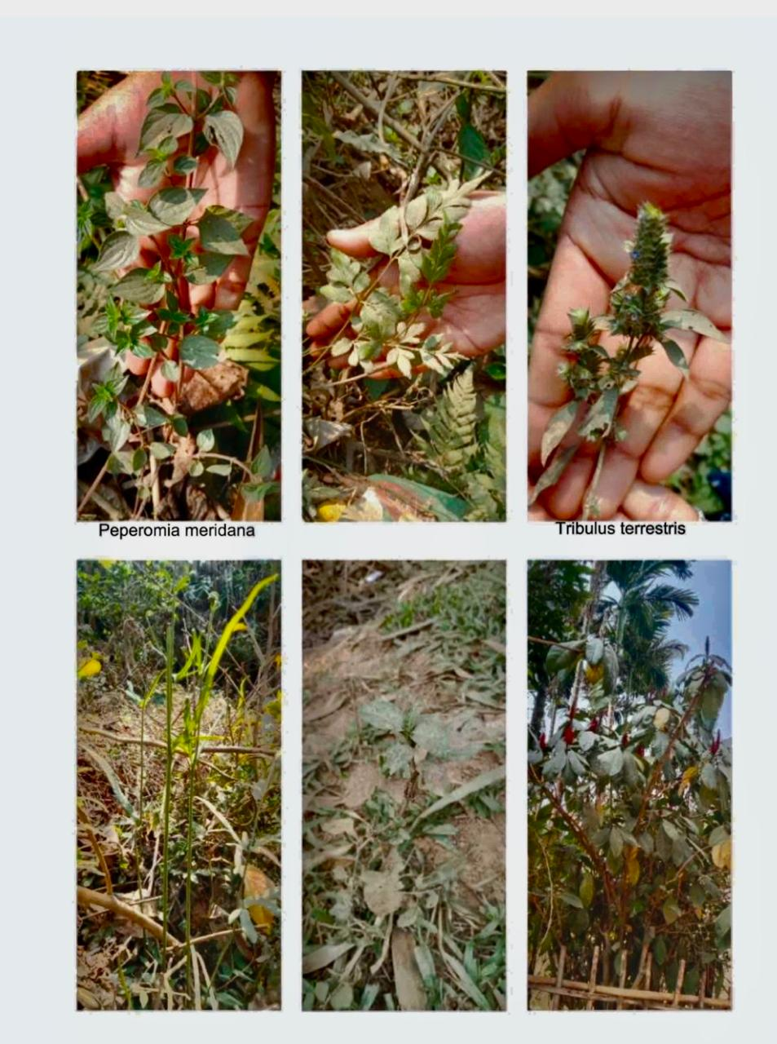
Presentation of Dissertation work during Practical Examination
on 03-06-2025
