DEPARTMENT OF BOTANY
JAWAHARLAL NEHRU COLLEGE, BOKO
SESSION: 2024-2025

Seminar Presentation by the Students of the Department of Botany-

Seminar presentation by - 1ST Semester students
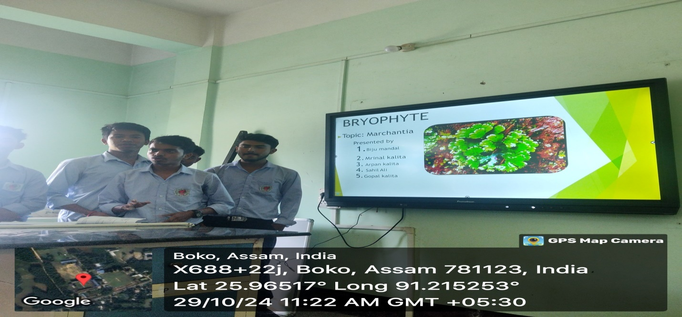

Seminar presentation by 3rd Semester students

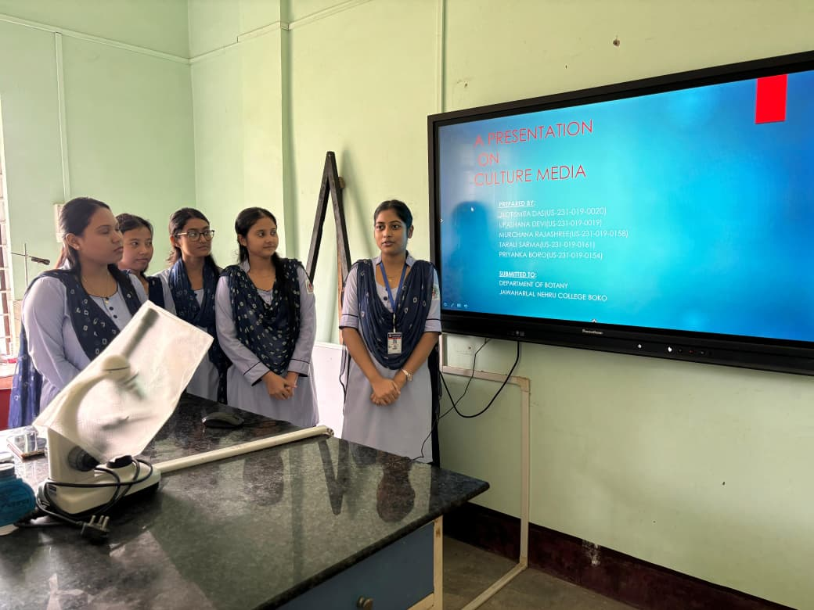
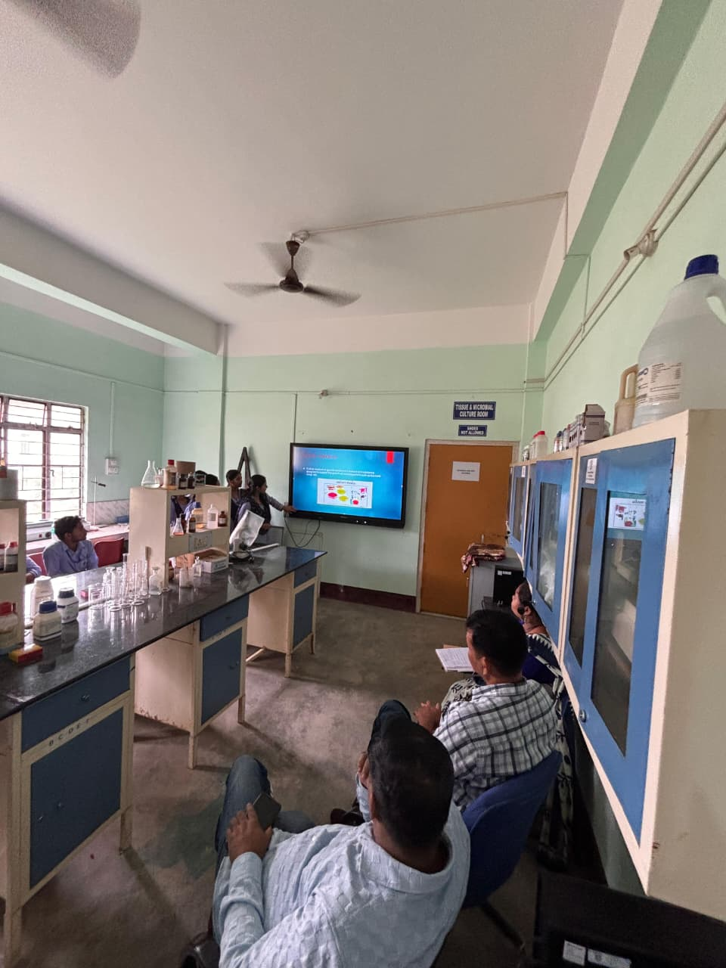

Seminar presentation by – 5th and 6th Semester students
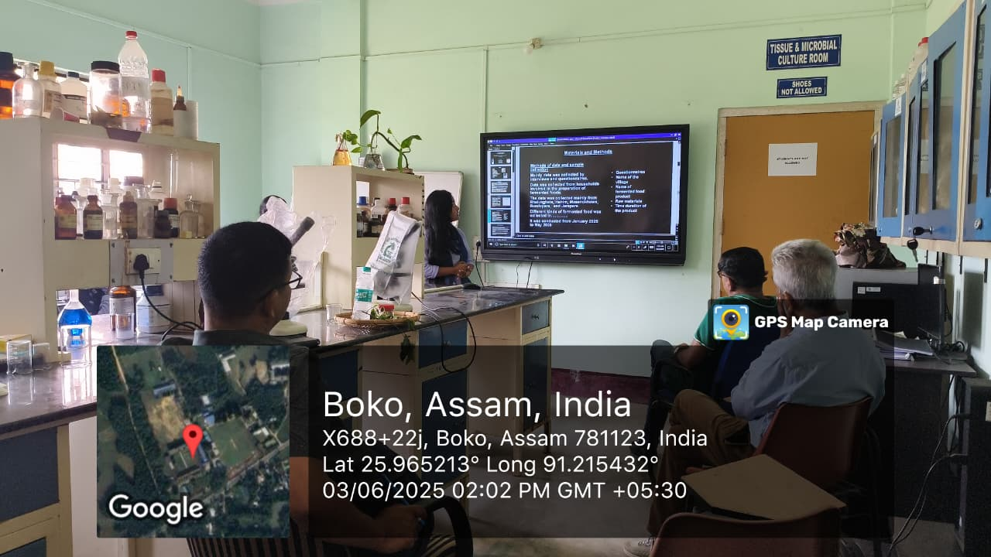
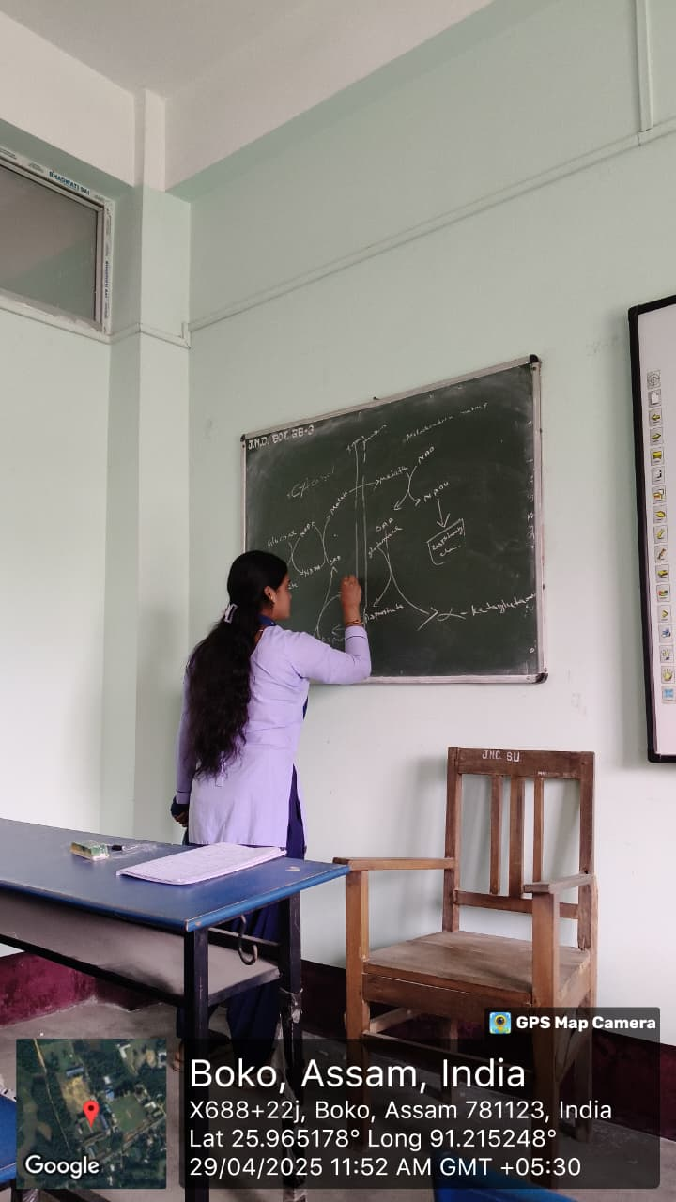
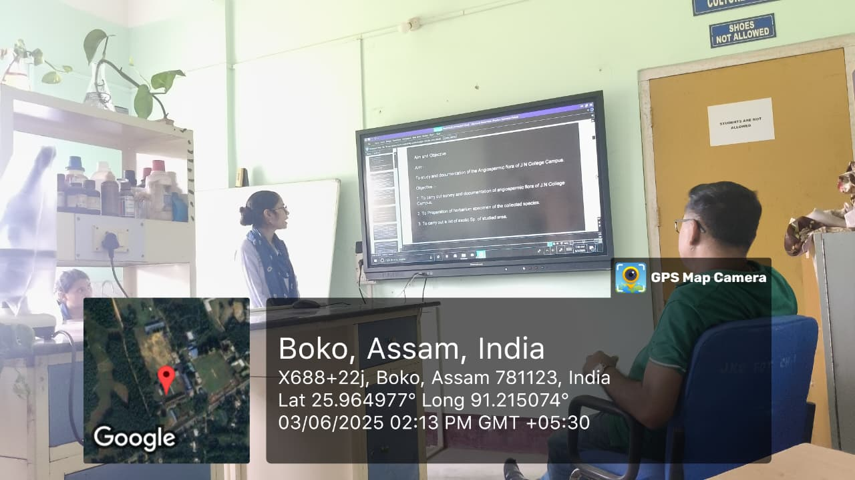
Departmental seminar record maintained by the Department-
- BSc 5th semester (Honours)
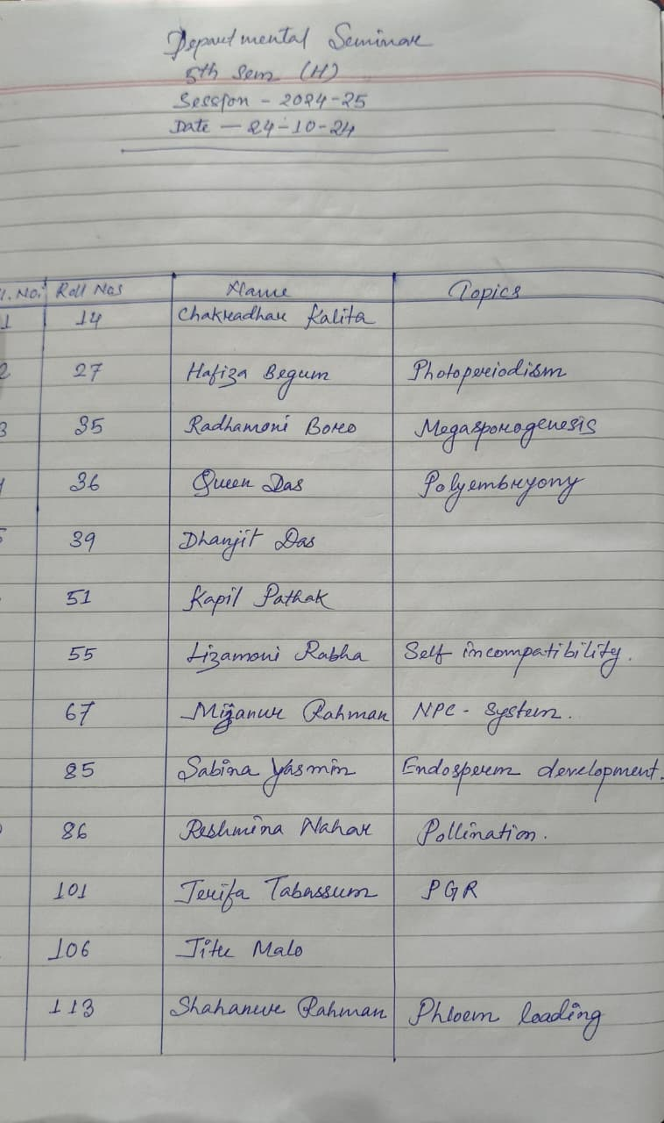
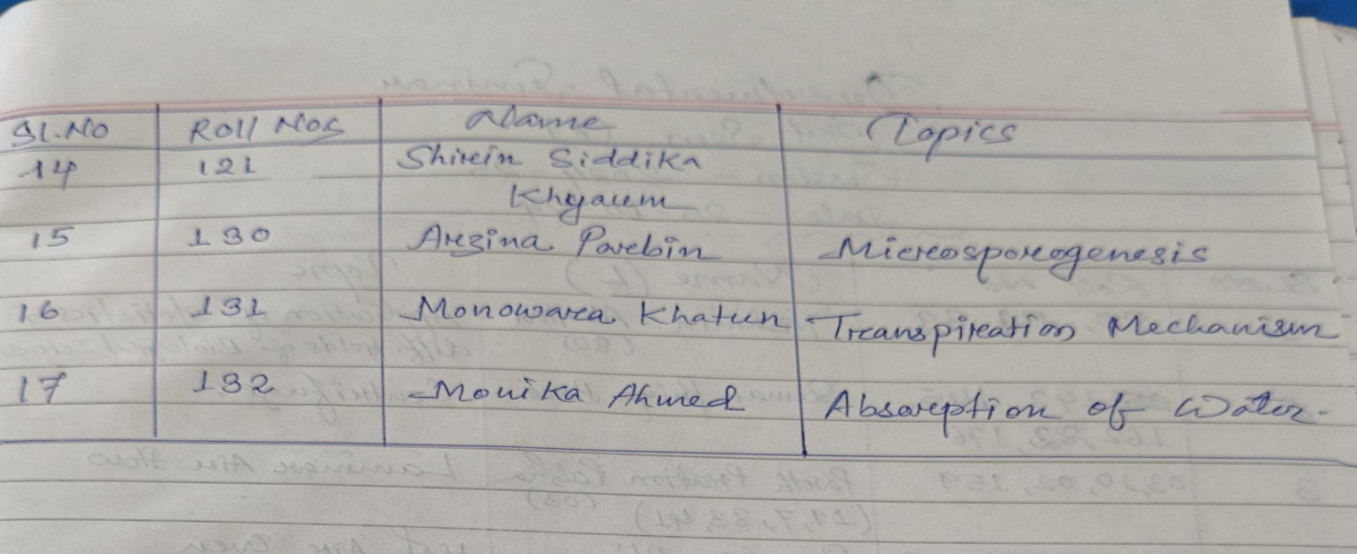
- FYUGP BSc 3rd Semester (Regular)

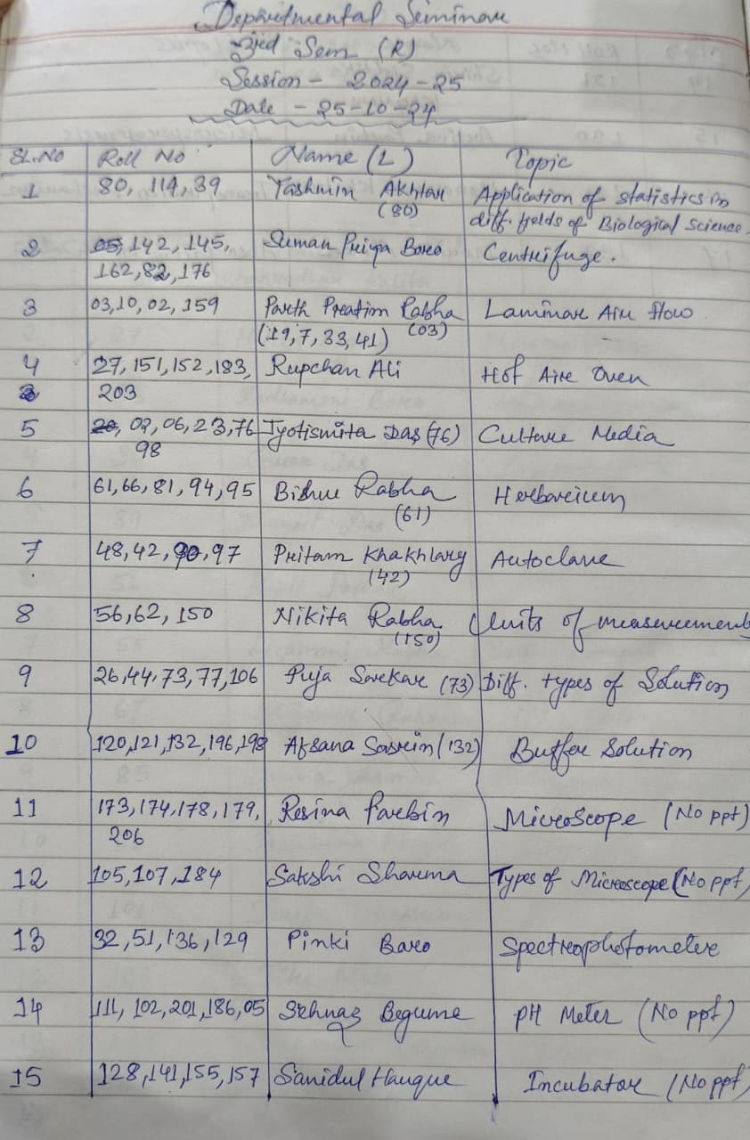
- FYUGP BSc 1st Semester (Regular)
