DEPARTMENT OF BOTANY
JAWAHARLAL NEHRU COLLEGE, BOKO
SESSION: 2024-2025

Pre-sessional examination/ sessional Examination marks display on notice board-

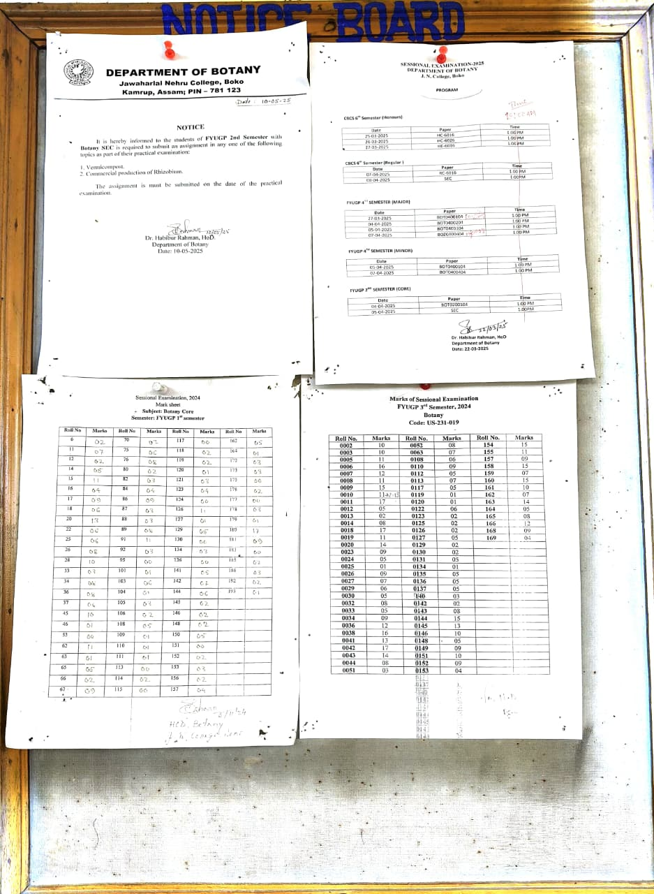

Photographs of conducting Pre-Sessional examinations by the Department of Botany during 2024-2025 session-
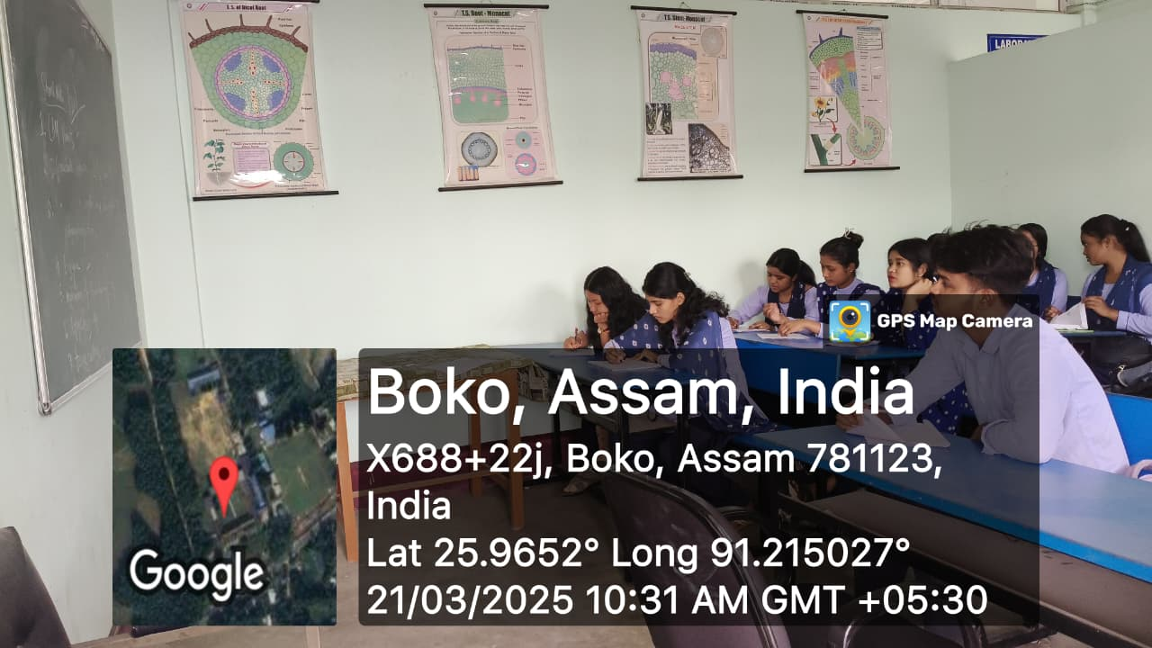
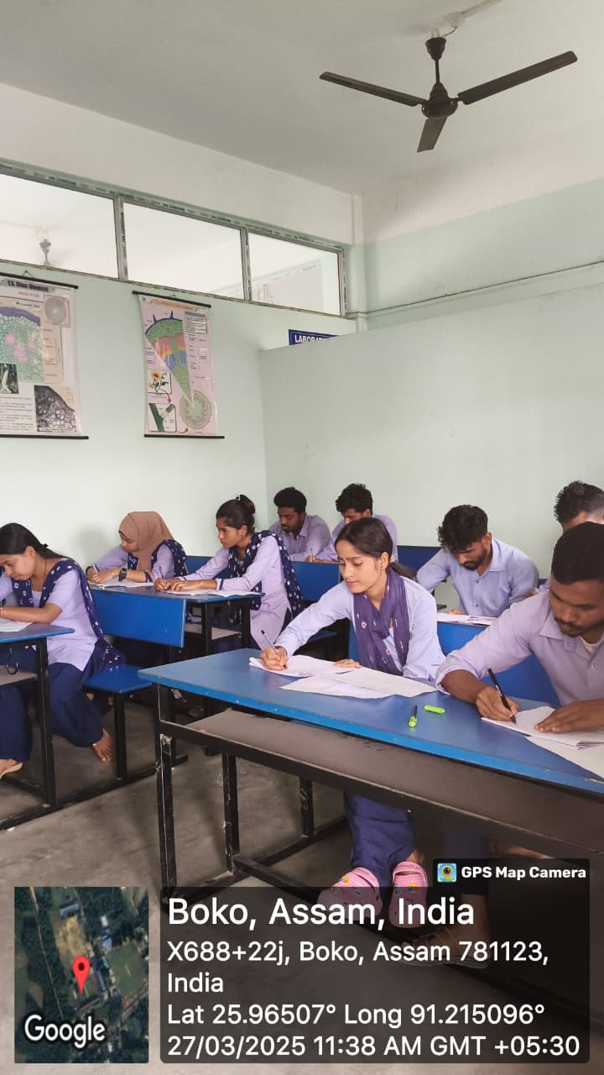

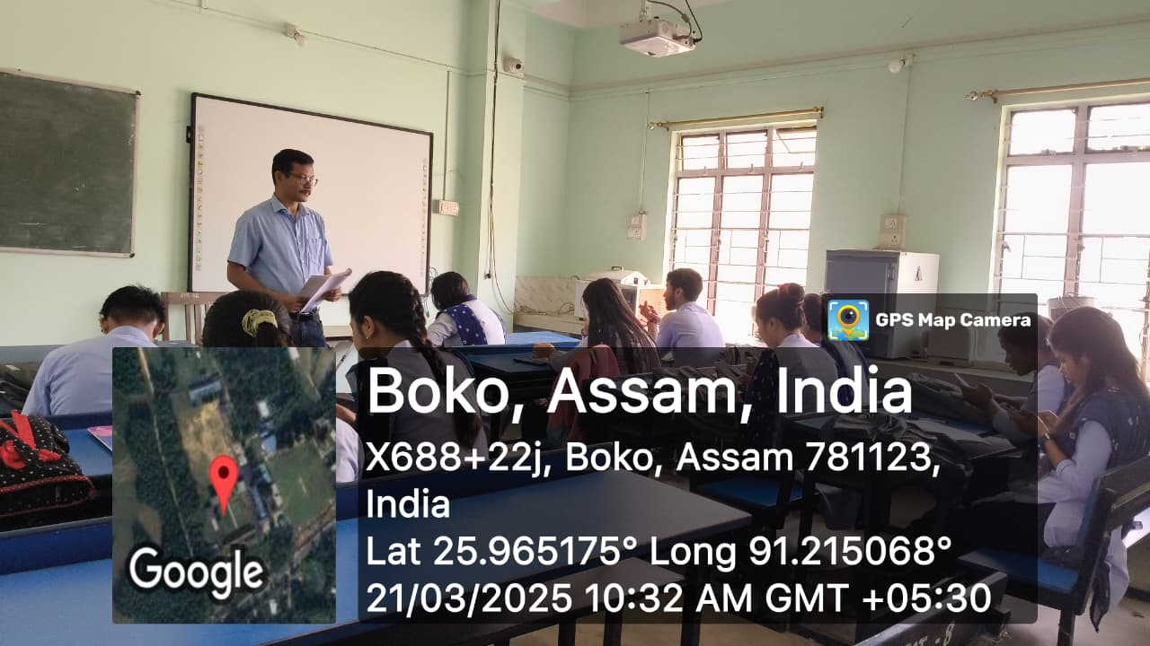
Photographs of conducting Sessional Examinations by the Department of Botany during
2024-2025 session-
