DEPARTMENT OF BOTANY
JAWAHARLAL NEHRU COLLEGE, BOKO
SESSION: 2024-2025

Report on the National-level Workshop on “Plant Identification and Nomenclature”

A national-level workshop entitled “Plant Identification and Nomenclature” was organized under the auspices of the Botanical Society of Assam (BSA) in collaboration with the Department of Botany, Jawaharlal Nehru College, Boko on 17th October, 2025. The programme also marked the release of the 2025 issue of the Journal “উদ্ভিদ বিজ্ঞান পত্ৰিকা” and the organization of the Biennial BSA–Scientist Award Ceremony, 2025.

The workshop was graced by several eminent academicians and scientists, including Prof. Partha Pratim Baruah, Working President of BSA; Prof. Nilakshee Devi, Secretary, BSA; Prof. Pradip Kumar Baruah; Prof. S. R. Patgiri; Mr. Bolin Bordoloi; and Dr. Tapan Dutta. The programme commenced with a welcome address by Dr. Habibur Rahman, Head of the Department of Botany, Jawaharlal Nehru College, who extended a warm welcome to all the dignitaries, resource persons, and participants. The workshop was formally inaugurated by Prof. Pradip Kumar Baruah. Prof. S. R. Patgiri released the 2025 issue of the Journal “উদ্ভিদ বিজ্ঞান পত্ৰিকা” and delivered an insightful address highlighting its academic significance.

The Biennial BSA–Scientist Award Ceremony, 2025 was an important component of the programme, during which four distinguished scientists were honoured for their outstanding contributions to botanical research. The Dr. Lily Mazinder Baruah Memorial Scientist Award, 2022 and the Dr. Lily Mazinder Baruah Memorial Scientist Award, 2024 were conferred upon Dr. Namita Nath, Associate Professor, Gauhati University, and Dr. Rajib Gogoi, Head of Office, BSI Sikkim, respectively. The Dr. Ananta Borah Memorial Young Scientist Award, 2022 and 2024 were awarded to Dr. Sanjib Baruah, Assistant Professor, Bodoland University, and Dr. Niraj Agarwala, Assistant Professor, Gauhati University, respectively. The award ceremony was conducted by Prof. Nilakshee Devi and Dr. Dipak Kunwar.

As part of the technical sessions-I of the workshop, Dr. Rajib Gogoi, serving as a resource person, delivered a comprehensive lecture on his research work and professional experiences. He discussed various aspects of plant identification and nomenclature and shared information on newly discovered plant species from Assam and other parts of the world. He emphasized the importance of documenting indigenous and wild plant species and encouraged students to engage in field-based botanical research.

In the technical session -II, Dr. Namita Nath addressed the participants in a clear and accessible manner, explaining the principles and methodologies of Plant Identification and Nomenclature. She introduced the newly discovered plant species _Torenia goalparensis_ and elaborated on the relevance of traditional knowledge and ethnobotanical studies in contemporary botanical research.

Dr. Niraj Agarwala and Dr. Sanjib Baruah also presented their ongoing research activities and discussed various research avenues and future opportunities available to students in the field of plant sciences. Their sessions provided valuable guidance to aspiring researchers.

The workshop witnessed active participation from researchers of Gauhati University and Bodoland University. More than one hundred students from Jawaharlal Nehru College and Dakshin Kamrup College attended the programme, making the event academically enriching and interactive.

The programme concluded with a vote of thanks by the Principal of Jawaharlal Nehru College, Dr. Tapan Dutta, who expressed his sincere gratitude to all the dignitaries, resource persons, members of the Botanical Society of Assam, faculty members, and students for their support and cooperation. He formally declared the successful completion of the national-level workshop.

Photo-Data
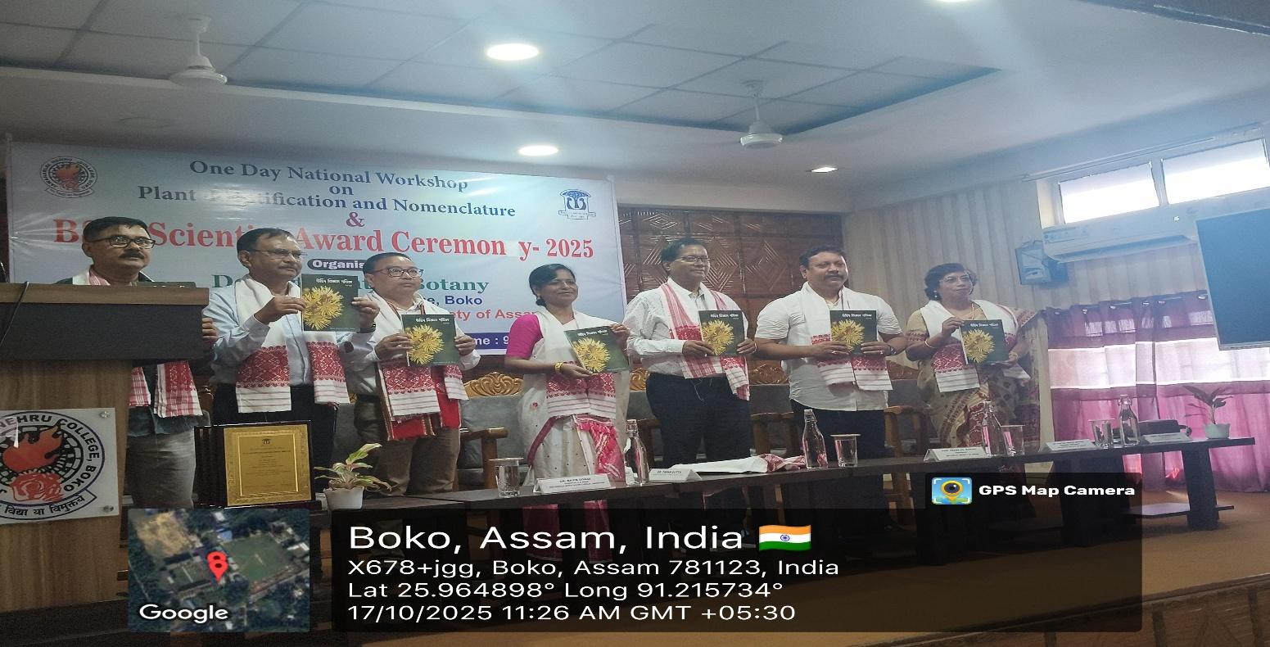
*Inauguration of the 2025 issue of the Journal “উদ্ভিদ বিজ্ঞান পত্ৰিকা”
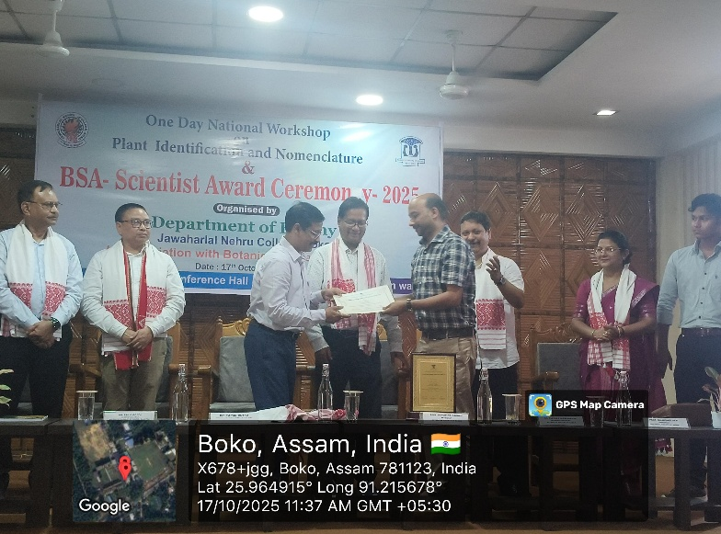
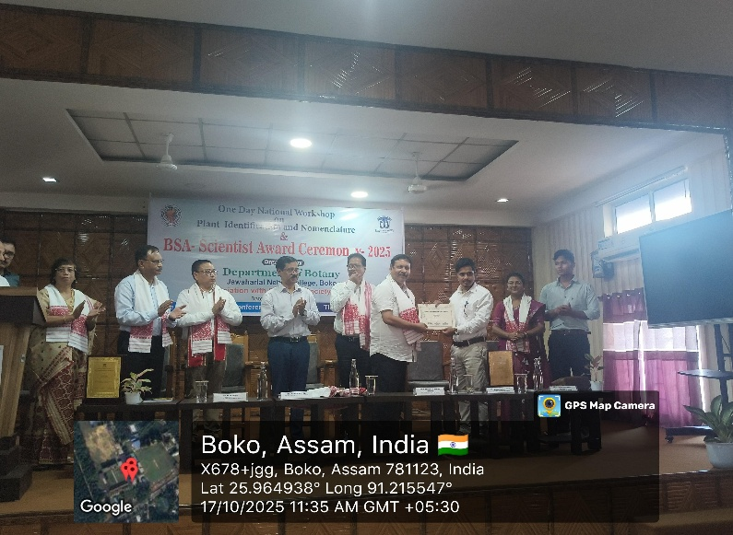

*The Dr. Ananta Borah Memorial Young Scientist Award, 2022 and 2024 were awarded to Dr. Sanjib Baruah, Assistant Professor, Bodoland University, and Dr. Niraj Agarwala, Assistant Professor, Gauhati University, respectively
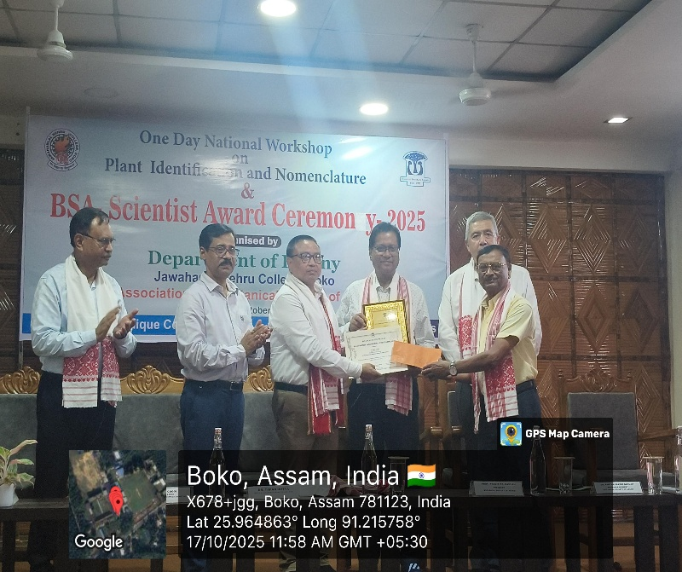
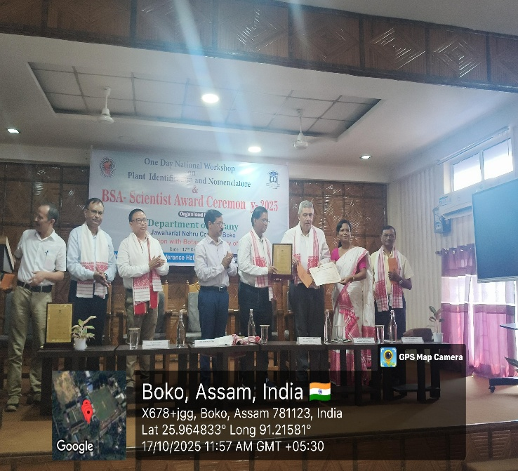
*The Dr. Lily Mazinder Baruah Memorial Scientist Award, 2022 and the Dr. Lily Mazinder Baruah Memorial Scientist Award, 2024 were conferred upon Dr. Namita Nath, Associate Professor, Gauhati University, and Dr. Rajib Gogoi, Head of Office, BSI Sikkim, respectively.

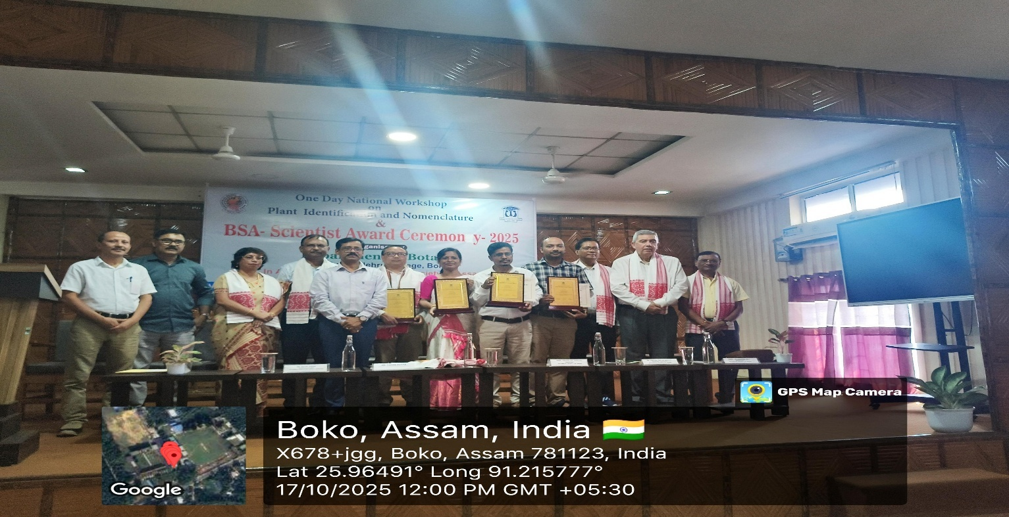

Technical Session -I
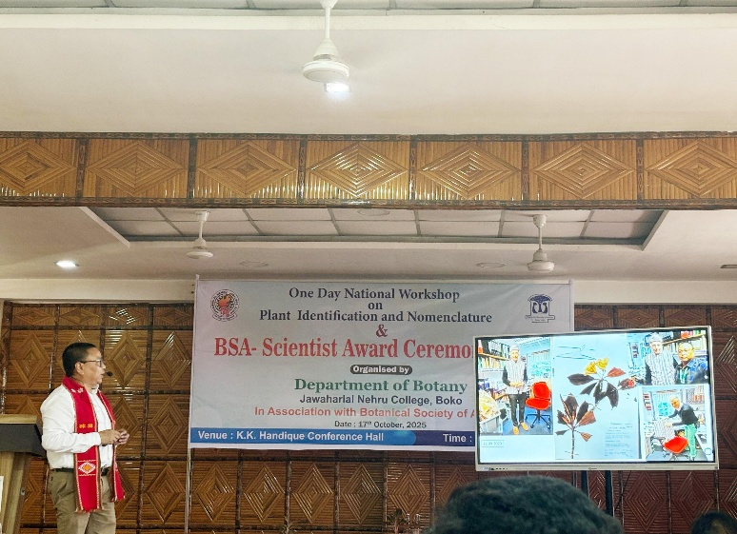
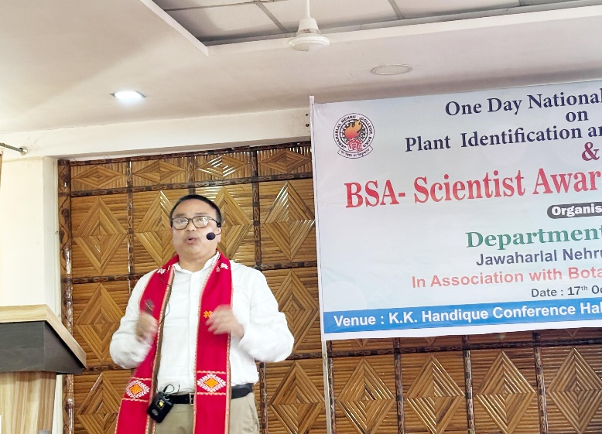
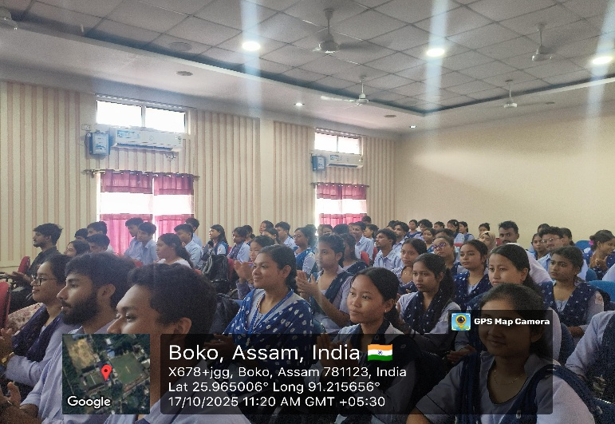
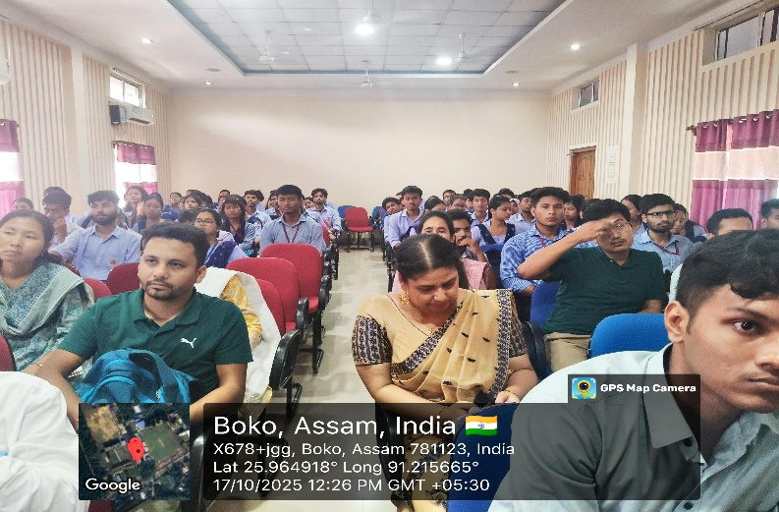
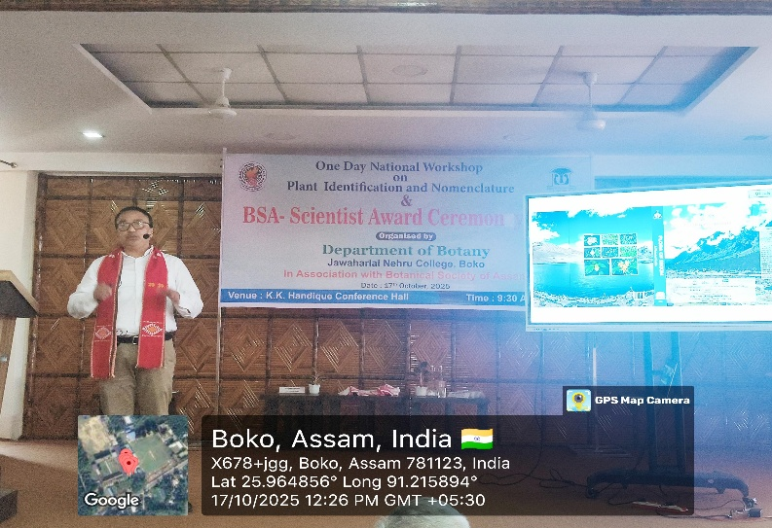
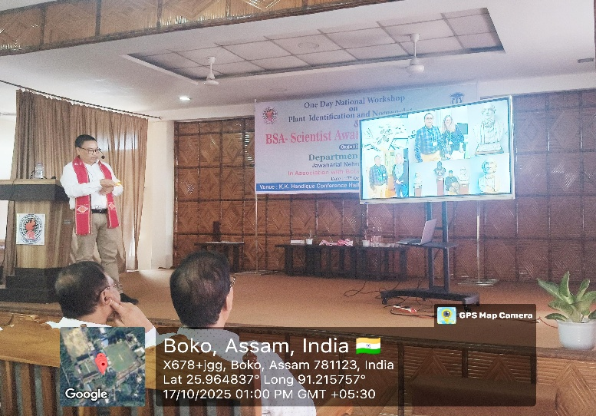

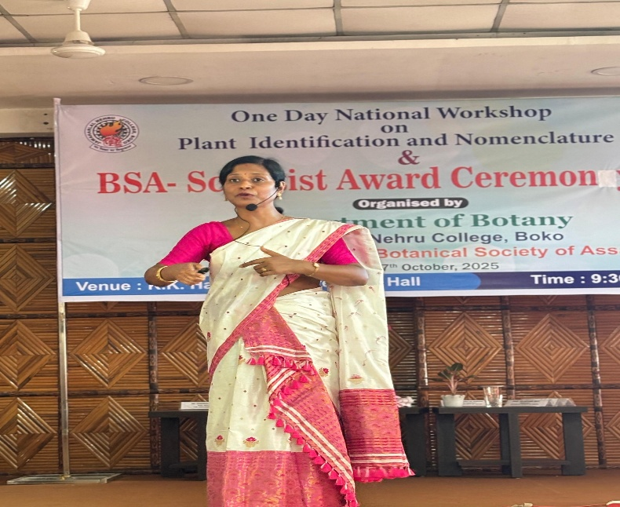
Technical Session -II
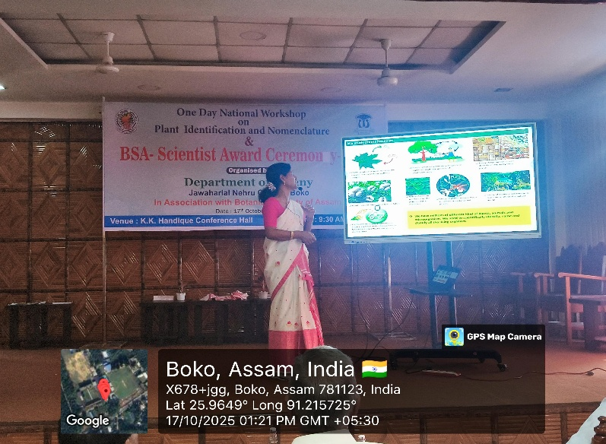
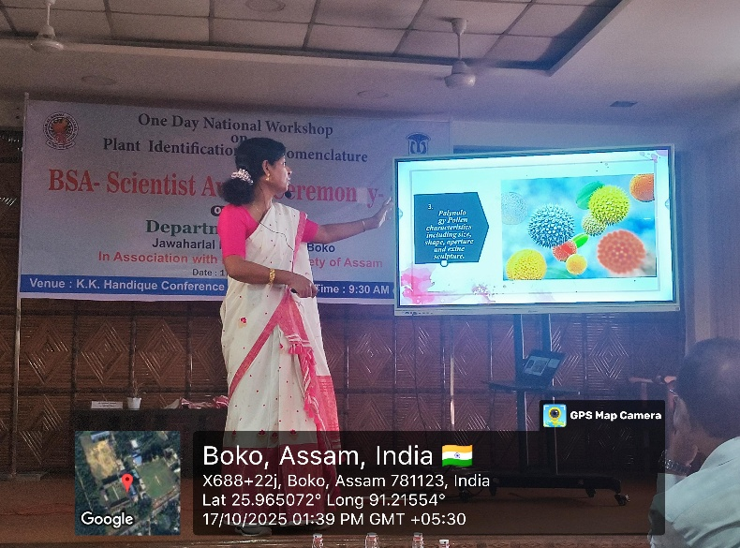
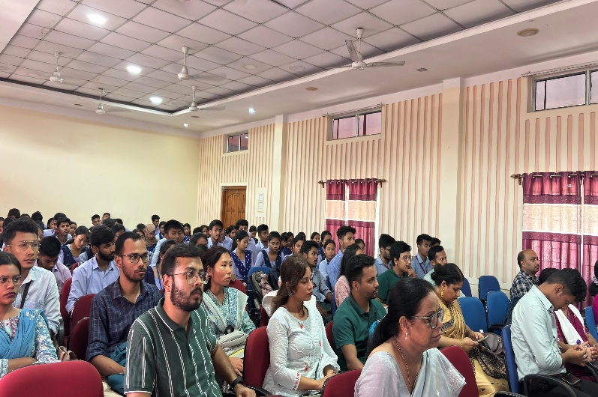
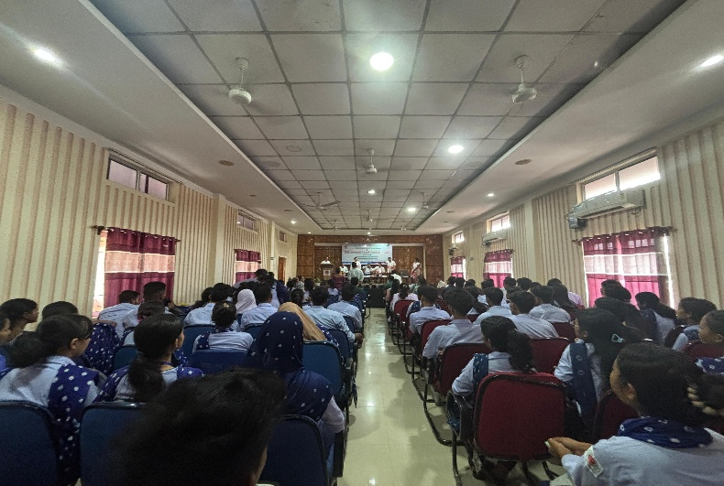
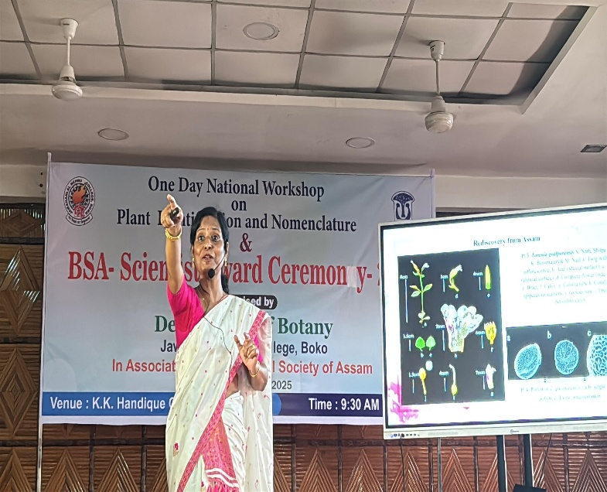

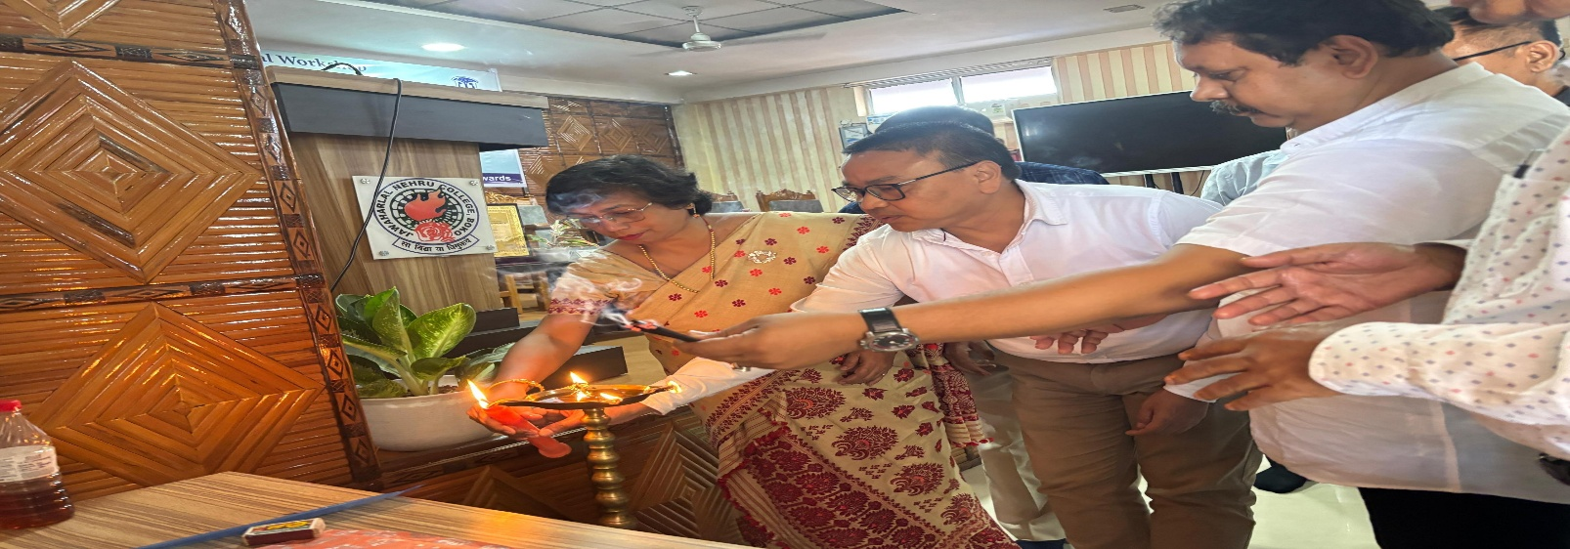
Others
