Field Trip to Majuli, Assam 30-10-2025 to 01-11-2025
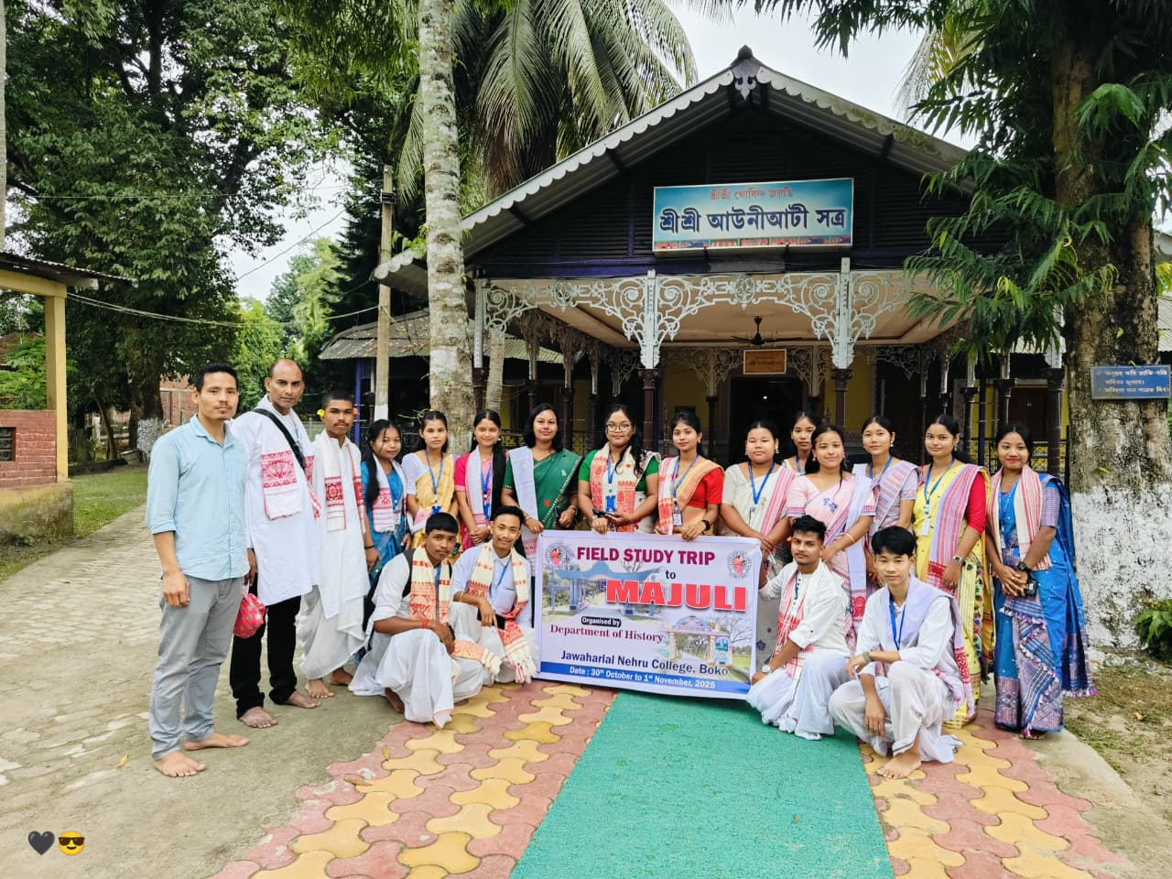

Objective:
- To study about the daily monastic lufe, preservation of the ancient texts and historical evolution of the Satriya culture of Majuli.
- To Document and analyse the Mukha Silpa (Musk Culture) of Samoguri Satra and life of Padmashree Hemachandra Goswami.

Results:
- The students came to know about the life of Satradhikaras (Head of the Satra) and how they play an important role in preserving the Satriya Culture.
- Students also acquired knowledge about the Mukha Silpa which used primarily in Ankiya Bhaona also as an decorative item.

Attendees:
5th Semester:
1.Himashree Kalita
2.Sunita Rabha
3.Mrityunjoy Sanyal
4.Nabajyoti Kalita
5.Anupam Das
6.Shikha Choudhary
7.Lanu Babha Thakuriya
8.Mrinmoi Mushahari
9.Pranay Kalita
3rd Semester:
1.Bijumoni Rabha
2.Pratima Rabha
3.Binita Basumatari
4.Praban Rabha
1st Semester:
1.Himashree Deka
2.Mandip Hajong
3.Pranjal Das
4.Manashjyti Boro
5.Jimi Begum
6.Jyotishma Boro
7.Konika Rabha
8.Bhaktima Basumatari
9.Bichitrajit Boro

