Competitive Exam Guidance Program 28-03-2026
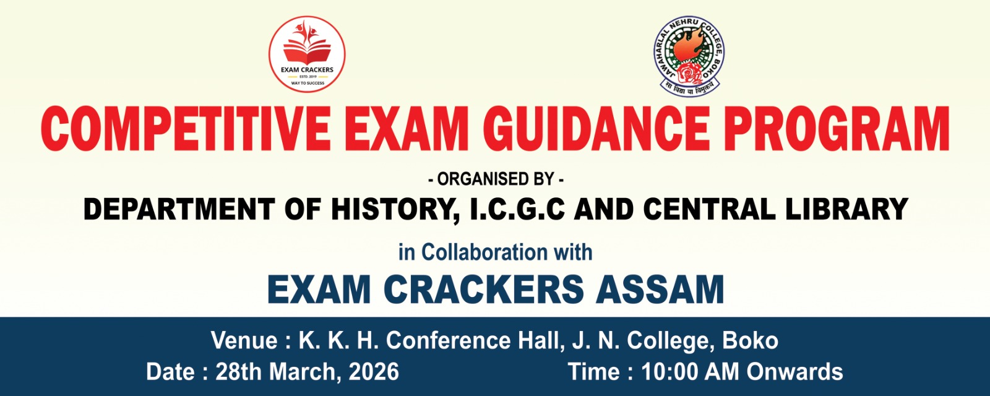

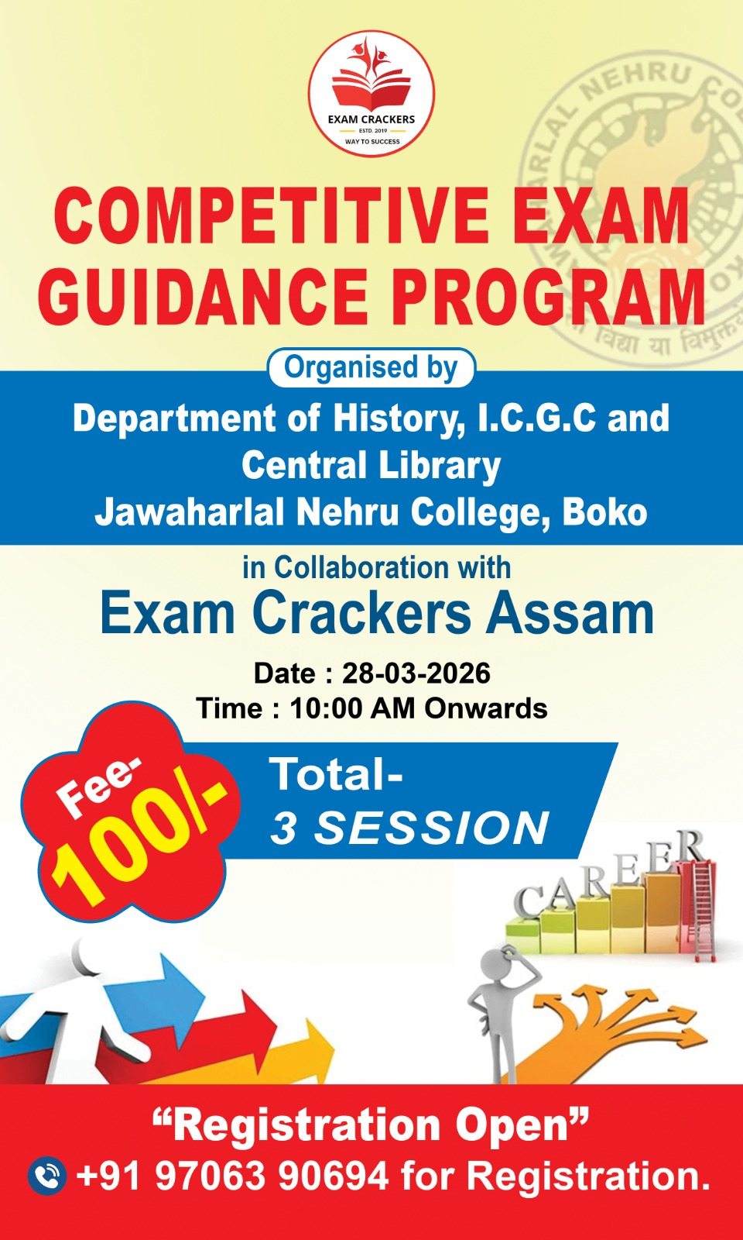
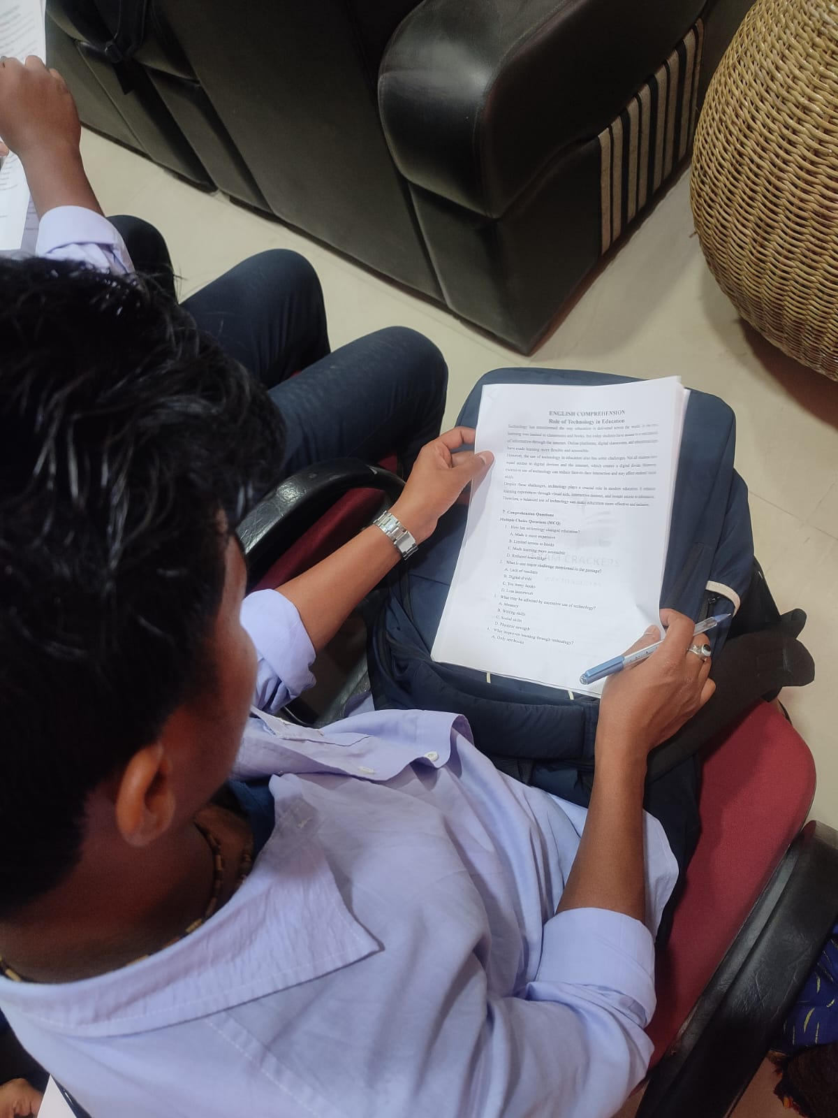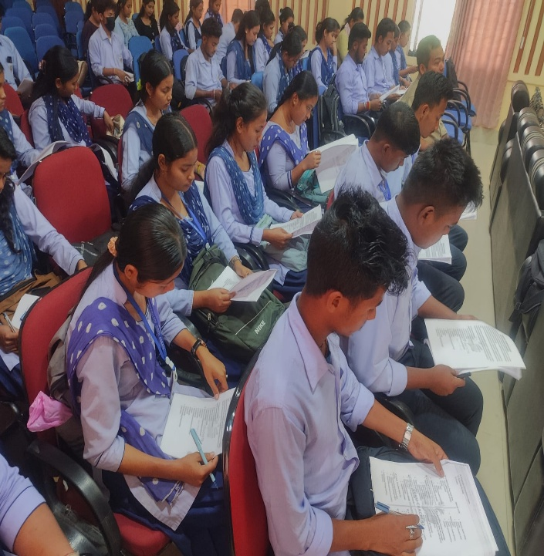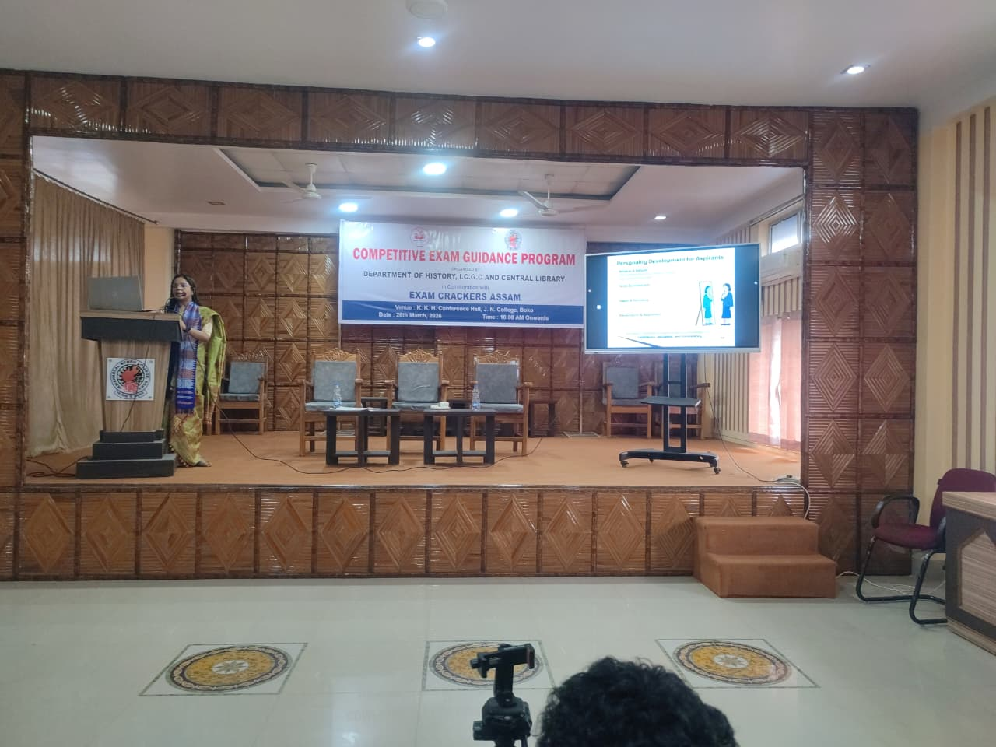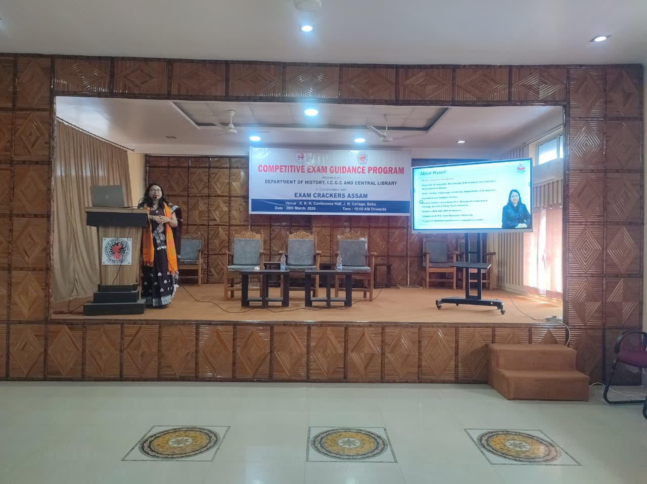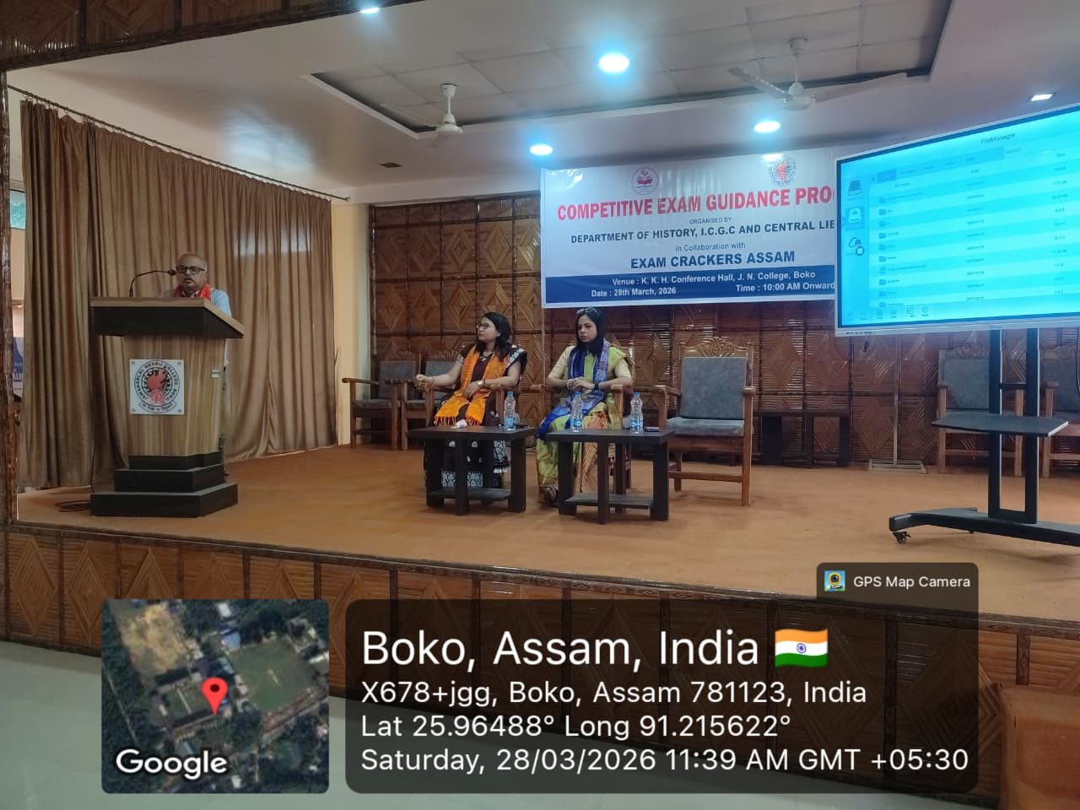

Objectives:
- To provide structured support, strategic preparation plans, and mentorship for aspirants aiming for government jobs, engineering/medical entrances, or banking and academic tests.
- To build essential skills such as time management, logical reasoning, and conceptual clarity.

Results:
- The Program enhanced exam preparation strategies and improved confidence and stress management.
- The program replaced confusion with clarity, allowing participants to focus on their goals and perform better under pressure.

