Field Trip to Shillong, Meghalaya 11-05-2026

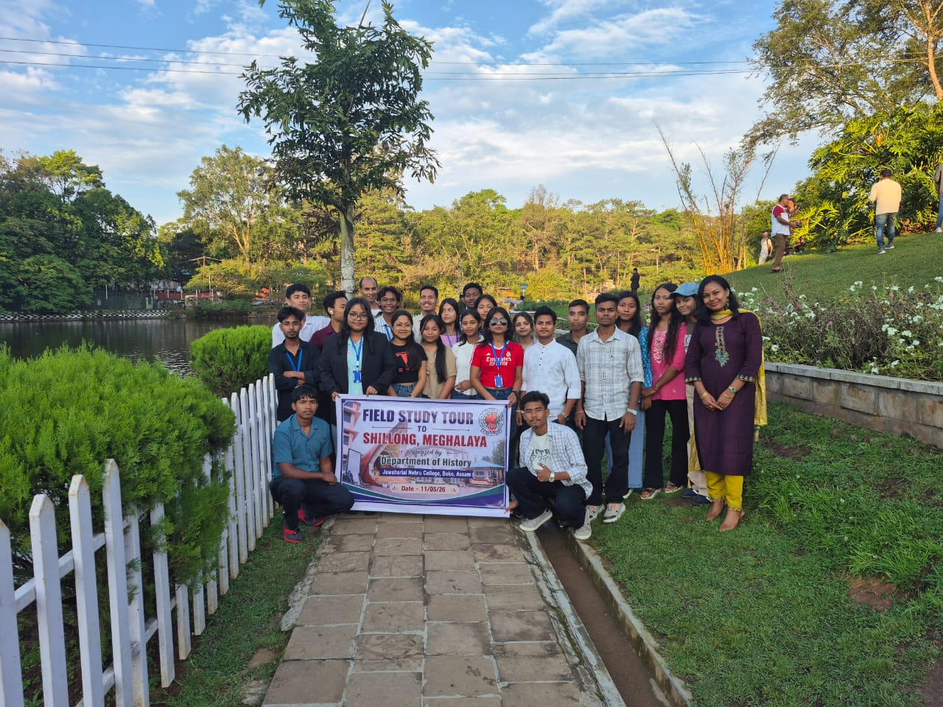
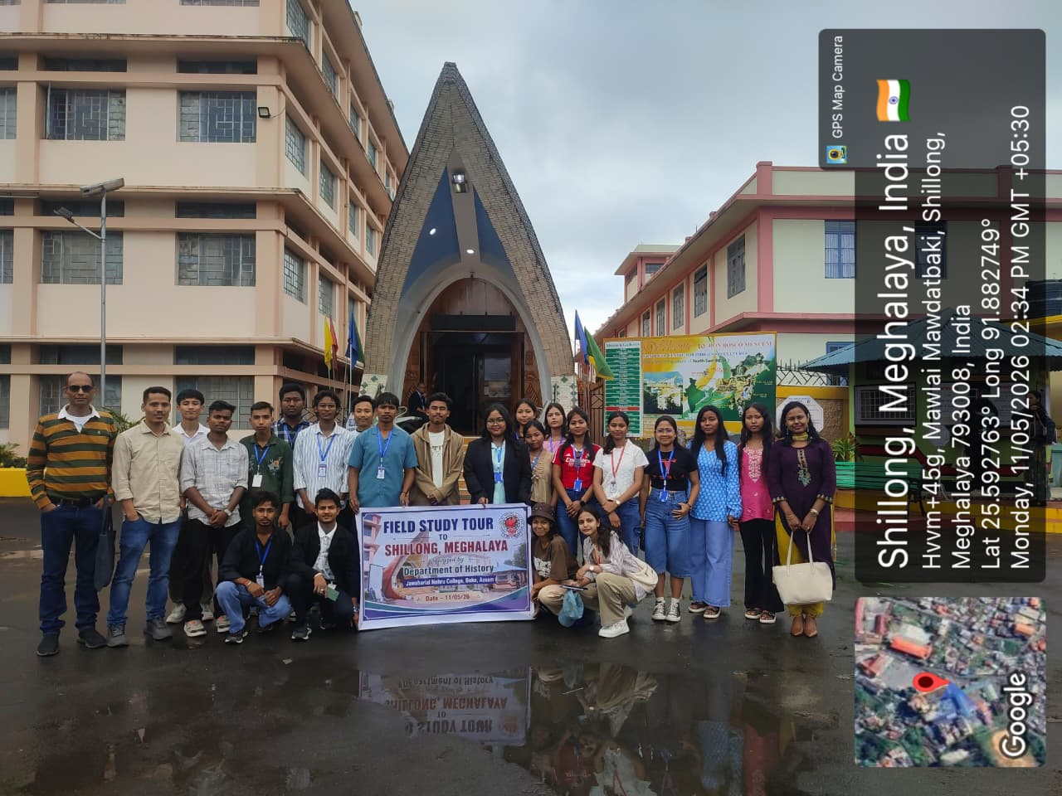
Objectives:
- To understand how the Indigenous tribes of North East India Traditionally sustained themselves through agriculture, handlooms and trade and how these practices shaped the region’s historical development.
- Observe the layout and historical significance of Ward’s Lake to evaluate its role its role as a recreational hub, and understand how British Colonial Urban Planning.
Results:
- Students will gain a firsthand understanding of the role played by the museums in documenting and preserving changing cultures and traditions across the Seven Sister States through the museum's extensive collection of 21 galleries.
- Students will develop the ability to distinguish between indigenous heritage (represented at the Don Bosco Museum) and colonial legacy (symbolized by Ward's Lake), fostering a holistic view of the layers of history that form modern-day Meghalaya.

List of Students attending Field Trip to Shilling Meghalaya on 11-05-2026
FYUGP 2nd Semester
1.Himashree Deka
2.Bhagyashree Rabha
3.Karabi Rabha
4.Rumi Kalita
5.Raja Roy
6.Mandeep Hajong
7.Rahul Das
8.Pranjal Das
9.Nabajyoti Sarkar
FYUGP 4th Semester
10.Tabushree Pathak
11.Shreya Bhadra
12.Ankita Das
13.Rupali Mandal
14.Ebhasmita Boro
15.Nilkamal Rabha
16.Protima Rabha
17. Bidisha Kalita
FYUGP 6th Semester
18.Mrityunjay Sanyal
19.Anupam Das
20.Lanubhaba Thakuriya
21.Johidul Ali
