Session Report, 2021-2022
Enrolment List-
- Grikma N Sangma-ST
- Deepanjali Rabha-ST
- Supriya Rabha-ST
- Sangita Boro-ST
- Amina Khatun-GENERAL

Slow Learner/ Advance Learner Test, 2021
Marks: 10
Questions:
- What is Source? 2
- What is your understanding on History? 2
- History can be categorised into how many parts? 1
- What is the difference between Century and decade? 2
- Name two Historians o Ancient Time. 2
- History, the word came from which language and word? 1
Results-
category | Roll No | Marks
Advance Learner | 30  143 | 6  7
Slow Learner | 377  83  256 | 3  3  2

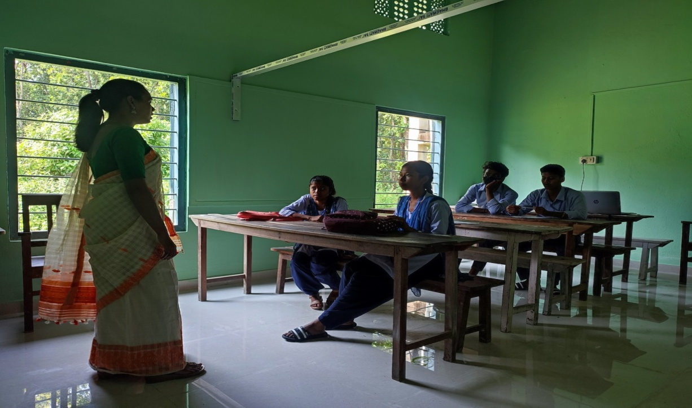
MENTORING

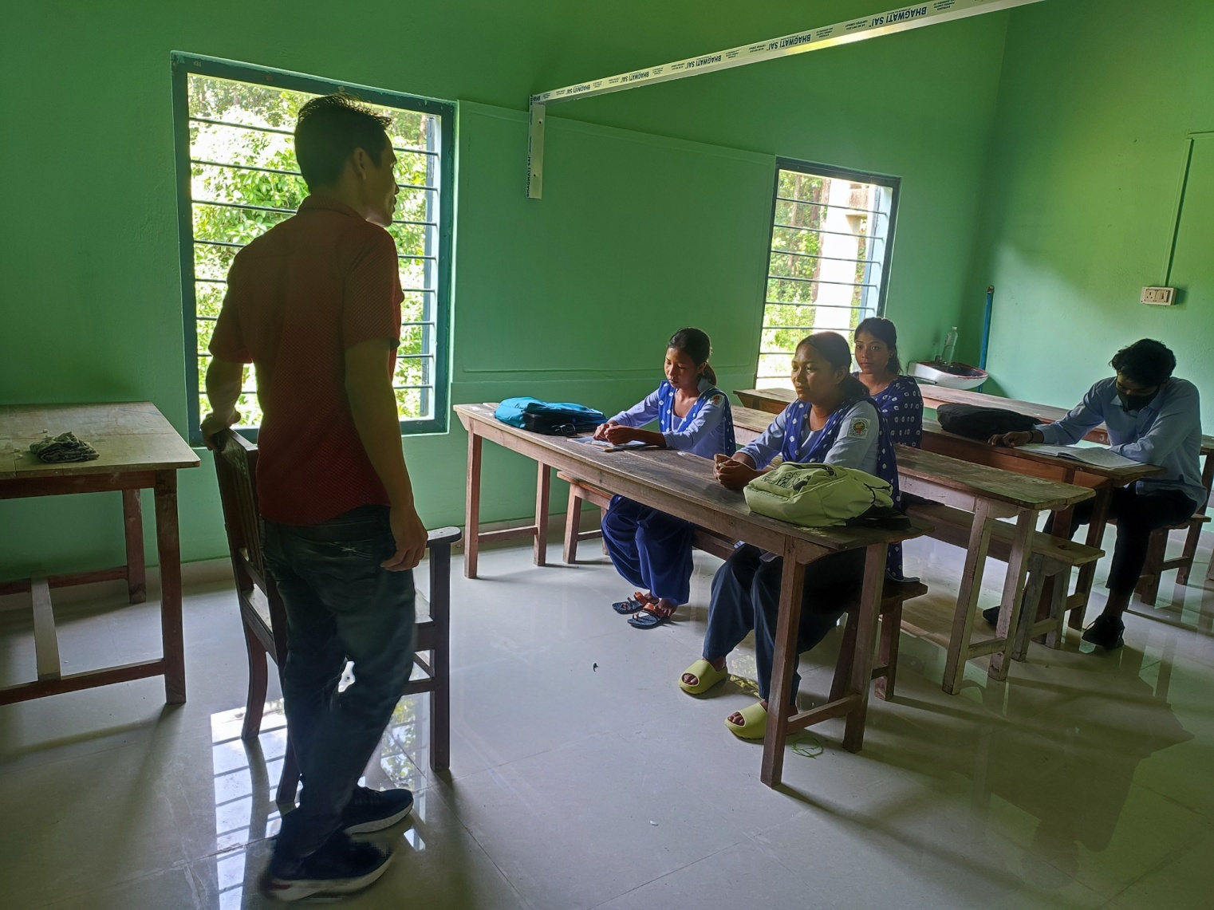
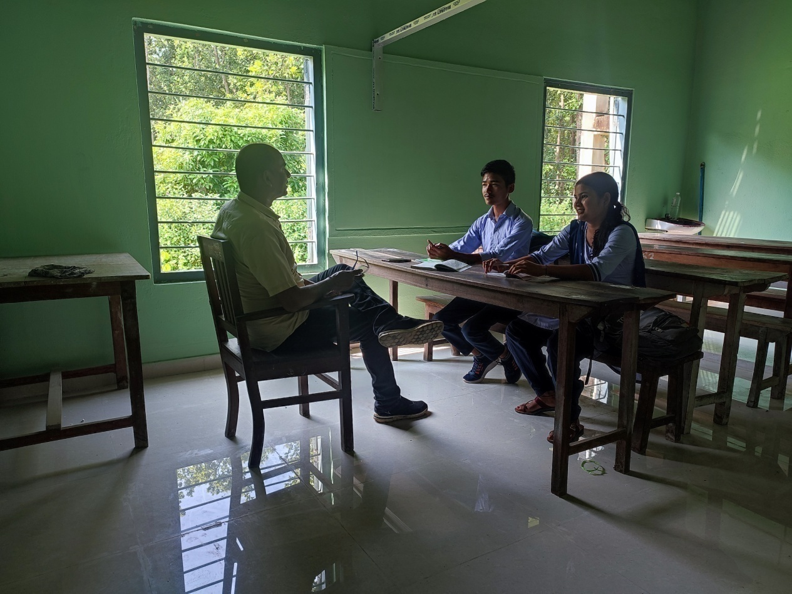
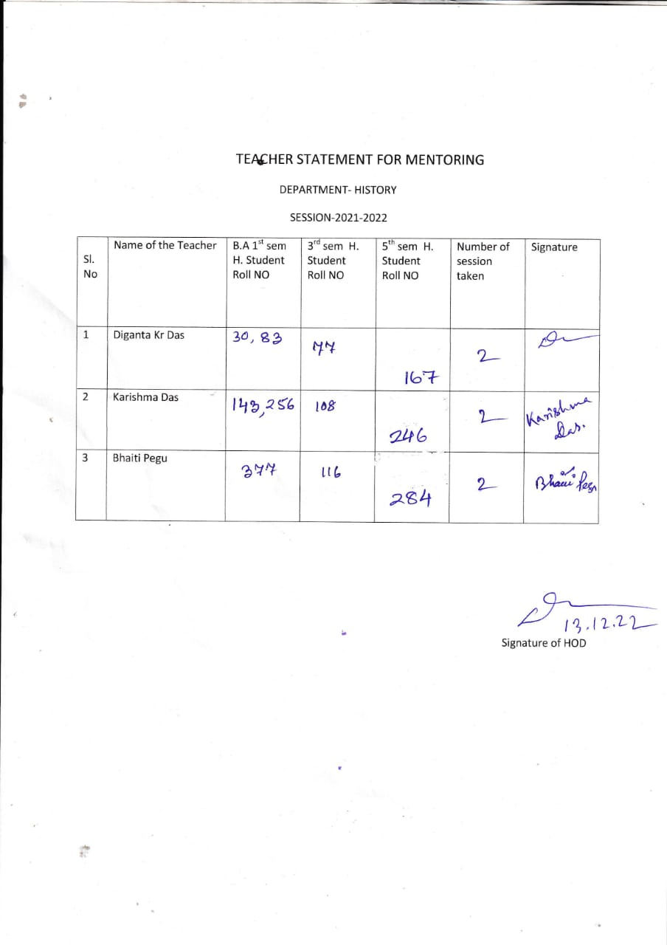

DEPARTMENT OF HISTORY
JAWAHARLAL NEHRU COLLEGE, BOKO
CLASS ROUTINE
SESSION -2021-22

Day/ Time | 09.00-10.00 | 10.00-11.00 | 11.00-12.00 | 12.00-01.00 | 01.00-02.00 | 02.00-03.00 | 03.00-04.00
Mon | HS-II-N-10-KD | SEM-V-(H)-DEPT-KD | SEM-V-(H)-DEPT-DKD | SEM-III-(H)-N-12-BP | SEM-I-(R)-N-7-KD | SEM-I-(H)-N-12-BP | SEM-III-(H)-N-12-DKD
Mon | SEM-I-(H)-N-12-DKD | SEM-V-(H)-DEPT-KD | SEM-V-(H)-DEPT-DKD | SEM-III-(H)-N-12-BP | SEM-V-(H)-DEPT-BP | SEM-I-(H)-N-12-BP | SEM-III-(H)-N-12-DKD
Tue | SEM-I-(H)-N-12-KD | SEM-V-(H)-DEPT-DKD | SEM-V-(H)-DEPT-BP | SEM-III-(H)-N-12-KD | SEM-I-(R)-N-7-BP | HS-I-N-3-DKD | SEC N-12 KD
 |  |  |  | SEM-V-(R)-DEPT-DKD | SEM-V-(H)-DEPT-KD | SEM-III-(H)-N-12-KD | SEC N-12 KD
Wed | SEM-III-(H)-N-12-KD | SEM-III-(R)-N-12-DKD | SEM-V-(H)-DEPT-BP | SEM-III-(H)-N-12-DKD | HS-I-N-6-BP | SEM-I-(H)-N-12-BP | HS-II-N-3-BP
 |  |  |  |  | SEM-V-(H)-DEPT-DKD | SEM-I-(H)-N-12-BP | SEM-I-(R)-N-1-DKD
Wed | SEM-III-(H)-N-12-KD | SEM-V-(H)-DEPT-KD | SEM-V-(H)-DEPT-BP | SEM-V-(R)-DEPT-KD | SEM-V-(H)-DEPT-DKD | SEM-I-(H)-N-12-BP | SEM-I-(R)-N-1-DKD
Thu | SEM-III-(H)-N-12-DKD | HS-II-N-7-KD | SEM-V-(H)-DEPT-KD | SEM-III-(R)-N-20-BP | SEM-III-(H)-N-12-KD | SEM-V-(H)-DEPT-BP
Thu | SEM-III-(H)-N-12-DKD | SEM-I-(H)-N-12-DKD
 |  |  |  | SEM-V-(H)-DEPT-DKD | SEM-III-(H)-N-12-KD | SEM-V-(H)-DEPT-BP
Fri | SEM-I-(H)-N-12-DKD | SEM-V-(H)-DEPT-KD | SEM-V-(H)-DEPT-DKD | SEM-III-(H)-N-12-BP | SEM-V-(H)-DEPT-BP | HS-I-N-8-BP | HS-II-N-7-DKD
 |  |  |  |  |  | SEC-SEM-III-KD N-12-DKD | HS-II-N-7-DKD
 |  |  |  |  |  | SEM-V-(R)-DEPT-KD | SEM-III-(R)-N-12-KD
Sat | SEM-III-(H)-N-12-KD | SEM-V-(H)-DEPT-DKD | SEM-V-(H)-DEPT-KD | SEM-III-(H)-N-12-BP | SEM-V-(H)-DEPT-BP | HS-N-21-DKD | SEM-III-(R)-N-7-BP SEC DKD
 |  |  |  |  |  | SEM-I-(H)-N-10-KD | SEM-III-(R)-N-7-BP SEC DKD
 |  |  |  |  |  | SEM-V-(R)-N-12-BP | SEM-III-(R)-N-7-BP SEC DKD

HOD, HISTORY, J.N. COLLEGE, BOKO
(Diganta Kumar Das)

RESULT OF FINAL YEAR, 2022

SL NO | NAME | ROLL NO | RESULTS
1 | JULI BORO | 167 | BACK
2 | PRANJAL BORO | 246 | BACK
3 | HIRAMBIKA BORO | 284 | PASS (6.58-CGPA)

