Field Visit to Darjeeling: 27th September to 1st October-2024
The Department of Economics, Jawaharlal Nehru College, Boko, organized four days Field Trip with 5th Semester Economics Honours Students to Darjeeling from 27th September to 1st October 2024 under the supervision of following faculty members:
- Mrs. Deepanjali Das, Associate Professor, HOD, Deptt. Of Economics
- Miss. Ankita Das, Assistant Professor, Deptt. of Economics,
- Miss. Pinky Gope, Assistant Professor, Deptt. of Economics.
- Monalisa Nath, Assistant Professor, Deptt. of Political Science
Objective of Visit: The field trip aims to provide students with practical insights into the economic dynamics of Darjeeling. The trip is to bridge economic theory with real-world applications outside the classroom, offering a deeper understanding of regional economic issues, focusing on key areas such as:
Outcome of the Visit: The visit has fruitful outcomes that emphasize both on practical skills and theoretical knowledge highlighting students’ ability to analyze, evaluate, and propose solutions to real-world economic issues. The outcomes of the Trip are as follows:
Field visit being a part of interactive learning outside the classroom, it gives students a major exposure to real working environments of economic concepts along with a practical perspective of a theoretical concept relevant to their domain. In short, the visit gives the right perspective of what is disseminated in the four wall classroom learning.
Participants
Sl No | Name of Student | Gender |  | Sl. No | Name of Student | Gender
1 | Limi Nath | Female |  | 10 | Abantika Rabha | Female
2 | Momishmita Basumatary | Female |  | 11 | Ankita Paul | Female
3 | Moromi Panthoi | Female |  | 12 | Manisha Sharma | Female
4 | Risika Jain | Female |  | 13 | Tamina Momin | Female
5 | Denim Kalita | Female |  |  | - | -
6 | Kritika Rabha | Female |  |  | - | -
7 | Bipasha Rabha | Female |  |  | - | -
8 | Anusmita Baishya | Female |  |  | - | -
9 | Chegen Sangma | Male |  |  | - | -

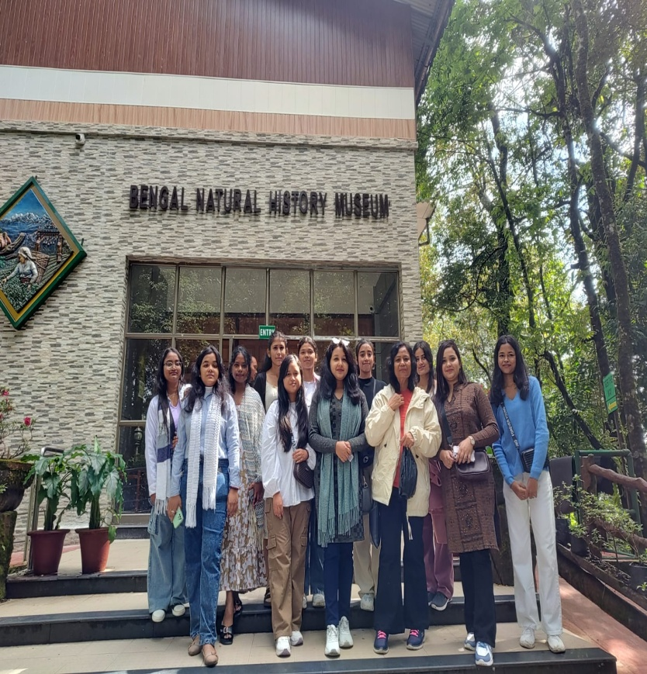
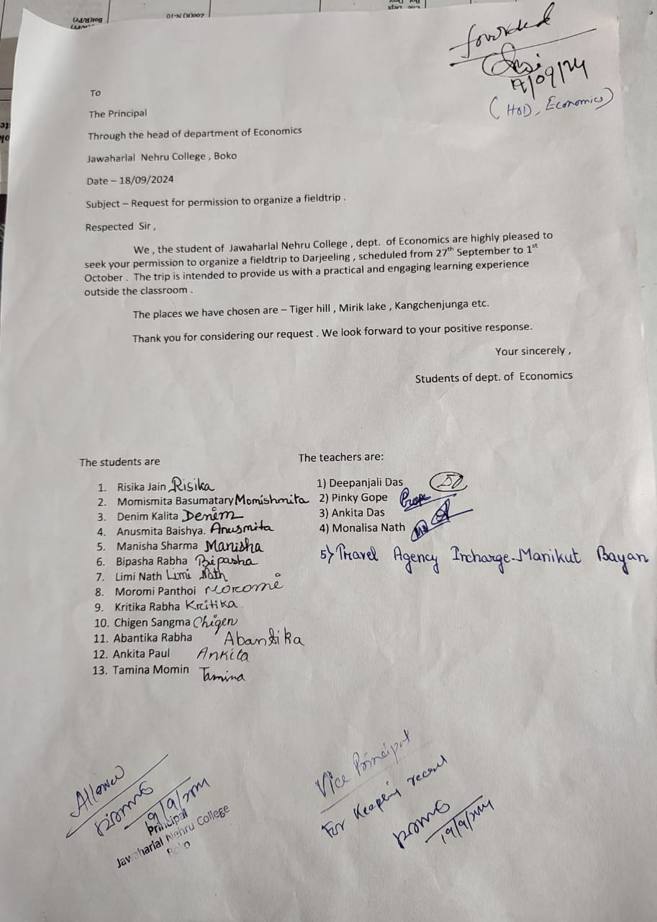
Photo Gallery

Student Seminar: 05-04-2025
Student Seminar for 6th Semester Economic Honours Students was organized by the Department of Economics on 5th April 2025 with Mrs. Deepanjali Das , Associate Professor as a chairperson of the seminar.
The topic of the Seminar is: International Environmental Problems

Objectives:
- Increase Awareness of global environmental issues like climate change, pollution, and biodiversity loss.
- Promote Critical Thinking by encouraging analysis and debate on environmental challenges.
- Highlight Multidisciplinary Approaches to solving environmental problems.
- Encourage Collaboration among students, experts, and organizations for shared learning.
- Inspire Action by motivating students to adopt sustainable practices and advocate for solutions.

Outcomes:
- Improved Understanding of global environmental problems and their interconnections.
- Stronger Analytical Skills through discussions and presentations.
- Practical Solutions for addressing environmental challenges.
- Broader Global Perspective on sustainability and its social, political, and economic dimensions.
- Motivation for Future Advocacy in environmental issues at local or global levels
The seminar has been an insightful discussions, thought-provoking ideas, and valuable exchanges of perspectives. Students have explored some of the most pressing environmental challenges facing the world today, from climate change and pollution to biodiversity loss and resource depletion. The seminar serves as a stepping stone toward continued learning and positive action on global environmental problems.
Participants
Sl No | Name of Student | Gender |  | Sl. No | Name of Student | Gender
1 | Bitopan Rabha | Male |  | 10 | Bhayolina Kalita | Female
2 | Momishmita Basumatary | Female |  | 11 | Ashique Ahmed | Female
3 | Parismita Boro | Female |  | 12 | Manisha Sharma | Female
4 | Risika Jain | Female |  | 13 | Labhita Choudhury | Female
5 | Denim Kalita | Female |  | 14 | Haynasri Boro | Female
6 | Niku Rabha | Male |  | 15 | Bhushan Rajbangshi | Male
7 | Bipasha Rabha | Female |  | 16 | Resham Gurung | Male
8 | Anusmita Baishya | Female |  | 17 | - | -
9 | Nisharani Boro | Female |  | 18 | - | -

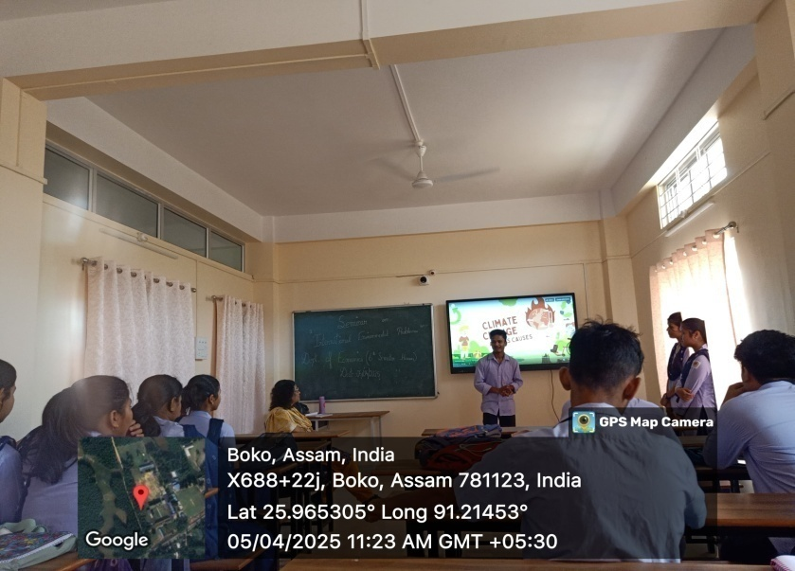
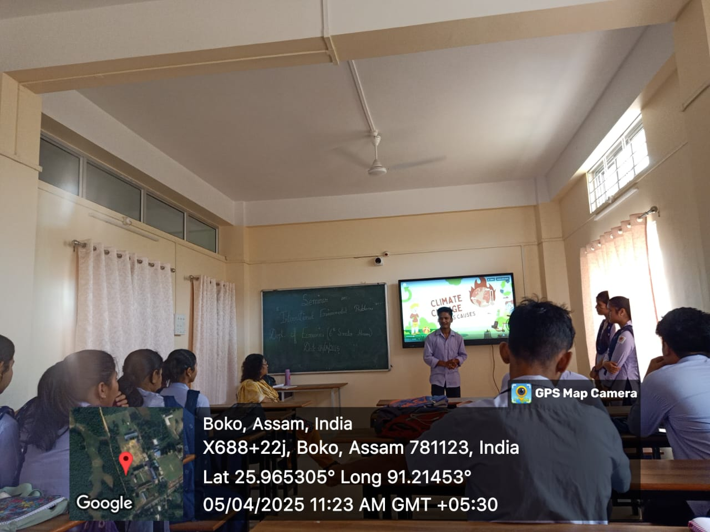
Seminar Photo Gallery

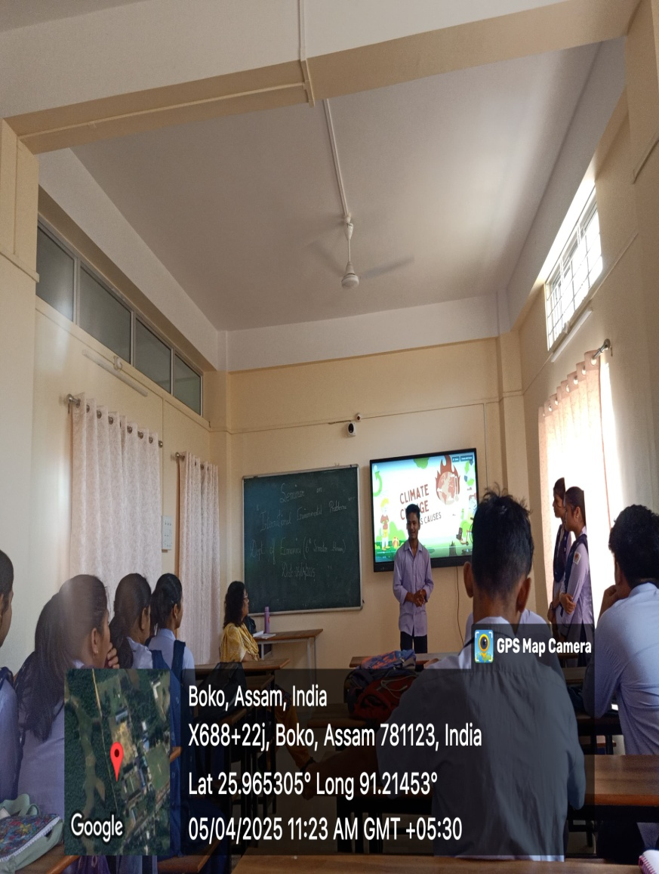

PREPARATORY CLASS FOR ITEP ENTRANCE TEST-2025
Date: 10th April 2025
Resource Person: Mr. Bau Nriame Kuizebe
Subject: Economics
A preparatory class for the ITEP Entrance Test 2025 in Economics was conducted on April 10, 2025, led by Mr. Bau Nriame Kuizebe, Assistant Professor, Department of Economics. The session aimed to prepare students for the Economics section of the entrance test by covering key economic concepts and exam strategies.

Key Topics Covered:
- Basic Economic Principles: Scarcity, opportunity cost, and government roles.
- Microeconomics: Supply and demand, elasticity, and consumer behavior.
- Macroeconomics: GDP, inflation, unemployment, and fiscal policies.
- Economic Policies: Monetary policies, international trade, and central banking.

Teaching Methodology: The Resources person used a combination of the following methods of teaching to engage students and help them understand the material effectively.
- Lectures
- Practice questions,
- Question & Answer session

Outcome:
- The preparatory class was successful in equipping students with the knowledge and strategies needed to perform well in the ITEP Entrance Test, enhancing their confidence and readiness for the exam.
- Students found the session insightful, particularly appreciating the clarity of explanations,

interactive approach, and practice exercises that helped them prepare for the exam format.
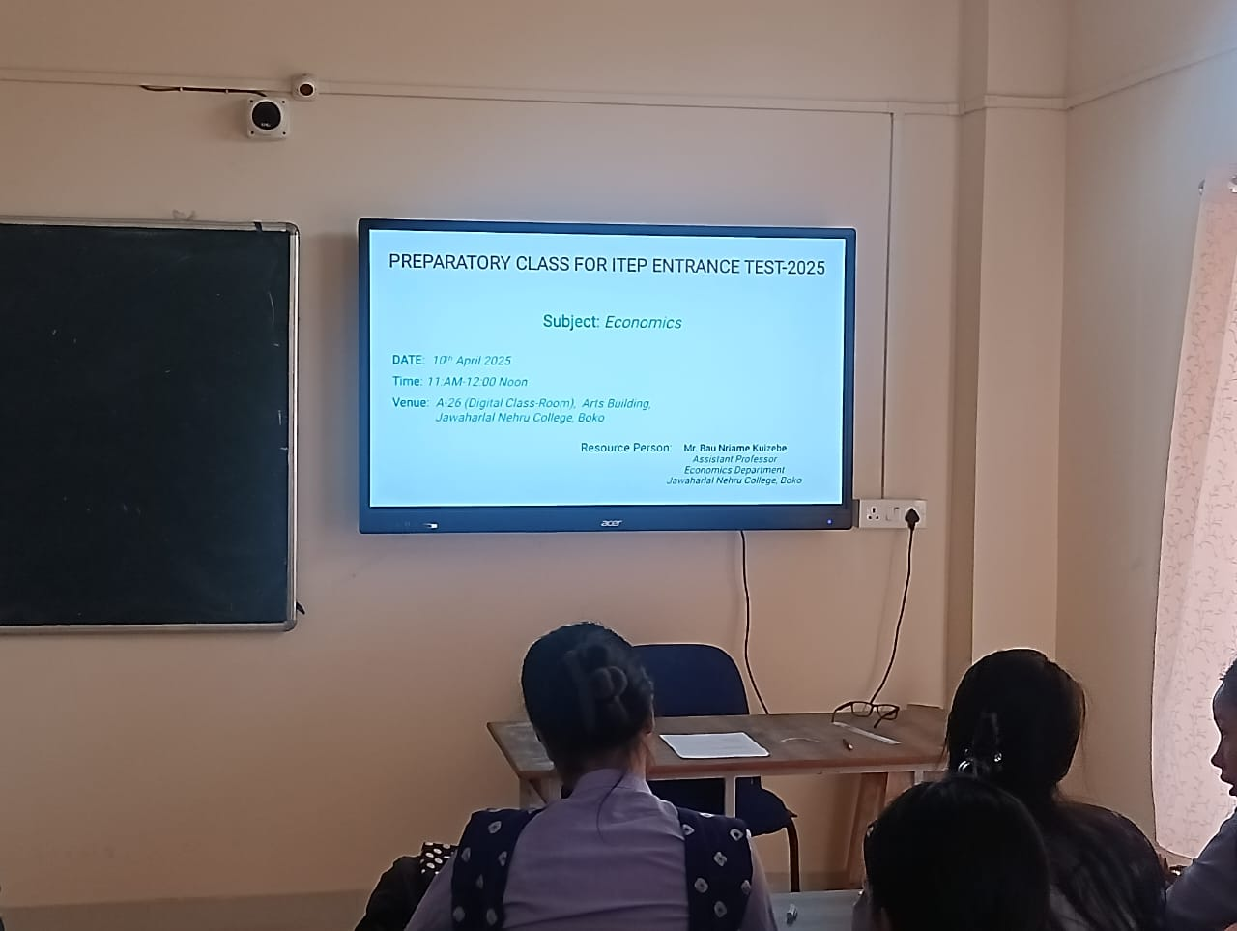
Photo Gallery

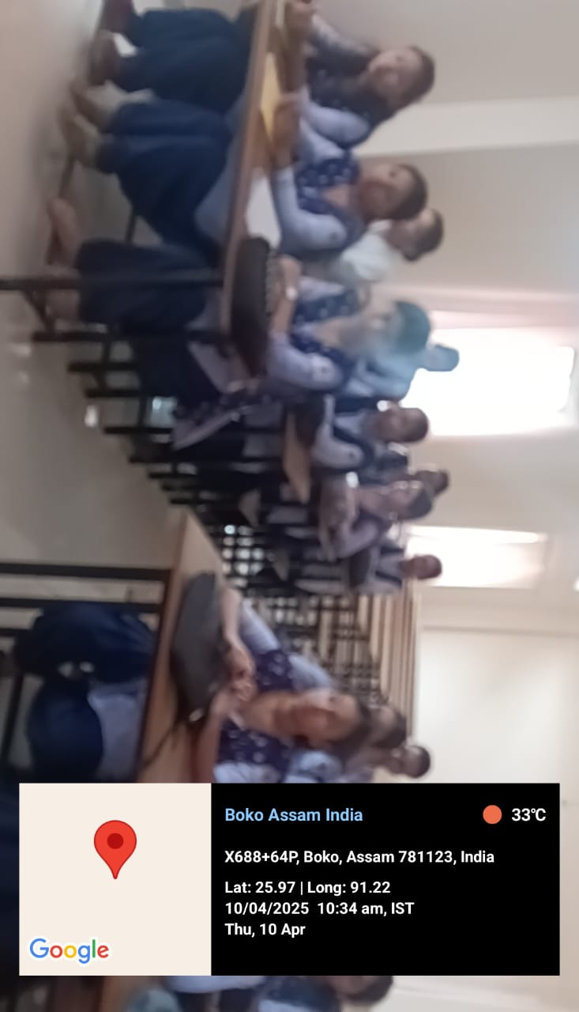
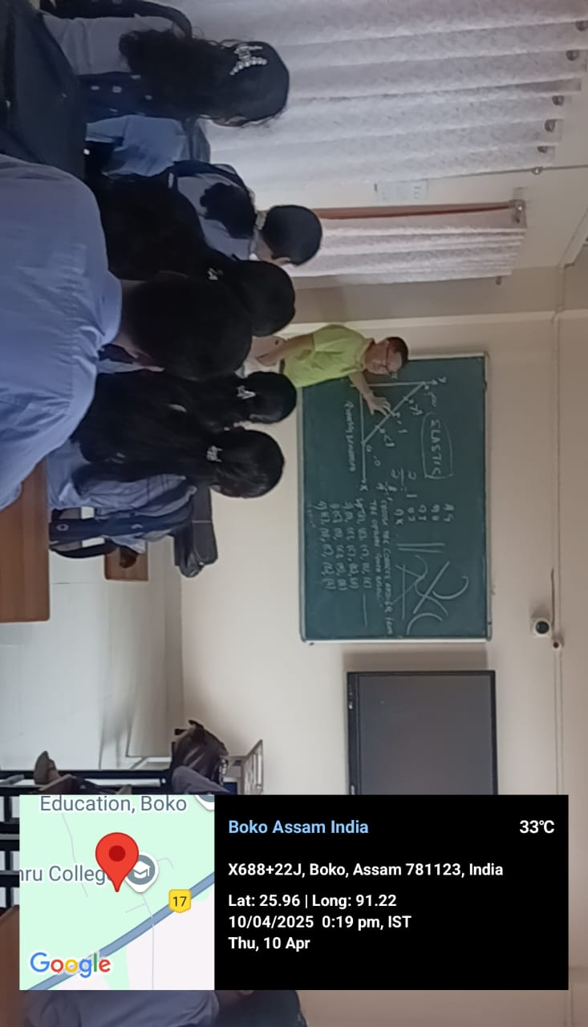

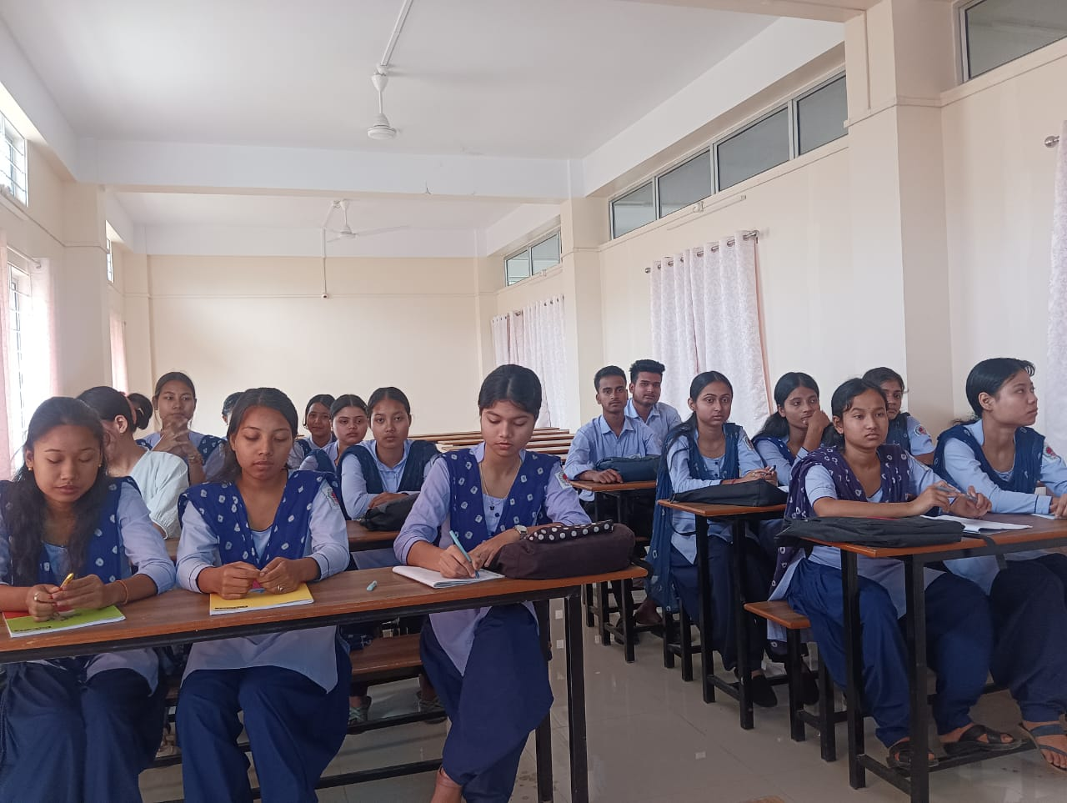

Field Visit to Mandira Integrated Farm, Hekra , Assam: 08-05-2025
Date of Visit: 8th May 2025
Course: SEC – Semester II (FYUGP)

The students of Semester-II undertook a one-day educational field visit to Mandira Integrated Farm, Hekra, Assam (Livestock Research Station, Assam Agricultural University) on 8th May 2025 as part of the SEC curriculum requirements. The visit was organized by the Department of Economics, Jawaharlal Nehru College, Boko, with the objective of providing hands-on exposure to integrated farming practices, sustainable agriculture, and modern farm management systems. The team was accompanied and guided by:
- Mrs. Deepanjali Das, Associate Professor, Economics Department
- Mr. Bau Nriame Kuizebe, Assistant Professor, Economics Department

Objectives:
- Understand Integrated Farming: Learn about combining agriculture, livestock, and aquaculture for sustainable productivity.
- Learn Sustainable Practices: Observe eco-friendly farming methods like organic practices and water management.
- Connect Theory to Practice: Apply classroom knowledge to real-world farming.
- Encourage Critical Thinking: Analyze the benefits and challenges of integrated farming.
Upon arrival, the students were introduced to the overall layout and operational model of the farm. Mandira Integrated Farm is known for its holistic blend of agriculture, livestock, aquaculture, and organic farming methods. The farm officials briefed the group about the concept of integrated farming—an approach that links various farm components to maximize resource efficiency, minimize waste, and enhance productivity. The students explored different units including poultry and dairy sections, fish ponds, etc.
Demonstrations and Lectures were also provided by Dr. M.C. Kanta, Principal Scientist, Dr. Dimpi Choudhury, Scientist, ZLRS, AAU, Mandira and Dr. Juripriya Brahma, Scientist, ZLRS, AAU, Mandira on soil-health management, water-use optimization, organic manure preparation, and the use of eco-friendly pest-control methods. The interaction with farm Technicians & Scientiest helped the students understand how integrated farming promotes environmental sustainability while ensuring economic viability for farmers.

Outcomes:
- Gained insights into integrated farming systems (IFS).
- Learned practical sustainable farming techniques.
- Bridged classroom theory with field experience.
- Developed critical thinking on farming practices and challenges
The field visit proved highly informative and productive. It not only broadened the students’ understanding of sustainable agricultural practices but also motivated them to explore innovative and eco-friendly farming models. The exposure gained from Mandira Integrated Farm will significantly contribute to fulfilling the learning outcomes of the SEC syllabus of Semester-II.
Participants
Sl No | Name of Student | Gender |  | Sl. No | Name of Student | Gender
1 | Prakash Rabha | Male |  | 10 | Mousumee Kalita | Female
2 | Kapil Boro | Male |  | 11 | Dimpymoni Das | Female
3 | Dibakar Medhi | Male |  | 12 | Joydeep Upadhyai | Male
4 | Tridiv Boro | Male |  | 13 | Pallabi Nath | Female
5 | Ankur Jyoti Rabha | Male |  | 14 | Priyanshu Sarkar | Male
6 | Bikash Ray | Male |  | 15 | Marthiu Marak | Male
7 | Pinki Sharma | Female |  | 16 | Debajit Sarkar | Male
8 | Dimpi Sutradhar | Female |  | 17 | Munna Karmakar | Male
9 | Lija Das | Female |  | 18 | - | -

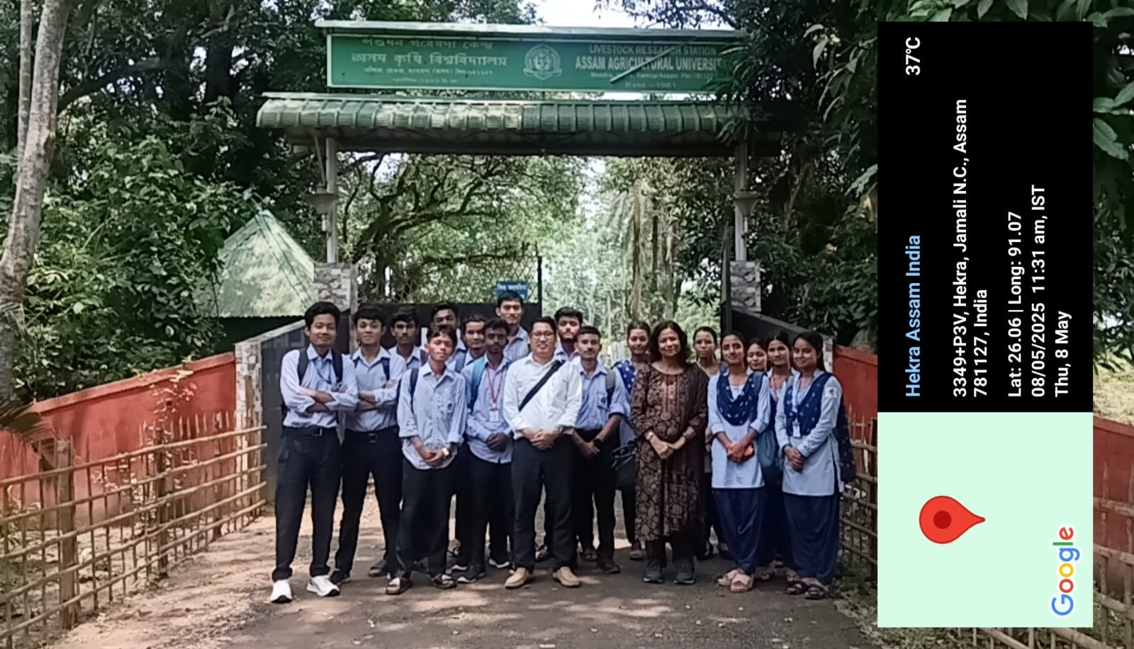
Photo Gallery

