Student Seminar: 13-09-2025
Student Seminar for 3rd Semester Economic Major Students was organized by the Department of Economics on 13th September 2025 with Mr. Bau Nriame Kuizebe , Assistant Professor as a Chairperson of the seminar. The topics of the seminar are:
- Credit Creation
- Inflation
- International Trade
Objectives of Seminar: The seminar aimed to enhance students’
- Knowledge on topics of Seminar
- presentation & Communication Skills
- Spirit of Collaboration & Teamwork
- Leadership Quality
The seminar consisted of three group presentations. The first group presented on Credit Creation, explaining how commercial banks create credit through deposits and lending activities, which helps increase the money supply and supports economic development.
The second group discussed Inflation, focusing on its meaning, causes, and effects. The group explained how a continuous rise in the general price level reduces the purchasing power of money and affects the economy and living standards.
The third group presented on International Trade, highlighting the exchange of goods and services between countries. The group also explained the benefits of international trade such as specialization, wider markets, and economic growth.
After the presentations, Mr. Bau Nriame Kuizebe, the Chairperson, delivered his valuable remarks and appreciated the efforts of the students. He encouraged them to continue improving their academic knowledge, teamwork, and communication skills. The seminar concluded with a brief interactive discussion session and proved to be informative and engaging for all participants.
Participants
Sl No | Name of Student | Gender |  | Sl. No | Name of Student | Gender
1 | Joydeep Upadhyai | Male |  | 10 | Pallabi Nath | Female
2 | Tridiv Boro | Male |  | 11 | Pinki Sharma | Female
3 | Prakash Rabha | Male |  | 12 | Mousumee Kalita | Female
4 | Kapil Boro | Male |  | 13 | Dimpymoni Das | Female
5 | Priyanshu Sarkar | Male |  | 14 | Marthiu K. Marak | Male
6 | Munna Karmakar | Male |  | 15 | Debajit Sarkar | Male
7 | Bikah Ray | Male |  | 16 | - | -
8 | Ankur Jyoti Rabha | Male |  | 17 | - | -
9 | Priti Rabha | Female |  | 18 | - | -
Seminar Photo Gallary of Student Seminar: 13-09-2025
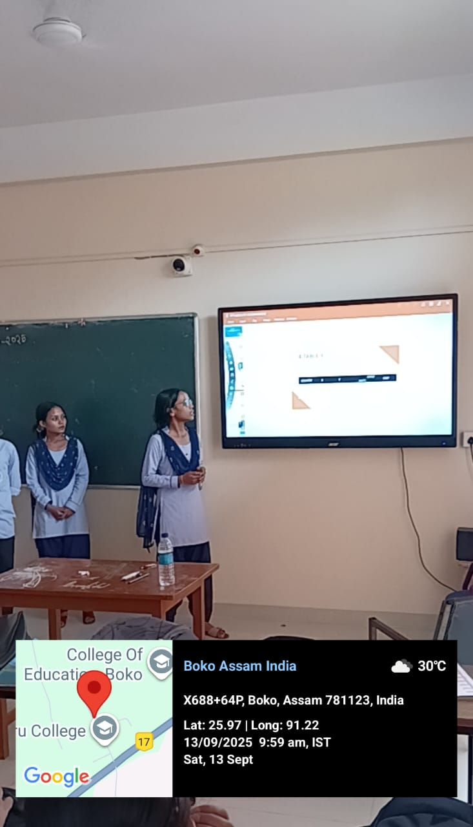
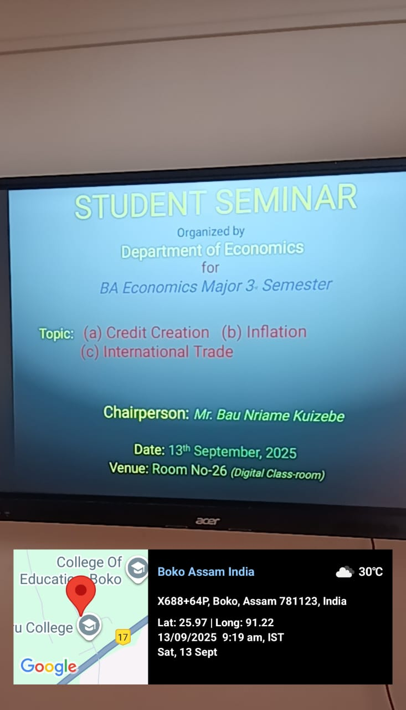

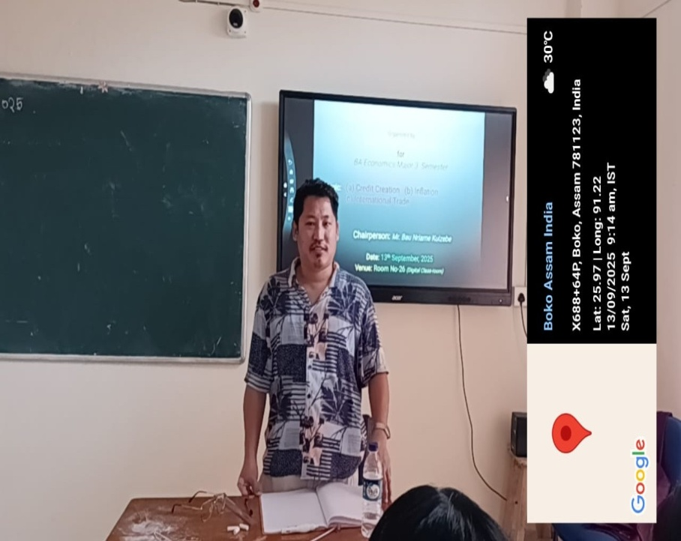
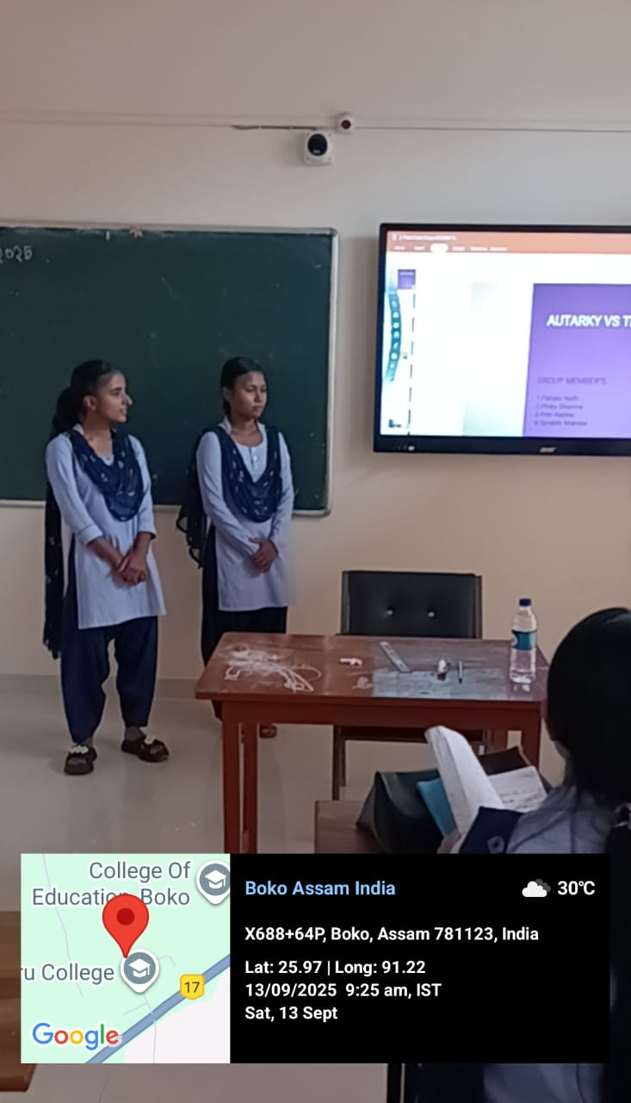

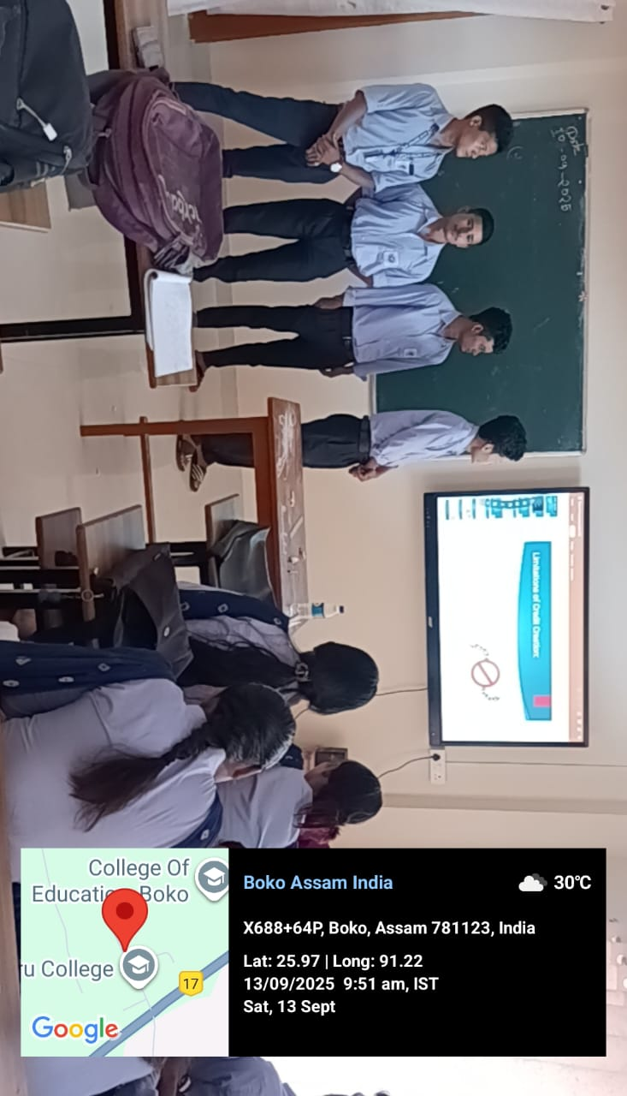
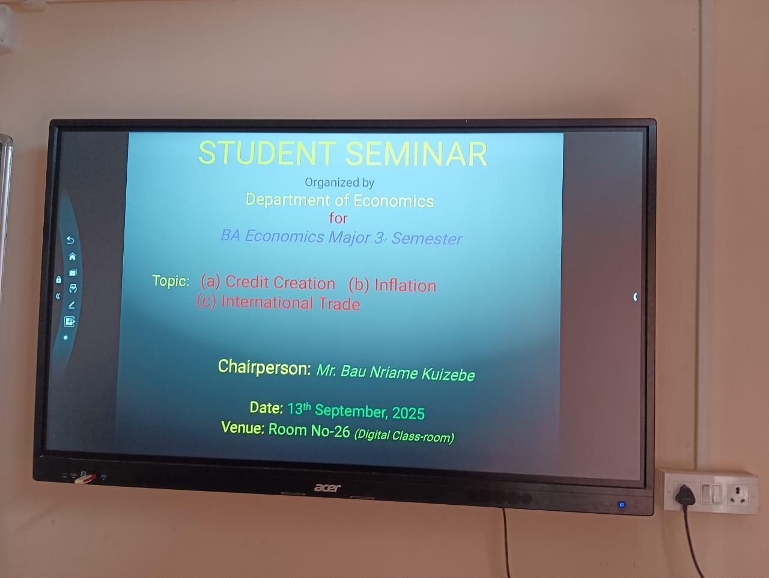

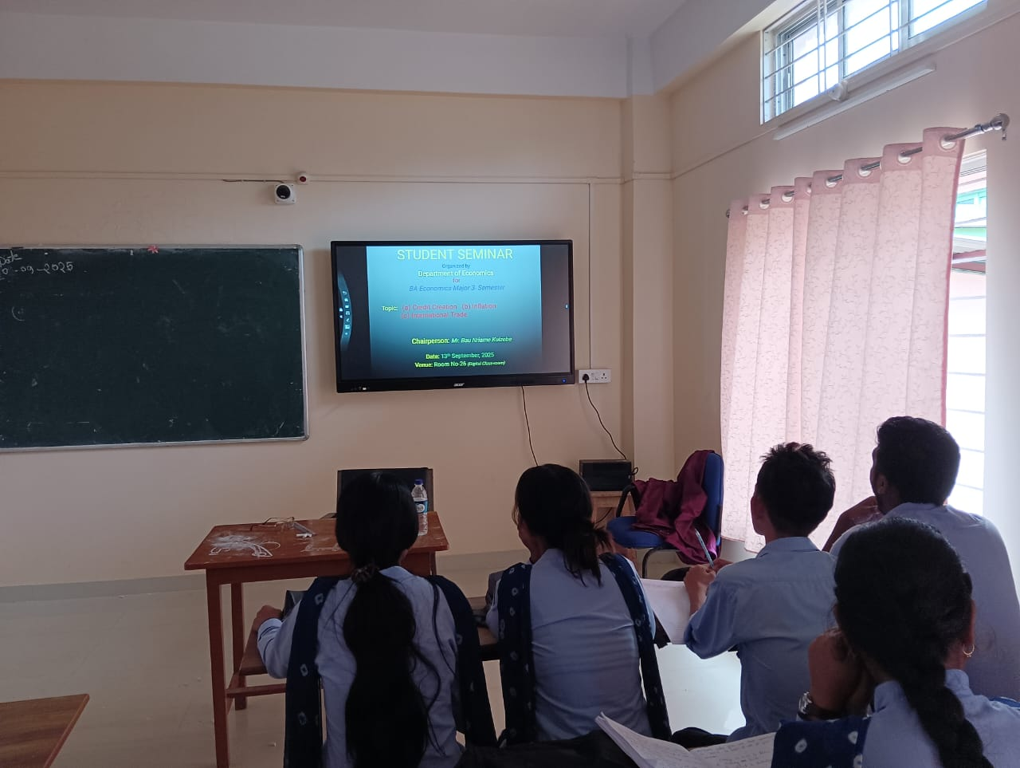
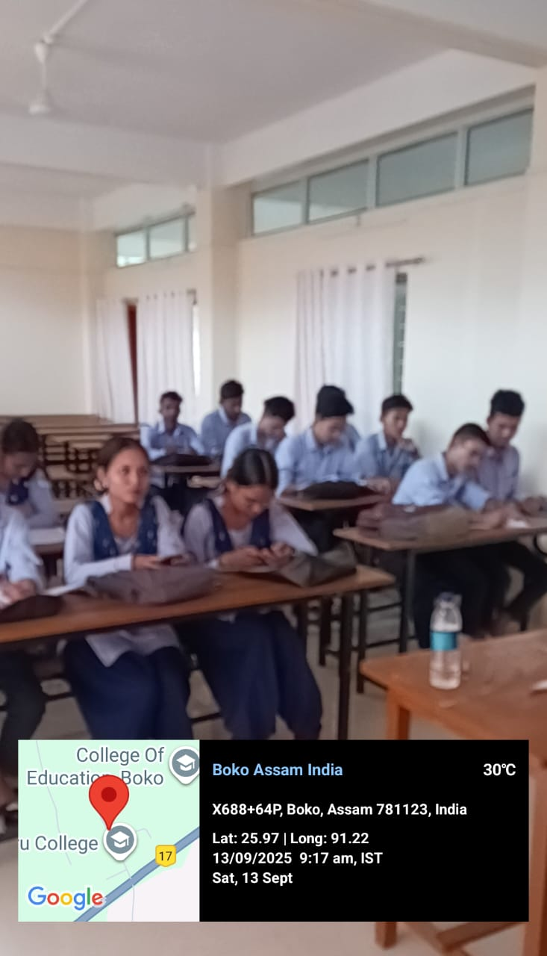

Student Seminar: 26-03-2026
Student Seminar for 6th , 4th & 2nd Semester Economic Major Students on “Sustainable Development” was organized by the Department of Economics on 26th March 2026 with Mr. Bau Nriame Kuizebe , Assistant Professor as a Chairperson of the seminar. The topics of the seminar are:
(a) Approaches to Sustainable Development
(b) Indicators of Sustainable Development
(c) Green Accounting & Goals of Sustainable Development
Objectives of Seminar: The seminar aimed to enhance students’
- Knowledge on topics of Seminar
- presentation & Communication Skills
- Spirit of Collaboration & Teamwork
- Leadership Quality
The seminar consisted of three group presentations. The first group presented on “Approaches to Sustainable Development”, explaining different Approaches such as economic, environmental, social, integrated, participatory, human development, and technological approaches that provide pathways to sustainability.
The second group discussed “Indicators of Sustainable Development”, focusing on its meaning, types and, importance. The group explained how Indicators of Sustainable Development provide information on the economic, social, environmental, and institutional dimensions of development, enabling governments, policymakers, researchers, and organizations to evaluate whether development is meeting present needs without compromising the ability of future generations to meet their own needs.
The third group presented on “Green Accounting & Goals of Sustainable Development”, highlighting the objectives of Green Accounting and different Goals of Sustainable Development. The group also explained how Green Accounting and the SDGs promote balanced development that ensures economic prosperity, social well-being, and environmental protection for present and future generations.
After the presentations, Mr. Bau Nriame Kuizebe, the Chairperson, delivered his valuable remarks and appreciated the efforts of the students. He encouraged them to continue improving their academic knowledge, teamwork, and communication skills. The seminar concluded with a brief interactive discussion session and proved to be informative and engaging for all participants.
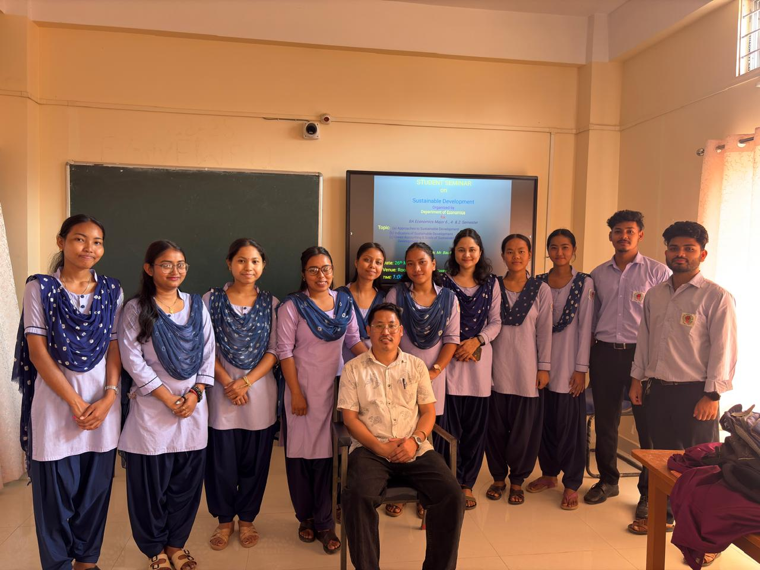
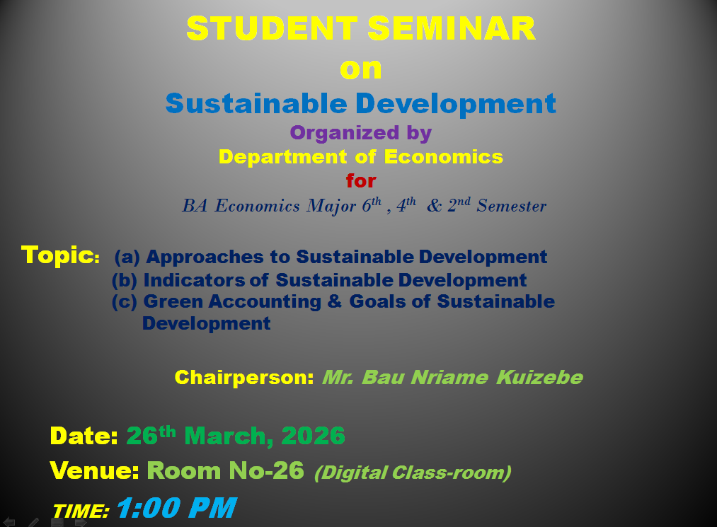
Photo Gallery of Student Seminar: 26-03-2026

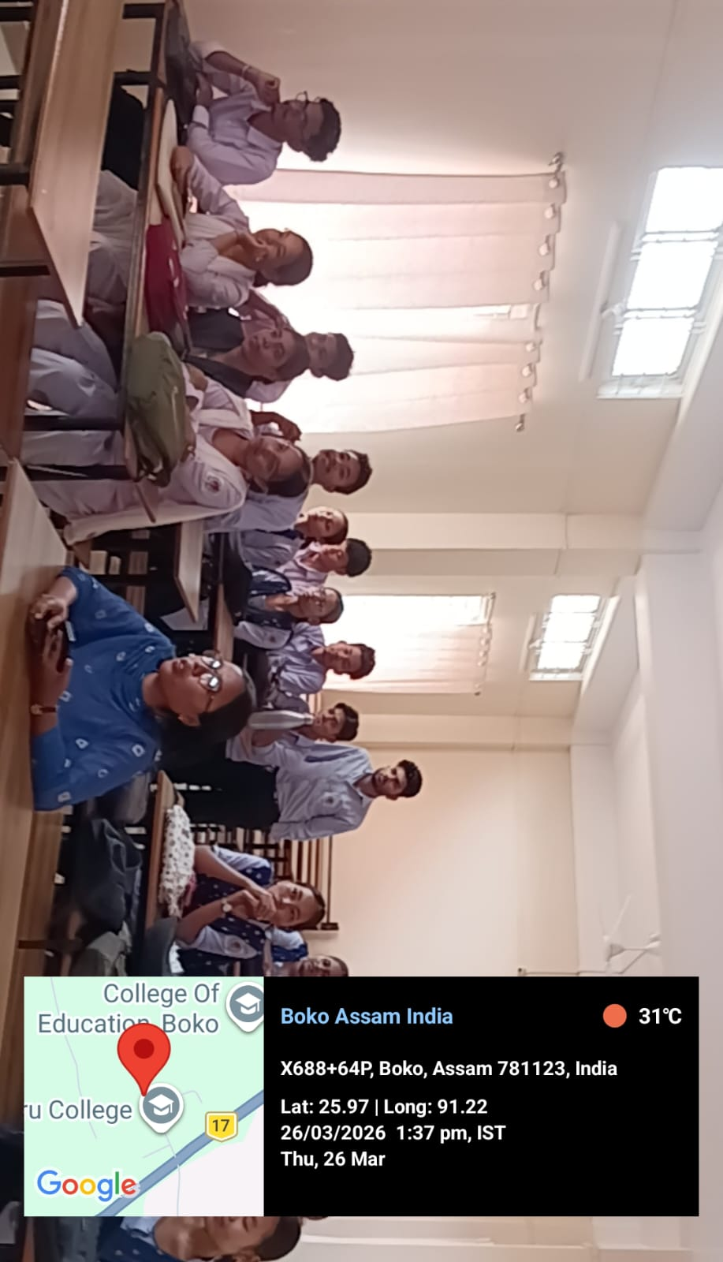
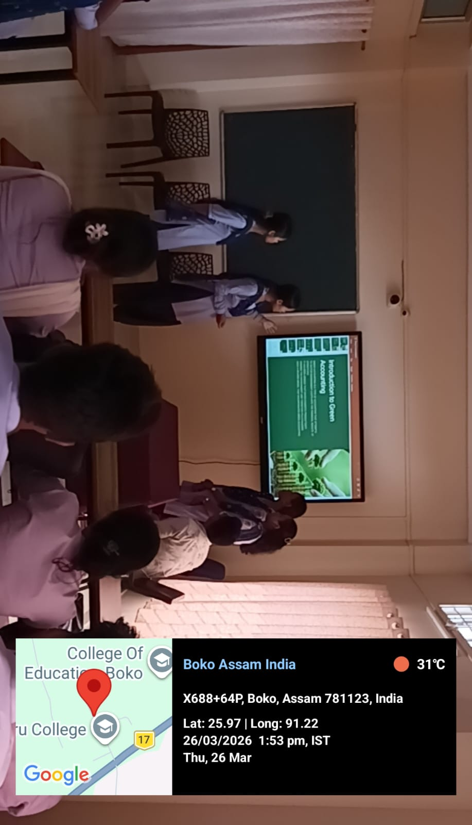

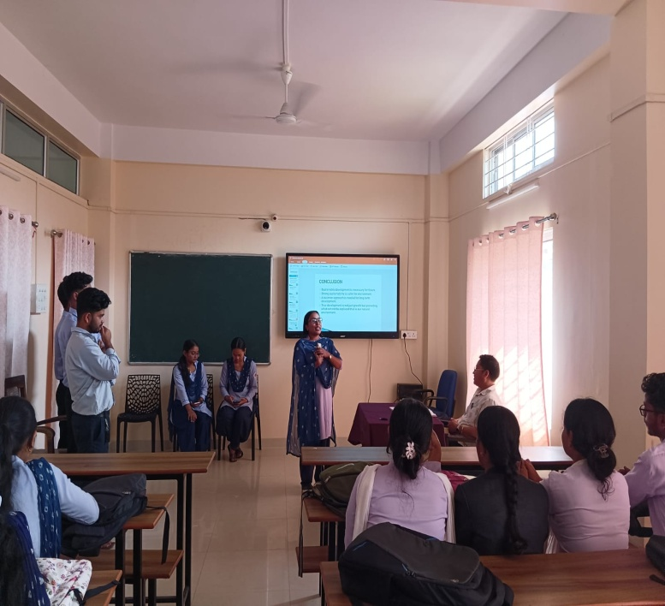
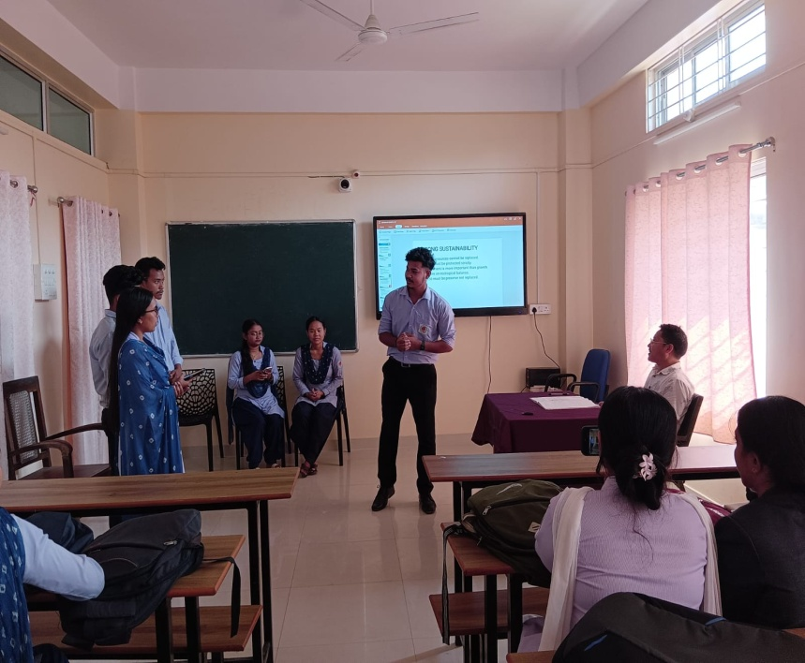

Farewell Programme

for

B.A. Economics 6th Semester Students-2026
Department of Economics
Jawaharlal Nehru College, Boko
Date: 16 May 2026
The Department of Economics, Jawaharlal Nehru College, Boko, organized a Farewell Programme for the outgoing B.A. Economics 6th Semester students on 16th May 2026. The programme was held to bid farewell to the graduating students and celebrate their academic journey.
The programme began with a welcome address by Senoir Faculty, Mr. Prahlad Bharali, followed by an inspiring speech from the faculty Members, who encouraged the students to pursue their future goals with dedication and integrity. Faculty members also extended their best wishes and appreciated the students for their academic achievements and active participation in departmental activities.
The outgoing students expressed their gratitude to the teachers and the department for their guidance and support throughout their college life. The junior students presented cultural performances, games, and entertainment, making the occasion both joyful and memorable. Mementoes were also presented to the graduating students as a token of love and appreciation.
The programme concluded with a vote of thanks, followed by refreshments and a group photograph. The farewell was a memorable event that strengthened the bond between teachers and students and marked the beginning of a new chapter in the lives of the graduating students.
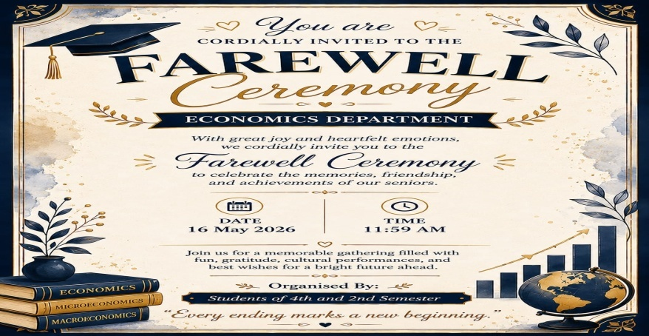
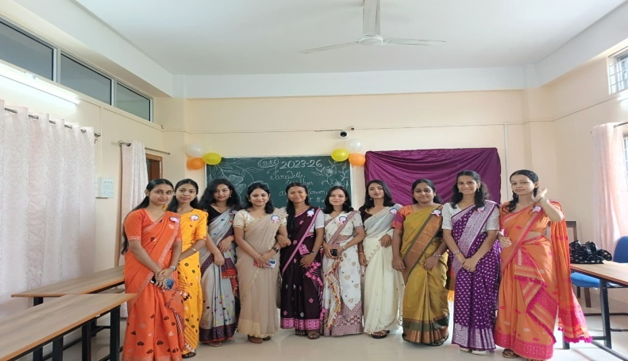

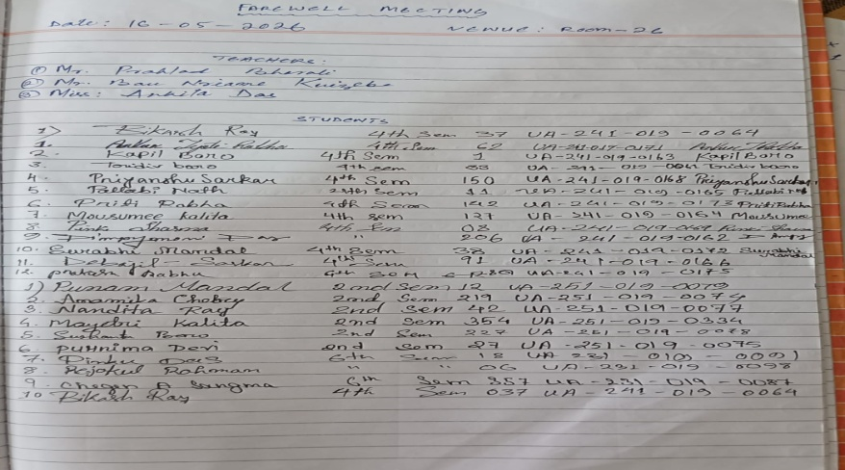
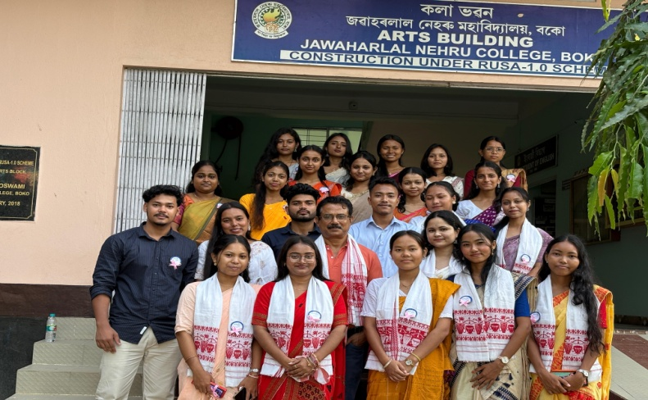

Public Speaking Programme-2026

At

M.V. School, Boko
Department of Economics
Jawaharlal Nehru College, Boko
Date: 3 June 2026
The Department of Economics, Jawaharlal Nehru College, Boko, organized a Public Speaking Programme for the B.A. Major Economics 6th Semester students on 3rd June 2026 at M.V. School, Boko. The programme was conducted under the guidance of the Head of the Department, Mrs. Depanjali Das, and faculty member, Miss Ankita Das, with the objective of enhancing the communication, presentation, and public speaking skills of the students.
As part of the programme, the students delivered short lectures on various socially relevant topics, including the importance of education, health, NCC, entrepreneurship, sports, and other contemporary issues. The activity provided the students with an opportunity to interact with school students while developing their confidence and public speaking abilities.
The teaching and non-teaching staff of M.V. School extended their wholehearted cooperation and support, which contributed significantly to the smooth and successful conduct of the programme. The Department of Economics expresses its sincere gratitude to the Headmaster and staff of M.V. School for their warm hospitality and encouragement.
The programme was highly interactive and beneficial, providing practical exposure to the students and helping them strengthen their communication skills, leadership qualities, and social awareness.

Photo Gallery of Public Speaking Programme: O3-06-2026
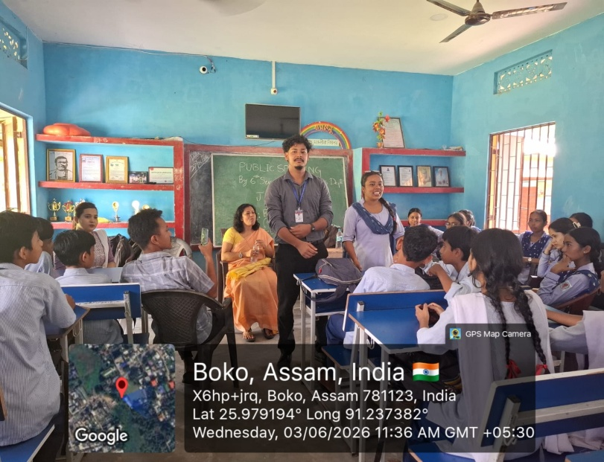
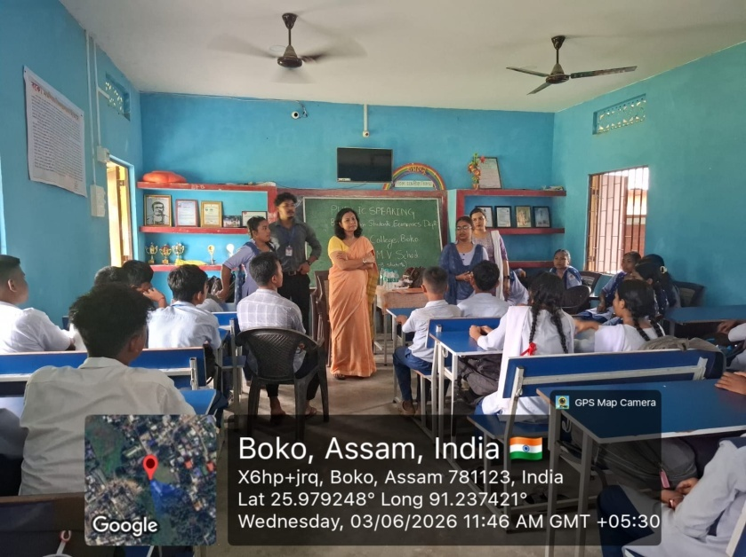

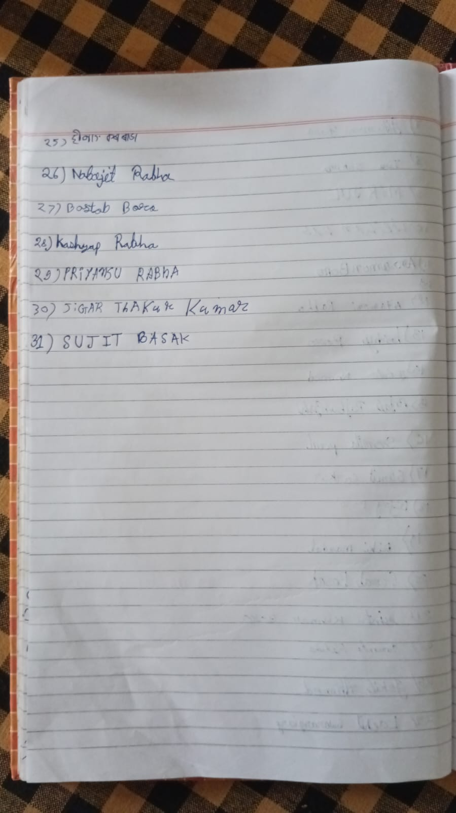
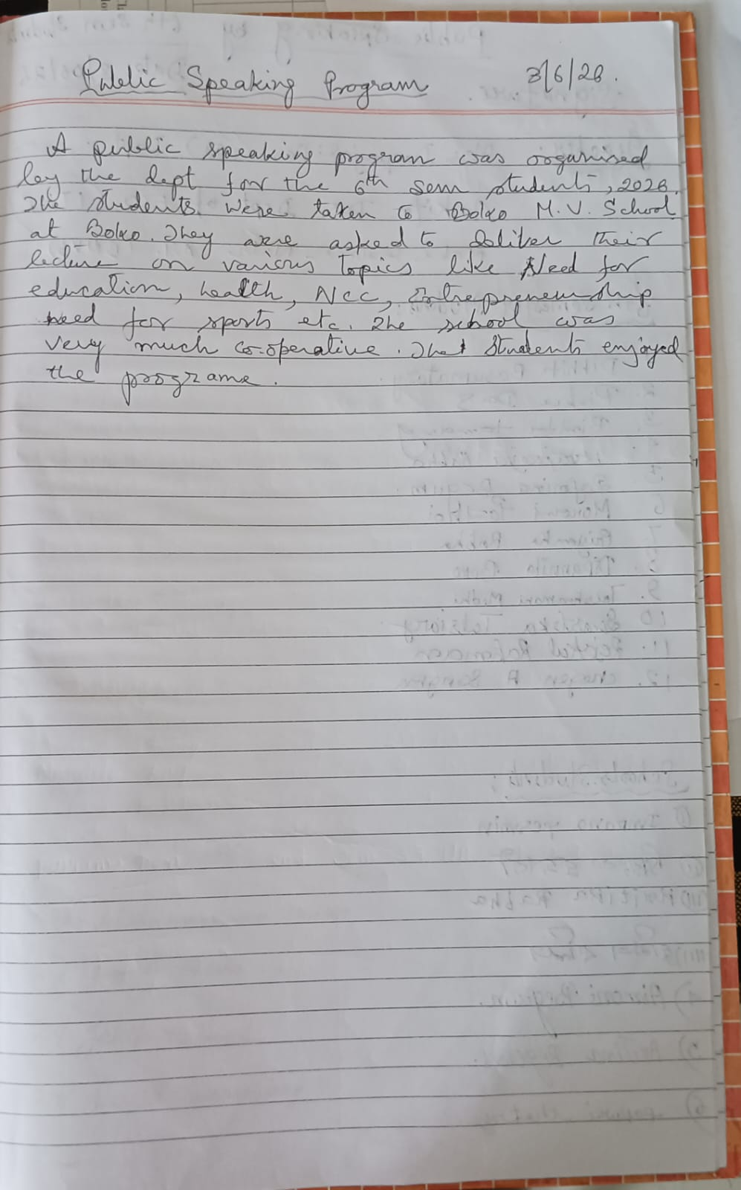
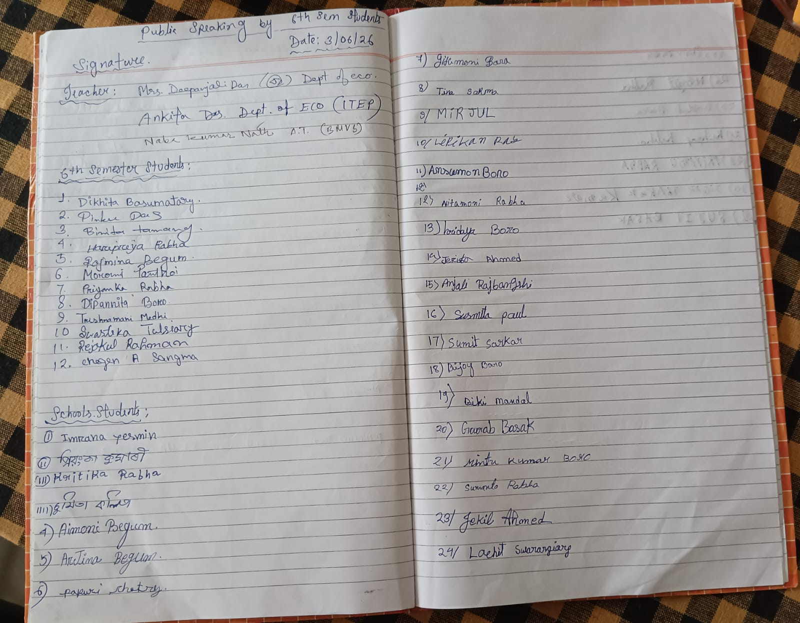
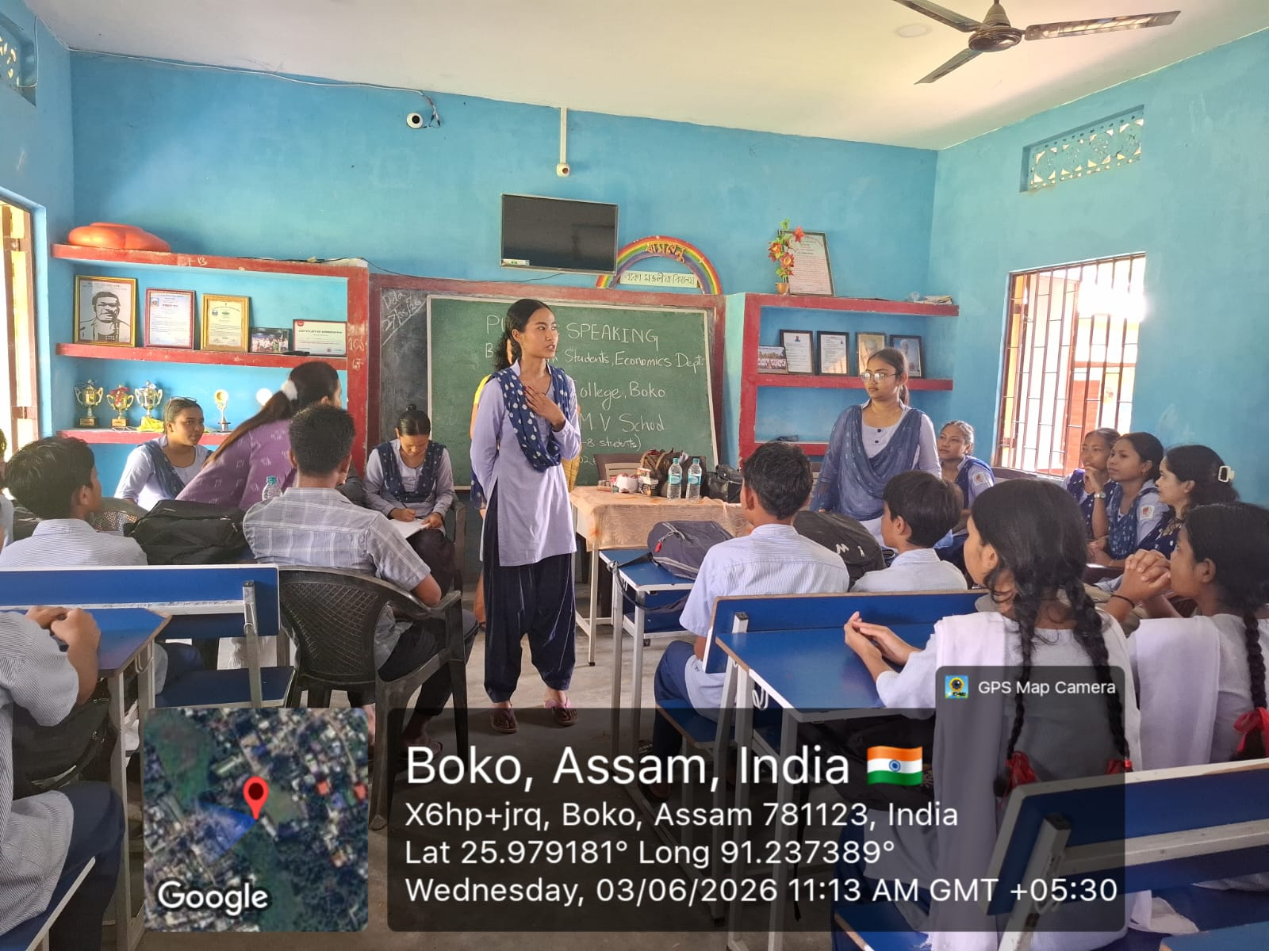
Photo Gallery of Public Speaking Programme: O3-06-2026

