Name of student enrolling into higher education | Program graduated from | Name of institution joined | Name of programme admitted to
- Momishmita Basumatary | BA- Economics Honours | College of Education, Boko, Assam | B.Ed
- Anushmita Bhaishya | BA- Economics Honours | Cotton University, Guwahati, Assam | Master of Library & Information Sciences
- Bhayolina Kalita | BA- Economics Honours | GIRIJANANDA University, Assam | MA in Economics
- Bipasha Rabha | BA- Economics Honours | GIRIJANANDA University, Assam | MA in Economics
- Risika Jain | BA- Economics Honours | GIRIJANANDA University, Assam | MA in Economics
- Ashique Ahmed | BA- Economics Honours | Krishna Kanta Handiqui State Open University (KKHSOU), J.N.College Study Centre, Boko, Assam | MA in Economics
7. Bitopan Rabha | BA- Economics Honours | Indira Gandhi National Open University (IGNOU), Regional Centre, GMCH Road Christian Basti, Guwahati-781005, Assam | MA in Economics
7. Bitopan Rabha | BA- Economics Honours | SPM IAS Academy | APSC Coaching
List of Student Progression to Higher Education for Academic Session: 2024-2025

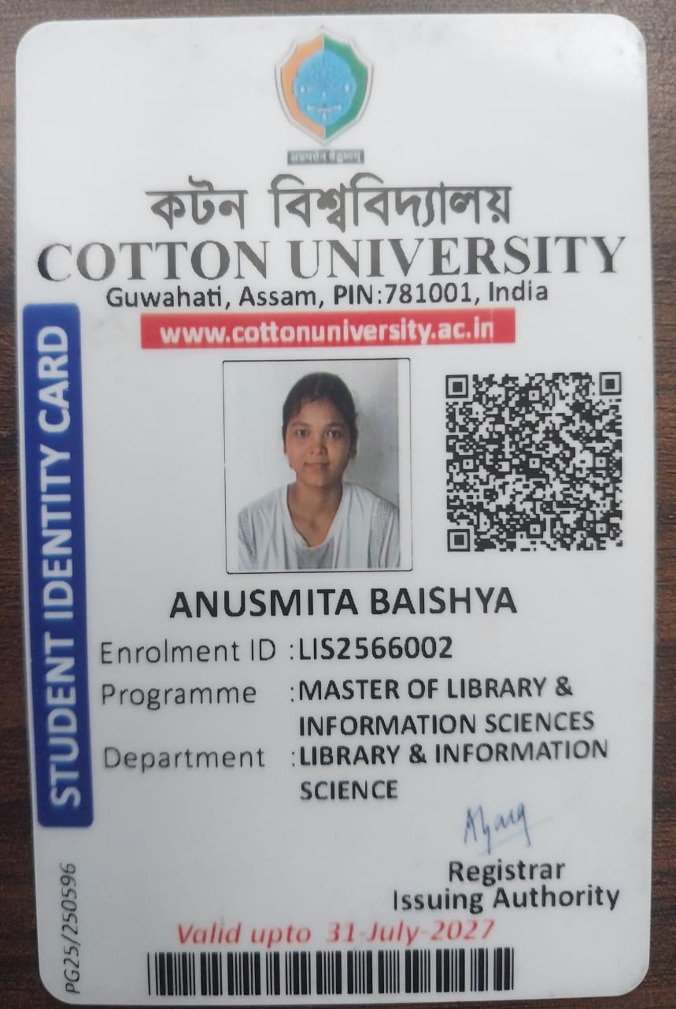
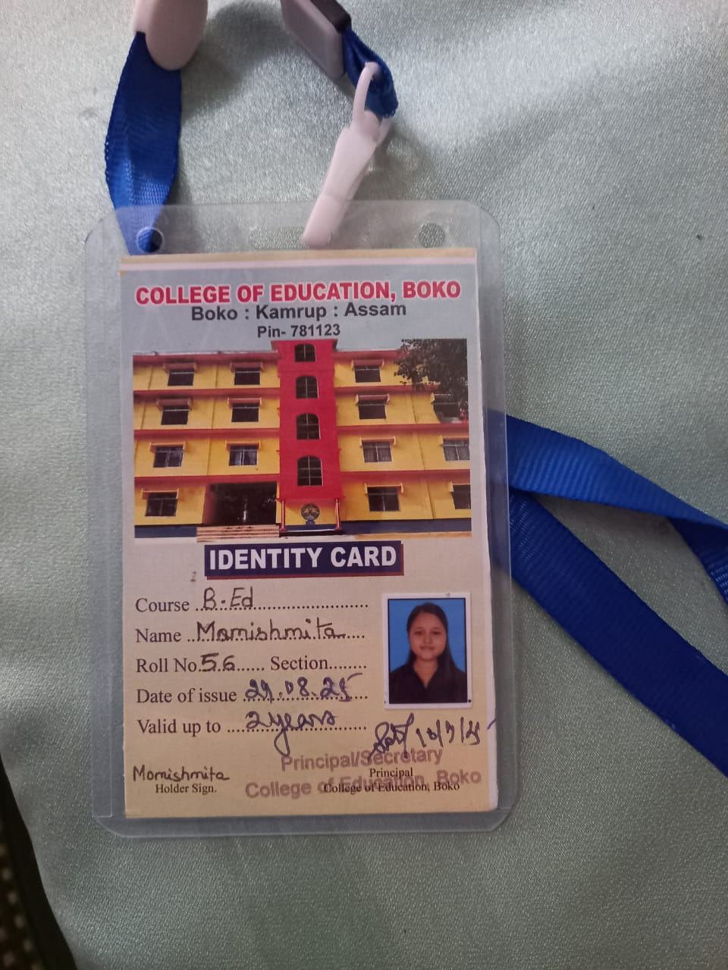
Supporting Documents

